Blood development: hematopoietic stem cell dependence and independence

Elaine Dzierzak^{1*} and Anna Bigas²

¹MRC Centre for Inflammation Research, University of Edinburgh, Queen’s Medical Research Institute, 47 Little France Crescent, Edinburgh, EH16 4TJ, UK
²Program in Cancer Research, Institut Hospital del Mar d’Investigacions Mèdiques, CIBERONC, Dr. Aiguader 88, 08003, Barcelona, Spain

*Corresponding author:
Elaine Dzierzak
University of Edinburgh
Centre for Inflammation Research
Queens Medical Research Institute
47 Little France Crescent
Edinburgh, EH16 4TJ, UK
Tel: +31 10 7043169
FAX: +31 10 7044743
Email: Elaine.Dzierzak@ed.ac.uk

Email: abigas@imim.es

ABSTRACT
Evidence on the diversity and multi-layered organisation of the hematopoietic system is leading to new insights that may inform ex vivo production of blood cells. Interestingly, not all long-lived hematopoietic cells derive from hematopoietic stem cells (HSC). Here we review the current knowledge on HSC-dependent cell lineages and HSC-independent tissue-resident hematopoietic cells, and how they arise during embryonic development. Classical embryological and genetic experiments, cell fate tracing data, single cell imaging, and transcriptomics studies provide information on the molecular/cell trajectories that form the complete hematopoietic system. We also discuss the current developmentally-informed efforts towards generating engraftable and multilineage blood cells.

INTRODUCTION
Hematopoietic stem cells (HSCs) are generally considered the base of the adult hematopoietic system, having the crucial function of long-term maintenance and production of all mature blood cell lineages during the lifespan of an organism. Pioneering studies from Till and McCulloch and others (Becker et al., 1963) used transplantation experiments to demonstrate the clonality of the adult hematopoietic system, and they have indicated that most blood cells originate from very few/single multipotent self-renewing HSCs. Interestingly, recent data has revealed that not all hematopoietic cells originate from HSCs. These HSC independent hematopoietic cells originate from the embryo and persist in the adult hematopoietic system.
In adult mammals, HSCs reside in the bone marrow niche, which is responsible for their maintenance. However, their origin is traced back to the period of embryonic organogenesis when many different cell types are specified. Understanding the steps involved in their generation is crucial to reproducing and adapting the process of HSC generation in vitro for translational applications. As a result, developmental hematopoietic generation has been the focus of high interest, and recent studies have provided an appreciation that other relevant blood cell types, both long-lived and short-lived, are generated in the embryo before HSCs.
Hematopoietic development in the vertebrate embryo occurs in several waves, with each sequential wave producing cohorts of cells that are increased in complexity of blood lineage potential (Figure 1A). The first embryonic wave or primitive wave gives rise to unipotent blood cell types, it is followed by a pro-definitive wave that generates multipotent hematopoietic progenitors. Interestingly, the first self-renewing HSCs are detected in the mouse embryo at least 72 hours later than the onset of primitive hematopoiesis, and their initial formation occurs mainly in the aortic endothelium of the Aorta-Gonad-Mesonephros (AGM) region (de Bruijn et al., 2002; de Bruijn et al., 2000; Medvinsky and Dzierzak, 1996; Muller et al., 1994; North et al., 2002) (Figure 1Ai). HSCs are most stringently defined by their complex in vivo function as self-renewing cells with long-term robust multilineage repopulating hematopoietic activity.
While these developmental aspects are widely accepted, new puzzling observations advise reconsideration of a long-held notion that all hematopoietic cells in the adult are derived from HSCs. These observations support the existence of long-lived HSC-independent hematopoiesis and lead to the conclusion that there is not only a single hierarchical differentiation route that generates functional blood types, but that other shorter differentiation routes exist in vivo.
Similarly, progress in producing hematopoietic cell types in vitro from embryonic stem cell (ESC) cultures or fibroblast reprogramming supports the concept that hematopoietic development does not always follow a single, fixed hierarchical order. In fact, in some cases it is more feasible and efficient to generate mature blood cell types from ESC rather than from bona fide functional HSCs. In this Review, we discuss the current knowledge of hematopoietic development obtained from classical embryologic and genetic experiments, and integrate it with recent cell fate tracing data, single cell imaging, and transcriptomics studies.

HSC-dependent hematopoietic development.
Studies in a variety of animal species have demonstrated that hematopoietic cells originating from HSCs are derived from the intra-embryonic aorta region during development (Figure 1A). Original findings in chick-quail embryo chimeras (Lassila et al., 1978) and amphibian blastomere injections (Ciau-Uitz et al., 2000) demonstrated that the cells providing sustained life-long adult hematopoiesis were derived from the intra-embryonic aorta region rather than the extra-embryonic yolk sac (Figure 1Aii). The presence of hematopoietic clusters closely associated with the aortic endothelium of the chick embryo led to the discovery that the adult hematopoietic system arises through a transition of endothelial cells to a hematopoietic cell fate (endothelial-to-hematopoietic transition; EHT; (Jaffredo et al., 1998)). In the mouse, HSCs are identified experimentally by their ability to produce a hierarchy of differentiating hematopoietic progenitors and mature functional blood cells, as well as their ability to self-renew when serially transplanted into adult myelo/immuno-compromised recipients (Figure 2). Bearing this in mind, functional HSCs are first detected in the wall of the dorsal aorta in the Aorta/Gonad/Mesonephros (AGM) region in the mouse embryo (de Bruijn et al., 2002; Muller et al., 1994) and are autonomously generated in the AGM as shown by explant cultures (Medvinsky and Dzierzak, 1996) thus supporting the findings obtained in vertebrate models that the adult hematopoietic cells in the bone marrow and kidney are generated from intra-aortic-derived cells (Figure 1B). In the human AGM, intra-aortic cells also generate the first multilineage hematopoietic repopulating cells (Ivanovs et al., 2011; Oberlin et al., 2002). In addition to AGM, HSC activity has also been found in other embryonic vascular sites in mouse as well as human, such as the vitelline/umbilical arteries, embryonic head, placenta and the yolk sac (de Bruijn et al., 2000; Gekas et al., 2005; Ivanovs et al., 2011; Li et al., 2012; Medvinsky and Dzierzak, 1996; Ottersbach and Dzierzak, 2005; Robin et al., 2009; Yoder et al., 1997)
Advanced vital imaging studies in mouse and zebrafish embryos have been instrumental in allowing the visualization of aortic endothelial cells evolving to hematopoietic cells. In zebrafish embryos cells lining the aorta first express a hemogenic endothelial-restricted flk1 reporter and then acquire the expression of Runx1, a definitive hematopoiesis marker (Figure 1Aiii) (Bertrand et al., 2010; Kissa and Herbomel, 2010). In the mouse embryo imaging of mid-trunk region thick sections (Boisset et al., 2010) reveal EHT with a Ly6aGFP reporter that marks HSCs throughout (Figure 1Ai). Since, the EHT process that produces definitive HSCs occurs after the establishment of the circulation between the embryonic and extraembryonic tissues in the mouse, the origin of these hemogenic cells is still under discussion. Runx1 expression and reporter labelling studies suggest that angioblasts from the mesoderm at E7.5 (Figure 1Ai) can migrate into the embryo and play a role in facilitating hematopoiesis in the dorsal aorta (Eliades et al., 2016; Tanaka et al., 2014). However, chick embryo grafting studies unequivocally show that the endothelial cells on the ventral ‘hemogenic’ wall of the aorta are derived from lateral mesoderm, whereas those on the dorsal ‘non-hemogenic’ wall are from somitic mesoderm (Pardanaud et al., 1996). These studies and results in Xenopus embryos (Figure 1Aii) (Ciau-Uitz et al., 2000) indicate an early partitioning of mesoderm to establish distinct cells with potential towards endothelial fate and other cells with hemogenic endothelial fate.

HSC-independent hematopoiesis
Vertebrate embryos generate unique types of hematopoietic cells at early stages to carry out specific developmental functions (Figures 1 and 2). New waves of emerging cells with distinctive hematopoietic potentials and functions leave behind previous ones, yielding an increasingly diverse and heterogeneous hematopoietic system with HSCs being the last hematopoietic cell type to emerge.

First embryonic hematopoietic wave. The first embryonic wave or primitive wave takes place in the yolk sac (day E7.5 in the mouse) and generates nucleated erythrocytes, macrophages and megakaryocytes (Palis et al., 1999; Tober et al., 2007) Primitive erythrocytes distribute oxygen throughout the embryo as it becomes too large to rely on oxygen diffusion, whereas megakaryocytes and the first macrophages are important for tissue remodelling (Tober et al., 2007). A recent study in βH1eGFP transgenic mouse embryos (reporter for embryonic globin) found that primitive erythroblasts emerge from hemogenic endothelial cells (Stefanska et al., 2017) or ‘hemogenic angioblasts’ (Lacaud and Kouskoff, 2017) (Figure 1Ai and Figure 2).
In zebrafish (Figure 1Aiii), primitive macrophages and erythrocytes have distinct developmental origins. While primitive macrophages derive from anterior lateral mesoderm, primitive erythrocytes derive from bilateral stripes of posterior lateral mesoderm simultaneously with endothelial cells. Together the endothelial cells and erythrocytes migrate to the midline, where the endothelial cells encapsulate the erythrocytes and form the cardinal vein. Only about 24 hours later do the first cells expressing HSC-associated genes appear (Ciau-Uitz et al., 2014).

Second embryonic hematopoietic wave. Shortly following the formation of primitive cells, the second or so-called ‘pro-definitive wave’ occurs in different sites of the mouse embryo (yolk sac, embryo proper and allantois; Figure 1Ai). Erythroid and Myeloid progenitors (EMP) are generated in vertebrate embryos at during this wave, but also B-1a and T lymphocytes have been detected (Figure 2). Their function and contribution to foetal and adult hematopoiesis is now an active field of research. Several lines of evidence indicate that EMP progeny seed the developing tissues of the embryo, and in some cases will become life-long tissue resident macrophages. This hypothesis about whether EMP-derived cells become microglia/macrophages in the brain, is now well supported (Ginhoux et al., 2010), however there is still controversy about the origin of other tissue resident macrophages, such as those within the lung and liver (Ginhoux and Guilliams, 2016; Perdiguero and Geissmann, 2016). Lineage tracing relying on the temporally-controlled activation of Cre recombinase in early development (E6 to E9) in cells expressing runx1 (Ginhoux et al., 2010), csf1r (Perdiguero et al., 2015), and ckit (Sheng et al., 2015) show different levels of macrophage progeny in the late embryo and the adult mice. Importantly, these macrophages develop in the absence of the c-myb gene, which is thought to be required for HSC formation (Schulz et al., 2012) and this is a focus of continuing investigation. Altogether these data indicate that EMP-derived cells are responsible for the formation of tissue resident macrophages, however the lack of specificity of current labelling techniques prevents drawing definitive conclusions.
Other hematopoietic cells with embryonic or fetal origin are the Immunoglobulin M-expressing cells, a B lymphocyte subset also known as B-1a cells. Some decades ago, the Herzenberg group showed that adult BM HSCs lack the ability to generate this B-cell subset upon transplantation. More recently, they have shown that fetal HSCs also lack capacity to fully regenerate the B-lymphocyte compartment (Ghosn et al., 2016). Several groups have now demonstrated the capacity of different mouse embryonic sites to generate B-1a cells prior to the onset of HSCs (Godin et al., 1993; Hadland et al., 2017; Kobayashi et al., 2014; Yoshimoto et al., 2011), suggesting an HSC-independent embryonic origin. Others have identified a yolk sac-derived immune-restricted and lymphoid-primed progenitor that would not persist into adulthood (Boiers et al., 2013). In contrast, lineage-tracing studies show the existence of a fetal HSC subtype for the origin for this particular B-cell population (Kristiansen et al., 2016). This atypical fetal HSC is characterized by expression of lin28b (Yuan et al., 2012) and flk2 (Beaudin et al., 2016). In summary, the current data indicates that B-1a cells have both HSC-dependent and HSC-independent origins.
Embryonic development of T-cells seems to follow a different pace from B-cells. Whereas cells with B-cell potential are detected as early as E8.5 (Cumano et al., 1993), it is not until E9.5 that para-aortic splanchnopleura cells can develop into T-cells under strong Notch signal conditions (Yokota et al., 2006) and T-cell activity has been regarded as an in vitro indication of definitive hematopoietic activity in the ES cell system (Kennedy et al., 2012). However evidence for T-cell potential has also been reported from the yolk sac at E9.5 prior to HSC emergence (Yoshimoto et al., 2012). More recently, Luis et al. showed that Rag1+ cells with full T-cell potential but also myeloid potential colonize the thymus rudiment at E11.25 from cells independent of von-Willebrand factor (vWF)-positive HSC cells (Luis et al., 2016).
Altogether, these observations indicate that the formation of specialized hematopoietic cells of the myeloid and lymphoid lineages occurs in the absence of HSCs (Figure 2), and thus has important implications for current approaches attempting the ex vivo production of functional blood cells.

Developmental precursors to hematopoietic cells
An understanding of what signals influence hematopoietic lineage fate choice of a hemogenic endothelial cell/developmental precursor is largely unknown. Time-controlled cell fate tracing studies (Chen et al., 2009; Zovein et al., 2008) and vital imaging confirm that functional HSCs are generated from endothelial cells (Bertrand et al., 2010; Boisset et al., 2010; Kissa and Herbomel, 2010). By genetically labelling cells expressing the vascular endothelial cadherin (VE-cadherin, cdh5) in the mouse embryo at E9.5, it was determined that HSC originate from VEC+ endothelial cells that are present around E10 and their progeny contribute to adult bone marrow, thymus, and spleen cells (Zovein et al., 2008). The HSCs are localized in intra-aortic hematopoietic clusters (de Bruijn et al., 2002; North et al., 2002), but out of about 700 of these cluster cells at E10.5 (Yokomizo and Dzierzak, 2010), only approximately 2 are functional HSCs (Kumaravelu et al., 2002). Majority of the cluster cells are HPCs or other hematopoietic cell types (Solaimani Kartalaei et al., 2015).
In vitro imaging studies (Eilken et al., 2009; Huber et al., 2004; Lancrin et al., 2009; Nishikawa et al., 1998) indicate the endothelial origin of earlier hematopoietic cell types such as EMPs. Flk+ and brachyury+ mesodermal cells from murine embryos (yolk sac, para-aortic splanchnopleura) undergo EHT as early as E7.5. Results obtained by genetic pulse labelling of Tie-2 expressing endothelial cells at E6.5-E7.5 (Perdiguero et al., 2015) demonstrated that labelled hematopoietic progeny in the brain and fetal liver. Importantly, a recent in vivo study showed that the yolk sac vasculature contains hematopoietic clusters (Frame et al., 2016). Hence, intra-vascular hematopoietic clusters contain a wide diversity of hematopoietic cell types generated through EHT.
Since not all cluster cells exhibit the identical hematopoietic fate, when does commitment to a specific hematopoietic cell type or lineage occur? Several models have been proposed. A ‘maturational’ model (Figure 3A) suggests that one initial cohort of hemogenic endothelial cells undergoes sequential maturational stages to produce three distinct cohorts of hemogenic endothelial cells that subsequently transdifferentiate to produce three distinct hematopoietic cell waves. A ‘distinct origin’ model (Figure 3B) suggests that three separate hemogenic endothelial cohorts are responsible for transdifferentiation to the three distinct hematopoietic cell waves. This model would imply that the mesoderm is spatially/temporally partitioned (as in chick (Pardanaud et al., 1996) or Xenopus (Ciau-Uitz et al., 2000) embryos). A third possible ‘cell-cell interaction’ model (Figure 3C) is suggested in which early cohorts of hematopoietic cells interact/signal the ‘mature/third cohort’ of hemogenic endothelial cells to induce HSC potential and/or generation. This model is supported by the requirement of a double transgene (Tie2- and Ly6a-directed CBFβ) to rescue HSC activity in CBFβ (Runx1 partner)-deleted mice (Chen et al., 2011). Thus, it is likely that the emergence of waves of intra-vascular cluster cells with distinct hematopoietic (lineage, multilineage, HSC) potentials occurs through a combination of these models, and also is influenced by the local microenvironment.

Hematopoietic potency or performance?
Embryonic hematopoietic development is confined to different anatomical sites (yolk sac, allantois, para-aortic splanchnopleura, head, and placenta) at different developmental times. To fully understand the contribution of each site, it is crucial to determine and distinguish their potential fate and their physiological fate. Sophisticated in vitro cultures have been developed to measure possible potentials – such as tissue explants, liquid cultures, stromal co-cultures, or reaggregate systems that artificially provide signals that reveal/enhance/promote HSC potential. To measure physiologically-relevant fate outcome, lineage genetic tracing, direct phenotypic analyses, and the direct isolation and functional analysis of cell potential by in vivo transplantation or in vitro colony forming unit assays are performed. The interpretation of these data is not always straightforward due to the complexity of the assays, and frequently the competence to become a cell type in culture is interpreted as in vivo physiological performance.
An interesting point is raised when one considers ESC/iPSC hematopoietic differentiation. In a recent study, Flk1+ cells from day 3 differentiated ESCs (in serum-free embryoid-body (EB)-type cultures) generated in vivo engrafting cells, suggesting that the potency of HSC specification exists early in these cultures (Pearson et al., 2015). Others previously used similar cultures to demonstrate the sequential production of all progenitor types in an order of increasing complexity that includes primitive and definitive erythrocytes, myeloid cells, and B and T cells (Irion et al., 2010; Kauts et al., 2017; Kennedy et al., 2012). These results suggest that early mesoderm has potency for all these lineages. However, longer EB culture periods provide a 3-dimensional structure that may more readily reflect the in vivo development of the precursors of hematopoietic cells.

Molecular regulators of developmental hematopoietic cell generation
A variety of coordinated signals lead to the correct formation of a new organism. The embryo is compartmentalised into different fields of competent cells that generally restrict their fate as development proceeds. How blood competence is established is still a matter of investigation, but the first functional blood cells in the extraembryonic tissues are HSC-independent and require different molecular signals than those giving competency to HSCs. It is in the embryo proper and after at least day 9 that cells will acquire the competence for generating HSCs.
The key to blood system development is a coordinated orchestration and reception of temporally and spatially dynamic extrinsic signals (Figure 4). The signaling pathways crucially establishing the guidelines are restricted to only a few categories, mainly represented by Notch, FGF, EGF, Wnt, Hedgehog, BMP/TGFβ, Hippo, cytokine/Jak/Stats, TNF/IFN/NFκB, JNK, and RAR (Perrimon et al., 2012). Most pathways have been directly or indirectly implicated in the EHT process or the specification of HSCs, however it remains difficult to fully understand their specific role(s) in the early decisions establishing the hematopoietic cell fate. The signaling pathways converge to activate expression of pivotal intrinsic factors. These master transcription factors control the expression of downstream hematopoietic genes. A few examples of such signals are covered here.

The BMP pathway. Early exploratory experiments showed the presence of BMP4 in the ventral mesenchyme of the dorsal aorta (Marshall et al., 2000). Further experiments testing the role of BMP4 in AGM explants showed enhancement of HSC repopulation (Durand et al., 2007). By using a genetic reporter approach (BRE-GFP) that indicates cells activated by the BMP pathway, it was shown that most HSCs in the fetal liver reside in the active-BMP population (Crisan et al., 2015). However, the requirement of BMP at the different stages of HSC maturation may vary, as the effect of BMPER (a BMP inhibitor) correlates with an enhancement of HSC maturation in vitro (McGarvey et al., 2017). These results further illustrate the importance of defining the specific cell and stage in which these signals are influencing the HSC precursors. Similarly, other pathways such as Wnt and Notch need to be turned down or turned off in specific cells at particular developmental periods in order for HSC development to proceed (Ruiz-Herguido et al., 2012; Souilhol et al., 2016).

The Notch pathway. Notch is a cell-cell interaction signaling pathway known to orchestrate cell fate decisions in many different tissues and lineages. Investigation of the Notch requirement in the hematopoietic and arterial system has revealed the importance of distinct activation threshold levels in cell fate determination. By using two mouse Notch-activation-tracing reporters with different efficiencies in the capacity to label cells exposed to Notch activity - in the sense that the low-efficient reporter requires high Notch activity and the highly-efficient reporter can label cells with high and low Notch activity - it was found that arterial cells were labelled in both reporters (thus suggesting high Notch activity), while hematopoietic cells were only labelled with the highly efficient reporter (thus suggesting low Notch activity). The main conclusion drawn was that arterial cells exposed to a strong Notch signal are not the precursors of HSCs (Gama-Norton et al., 2015). Similarly, differentiation of human ES cells showed that non-arterial, non-venous (CD34⁺CD73⁻CD184⁻), Notch-dependent endothelial cells were the precursors for HSC/HPC (Ditadi et al., 2015).
Strong evidence that Notch signals are required to generate HSCs is supported by experimental results in mouse, xenopus, zebrafish, and human ES cells (reviewed in (Bigas et al., 2013)). The Notch pathway family is composed of 5 ligands (Delta-like 1,3,4 and Jagged1,2) and 4 receptors (Notch1-4). The specific combination of ligand and receptors seems to play important roles in the specificity of the signal, however our current knowledge about the ligand-receptor interplay and the outcome of each combination is still poor. HSC development requires at least Notch1 and Jagged1, but simultaneously Notch1 and Dll4 are required by neighbouring endothelial cells to engage the arterial program. How the generation of the specific signals in the hematopoietic precursors is established is not known, but threshold levels of activation play a role. The final output of the Notch pathway is associated with the onset of the hematopoietic transcriptional program in the mouse embryo. For example, Notch is upstream of the crucial hematopoietic regulator GATA2 (Robert-Moreno et al., 2005) and it is not only required for its expression, but also to obtain the just-right levels of this transcription factor through an ‘incoherent feed-forward’ loop (Guiu et al., 2013).

Inflammatory signals. Another group of signals crucial to hematopoietic development are the inflammatory pathways that mainly converge on NF-κB. The zebrafish model has facilitated the identification of these signals that have been primarily validated in the mouse models. Some examples include TNFα and IFN that are key elements of the inflammatory pathway affecting HSC development (Espin-Palazon et al., 2014; Li et al., 2014; Sawamiphak et al., 2014). Interestingly, TNFα was found to favour Notch signalling through activation of Jag1 transcription (Espin-Palazon et al., 2014), thus revealing a complex coregulation between different signals. IFNγ and IL1 also affect the development of HSCs in the AGM, but the mechanisms underlying this function have not been elucidated. The inflammatory signals may originate from early extraembryonically-derived innate immune cells to affect HSC identity, EHT, and/or HSC mobility (Travnickova et al., 2015).

Master hematopoietic transcription factors. The aforementioned pathways orchestrating blood development eventually converge to activate the onset of expression of hematopoietic-specific transcription factors. A core group of transcription factors (TF) has been found to play an essential role in the development of the hematopoietic system. Tal1/SCL, Lmo2, and Fli1 TFs are involved at an early stage in either mesoderm or endothelial cells and ‘primitive’ hematopoiesis. Loss-of-function mutations of these factors impose strong defects in both endothelial and hematopoietic cells, thus supporting the close connection between lineages.
Pivotal TFs involved in the generation of ‘definitive’ hematopoietic progenitors and HSCs include the intensely studied Runx1 and Gata2. Homozygous deletion of the respective factors results in E12.5 and E10.5 embryonic lethality, and while primitive hematopoiesis and vasculogenesis are generally normal, the fetal liver is severely anemic and contains no definitive HSCs (Tsai et al., 1994; Wang et al., 1996a; Wang et al., 1996b). Runx1 deletion in the VE-cadherin (Cre) expressing cells abolishes HSC formation at the endothelial-to-hematopoietic-transition stage (Chen et al., 2009). However, Runx1 deletion in Vav1-expressing (committed HSC) cells produces no hematopoietic defects, indicating that the requirement for Runx1 is lost once HSCs are specified (Chen et al., 2009; Tober et al., 2013). In contrast, such conditional knockout studies for Gata2 show that it is required not only for EHT and HSC generation, but also for the life-long maintenance of HSCs (de Pater et al., 2013). HSC function is extremely dependent upon the threshold levels of Gata2 expression, since haploinsufficiency or overexpression lead to HSC abrogation or non-function (Guiu et al., 2013; Ling et al., 2004). Haploinsufficiency of Runx1 has less severe consequences, changing the timing and possibly the sites of HSC generation in the embryo, while adult hematopoiesis appears unaffected. Several pathways such as Notch (Guiu et al., 2013), BMP4 (Maeno et al., 1996; Walmsley et al., 2002) or ETS/EGR (Taoudi et al., 2011) have been found upstream of Gata2 and Runx1 transcriptional regulation.

Induction of the hematopoietic program. The transcription of downstream hematopoietic-related genes occurs through the assembly of multiple transcription factors, enzymes, and chromatin remodelling proteins, as seen in hematopoietic progenitor cell lines (Wilson et al., 2010) and in vitro hematopoietic differentiation of ESCs (Goode et al., 2016). The establishment of the hematopoietic program relies on a combination of up to 12 transcription factors including the ’heptad’ factors SCL, LYL1, LMO2, GATA2, RUNX1, ERG and FLI-1. In the ESC system, early priming of hematopoietic genes has been revealed in the absence of Runx1. However, hematopoietic fate acquisition occurs through Runx1-dependent reorganization of the TF assemblies (Lichtinger et al., 2012). Once the hematopoietic fate is established, the robustness of the program is accomplished by interactions among these transcription factors at specific enhancer/promoter regions of the DNA (Wilson et al., 2010). A further understanding of how specific programs establish the diversity of hematopoietic cells in vivo awaits technical advances with single cells that will allow simultaneous ‘omics’ analyses together with association to cell function.

Transcriptional analyses in hematopoietic development
A revolution in single cell technologies has opened the field to an awareness of the wide diversity of blood cells and their relatedness. Previously, the cytometric sorting of cells based on cell surface characteristics allowed phenotypic classification according to in vitro and/or in vivo hematopoietic function with construction of a conceptual framework for the adult blood lineage differentiation hierarchy. Assumptions were made that lineage restriction occurs in steps, with lineage potentials segregating in multiple progenitor stages following the HSC stage. Indeed, multilineage gene expression prior to hematopoietic lineage restriction was first demonstrated in a hematopoietic progenitor cell line (Hu et al., 1997). The so-called epigenetic landscape of Waddington proposed the canalization of cells in directional differentiation paths with decision points or nodes in which an unstable program becomes stabilized leading to terminally mature functional blood cells. However, the onset of hematopoiesis in the early embryo challenges this concept, as many differentiated blood cells are made prior to and independent of HSCs. Improved multiparameter immunosorting allows more refined cell isolations and clonal functional analyses of adult primary hematopoietic cells so that previously defined lineage branchpoints appear to be more of an overlapping continuum than previously suggested.
It was demonstrated over two decades ago that it is possible to convert hematopoietic cells from one lineage to another through the induced expression of specific hematopoietic TFs (reviewed in (Graf, 2002)). For example, mouse B cell transduction with the C/EBPα TF converted them to macrophages through a GMP-like transition, thus introducing the concept of molecular interconvertibility or transition states in the adult hierarchy (Xie et al., 2004). How wide is the inherent instability of the hematopoietic developmental gene expression program? In embryonic development, are there stepwise binary fate choices in the generation of the precursors to the HSC-independent and HSC-dependent stages, or are diverse fates derived from distinct already-fated precursor cells (Figure 3)? Single cell RNA sequencing of embryonic cells and enriched cell fractions containing HSCs and HPCs suggests a close continuum of hematopoietic expression programs that could incorporate both cell fate propositions to facilitate HSC-independent and HSC-dependent hematopoiesis during development.

Early hematopoietic specification from mesoderm by single cell RNA-sequencing. The onset of the earliest wave of hematopoietic cell generation occurs in the extraembryonic yolk sac following mesoderm formation during gastrulation. Nascent mesoderm has been identified by the surface expression of the Flk1 receptor tyrosine kinase and the effects of its genetic deletion (Fehling et al., 2003; Shalaby et al., 1997). These cells migrate to the extraembryonic and embryonic regions of the conceptus and have been found to differentiate to endothelial, cardiac, and hematopoietic cells.
The diverse nature of the mesodermal cell gene expression program in the mouse conceptus was examined in over 1,200 single cells taken at embryonic day (E) 6.5-7.75 (Scialdone et al., 2016). In unsupervised hierarchical clustering, over 2000 genes showed significantly robust heterogeneous expression levels. What has emerged in dimensionality reduction analyses is an in vivo view of at least 10 transcriptionally distinct cell clusters. Most epiblast (E6.5) cells formed one large expression signature cluster, whereas hematopoietic and endothelial gene expression was confirmed in the other clusters and showed overlap in cells from E7.5 neural plate stage and E7.75 head fold stage embryos. As vascular genes were downregulated, hematopoietic genes and particularly erythroid-specific signature genes were upregulated (Moignard et al., 2015). Developmental cell trajectories could be inferred through pseudotime and pseudospace distances between the distinct/ and overlapping cell clusters showing known cell-type specific transcriptional signatures. Posterior mesodermal cells associate with allantois, blood, and endothelial clusters and show BMP signaling, hindlimb development, and endothelial cell differentiation signatures, whereas anterior mesoderm identity is associated with somite and endoderm development and Notch signalling signatures. Presumptive cardiac mesoderm is localized between these regions on the anterior/posterior axis.

Cardiac, endothelial and hematopoietic diversification. Interestingly, the Tal1/SCL transcription factor has been studied as a pivotal regulator of mesodermal cell diversification to cardiac and hematopoietic lineages. Tal1/SCL is essential for all blood cell development (Porcher et al., 1996; Shivdasani et al., 1995). In its absence, yolk sac mesodermal cultures give rise to cardiomyocyte progenitors (Van Handel et al., 2012) and the ectopic overexpression of Tal1/SCL in ESC or zebrafish drives transdifferentiation to hematopoietic progenitors (Batta et al., 2014; Gering et al., 1998; Gering et al., 2003). Together, these results implicate a role for Tal1 either in the specification of hematopoietic fate and/or alternatively as a repressor of cardiac fate.
To explore this issue, Tal1/SCL function was re-evaluated at single cell resolution. Transcriptomics analysis of Tal1^{-/-} endothelial cells revealed a downregulation of hematopoietic genes. However, no upregulation of cardiac marker genes was observed, making it likely that induction of the blood program is the primary role of Tal1 and that induction of cardiac gene ectopic expression is a secondary event. The implication is that mesodermal cells in these early stages of development are genetically flexible, maintaining cell plasticity for cardiac, endothelial, and hematopoietic lineages. In the next stages of development, some endothelial cells also retain a degree of flexibility, competence to respond to Runx1, and potential for hematopoietic fate (Eliades et al., 2016; Yzaguirre et al., 2018).
As stated earlier, partitioning of mesoderm with respect to endothelial and hematopoietic lineage potential is most apparent in the chick embryo: Endothelial cells (hemogenic endothelium) lining the ventral wall of the aorta are derived from lateral mesoderm, whereas the (non-hemogenic) endothelial cells of the dorsal wall are somatic mesoderm-derived (Pardanaud et al., 1996; Pouget et al., 2006). Recently, human ESC-derived hematopoietic cultures have been used to explore the issue of distinct endothelial lineages. At the clonal level, hemogenic endothelial and arterial or venous endothelial cells are derived from separate lineages. Molecular identity of the hemogenic endothelial fraction of day 8 EBs includes Notch dependent generation of RUNX1C positive cells exhibiting multilineage hematopoietic function (Ditadi et al., 2015).

Single cell Transcriptomics to understand HSC specification: EHT and pre-HSCs. Prior to HSC generation, EMPs emerge from the yolk sac vascular hemogenic endothelium (Frame et al., 2013) and slightly later, lymphoid and multipotential progenitors are generated in the yolk sac, AGM, and placenta. The precursor-progeny relationships leading to the generation of these HSC-independent hematopoietic cells have been difficult to understand, and recent attention has focused on obtaining and comparing the transcriptional signatures of these early HPCs with HSCs to dissect the unique genetic determinants and networks that direct cell fate to functional adult repopulating HSCs.
In this regard, single cells from the mouse embryonic aorta at E8.5, E9.5, and E10.5, the time prior to and contemporaneous to the appearance of the first adult-repopulating HSCs, have been characterized. Swiers et al (Swiers et al., 2013) was first to characterize the dynamic changes in the function and transcriptome of the hemogenic endothelium at the single cell level. Using a reporter for Runx1 expression to distinguish between hemogenic and non-hemogenic endothelium, transcriptomic analysis of 268 single cells was performed during EHT. By comparing the expression levels of 18 pivotal hematopoietic and endothelial genes, it was found that hematopoietic specification initiates at E9.5 with the upregulated expression of pivotal hematopoietic transcription factors. Functional assays confirmed endothelial or hematopoietic progeny from single E9.5 and E10.5 Runx1+ hemogenic endothelial cells, whereas only endothelial progeny was obtained from E8.5 Runx1+ hemogenic endothelial and E8.5-E10.5 Runx1- endothelial cells. The early onset of the hematopoietic transcription program in E9.5 hemogenic endothelial cells is consistent with the emergence of the first functional hematopoietic progenitors and hematopoietic cluster cells, and this onset is one full day prior to functional HSC detection in the aorta.
Recently, single-cell RNA sequencing of surface marker enriched AGM cells has been performed to capture and compare the transcriptomes of E11 aortic endothelial cells, pre-HSCs (CD45- Type 1; and CD45+ Type 2) (Rybtsov et al., 2011), E12 AGM HSCs, and E14 fetal liver HSCs (Zhou et al., 2016). Global gene expression dynamics (principal component analysis) reveal the overlap between Type 1 and Type 2 pre-HSC clusters, but show no overlap between ECs, pre-HSCs, and HSC clusters. Gene set enrichment analyses revealed 57 pathways overrepresented in Type 1 pre-HSCs as compared to ECs, most notably the mTOR pathway. Indicative of mTOR signaling activation, upregulated gene expression of growth factor receptors, ribosomal subunits, and membrane-cytoskeletal-coupled cellular processes was observed. One of the mTOR core components, Rictor, was found to be expressed in AGM HSCs but not HPCs. In contrast to the studies utilizing reporters expressed in AGM HECs, this study did not distinguish AGM ECs from HECs.
Earlier studies prior to single cell RNA-seq focused on the transcriptome of AGM subpopulations and made big contributions to cell type characterization (McKinney-Freeman et al., 2012; Solaimani Kartalaei et al., 2015). EC, HEC and HSPC populations defined by c-kit, CD31 cell surface markers combined with the expression of the Ly6a(Sca1)GFP reporter have been functionally characterized (de Bruijn et al., 2002) and imaged during EHT by time lapse microscopy (Boisset et al., 2010). These cell populations were sorted from E10.5 AGM and analysed by RNA sequencing to reveal the complete transcriptome (Solaimani Kartalaei et al., 2015). Upregulation in the expression of pivotal (heptad) hematopoietic transcription factors was observed in comparisons of ECs to HECs and HECs to HPSCs. Several published HSC gene sets were found to be upregulated already in HECs, consistent with the early onset model of EHT proposed by Swiers. Of the 530 differentially expressed genes, Gpr56 was found to be the most upregulated receptor in the transition from HECs to HSCs and was functionally validated in zebrafish. Similar RNA-seq studies also identified EHT regulators, such as the surface marker CD27 (Li et al., 2017) that was first found expressed in AGM HSCs and yields a high enrichment of long-term repopulating HSCs as shown by in vivo transplantation.
Transcriptomics data have expanded our knowledge and provided important insights into some of the genes that could be involved in EHT and/or the generation of HSCs. They have indicated upregulation of the pivotal heptad transcription factor genes during the early onset of hematopoietic fate, and now beg the full characterization of all the downstream target genes that alone or together in a combinatory transcription factor complex are activated to generate distinct hematopoietic fates and functions. In fact, the hematopoietic heptad transcription factor complex was originally described by genome-wide chip-seq analysis on a hematopoietic progenitor cell line, HPC7 (Wilson et al., 2010). Performing this type of analysis on the rare cells undergoing EHT in the mouse embryo will require state-of-the-art methodologies to identify the complexes and gene targets. Until this becomes possible, the question of what specific factors, factor combinations, onset/order/levels of factor expression drive the decision to become an HSC, HPC and/or pre-HSC in the transition from hemogenic endothelium remains open.

Programming/Reprogramming/Conversion to hemogenic endothelium and hematopoietic cells
The possibility to molecularly direct a cell to a chosen fate through extrinsic and intrinsic cues highlights the challenge to generate specific hematopoietic cell types as well as generate HSCs. To date, although most lineages of hematopoietic cells can be formed ex vivo, robust HSCs have not. This inability may be explained by inadequate microenvironmental cues and lack of a defined genetic program for HSC generation in cultures. A growing number of human hematopoietic cell transcriptomics datasets from single cells (Angelos et al., 2018) and enriched cell populations (Cesana et al., 2018) facilitate attempts to program, reprogram, and convert various types of cells to the hematopoietic lineage. Two main strategies are used to direct the ex vivo generation of hemogenic endothelium, mature hematopoietic cells, HPCs, and HSCs (Figure 5). These involve the addition of extrinsic factors to differentiation cultures, or the overexpression of specific hematopoietic TFs in non-hematopoietic cells, mature hematopoietic cells, ESCs, and induced pluripotent stem cells (iPSC). In some recent cases both strategies are combined.

Extrinsic factor-driven hematopoietic differentiation. The timely addition/removal of factors/morphogens (activin/nodal, Wnt, BMP, FGF, and Vegf) known to be important for the in vivo development of the primitive streak, mesoderm, and hemangioblast/hemogenic endothelium to ESC/iPSC hematopoietic differentiation cultures (performed under serum-free conditions) influences the in vitro production of Flk1+ mesodermal cells, hemangioblasts/hemogenic endothelium, and HPCs (Figure 5) (Irion et al., 2010; Nostro et al., 2008; Pearson et al., 2015; Pearson et al., 2008; Sturgeon et al., 2014). Activin and FGF induce hemangioblast formation and VEGF induces committed HPCs (Pearson et al., 2008). Interestingly, Wnt influences the formation of definitive HPCs, whereas blocking Wnt results in primitive HPC formation (Sturgeon et al., 2014). Recently, a mouse ESC study defined an early differentiation stage in which hematopoietic signatures for primitive and definitive hematopoiesis simultaneously appear in the mesoderm (Pearson et al., 2015). Under the influence of BMP followed by addition of Activin A and FGF in EB cultures, Flk1-expressing cells are generated and harvested at day 3. These cells are induced in hemangioblast cultures for one day with BMP, Activin A, and VEGF, and on the second day with BMP and VEGF to yield cKit-expressing hematopoietic cells that engraft in vivo, as well as primitive and definitive HPCs, thus suggesting that there is an absence of positional developmental cues that coordinate the wave-like emergence occurring in the dynamic three-dimensional physiological context within the embryo.
Directed differentiation of human iPSC with morphogens and cytokines has also been successful in generating cells with nascent HPSC and hemogenic endothelial characteristics (Guyonneau-Harmand, BioArchives, 2017). In this transgene-free and stromal cell-free GMP-grade EB culture system, transcriptional analyses reveal EC commitment at day 13, hemogenic endothelial commitment at day 16, and overt HPSC commitment at day 17. Only day 17 EBs showed hematopoietic-forming capacity and could engraft with multilineage capacity in immunocompromised mice (up to 12% in BM at 20 weeks post-transplantation). Hence, the production of HPSCs from human iPSC without transgenes offers advantages for the generation of GMP grade patient-specific cells for therapy.

TF-directed programming/reprogramming. Reprogramming approaches for the blood system are based on the premise that pivotal master TFs direct the expression of downstream target genes involved in hematopoiesis. Panels of TFs expressed during or known to be required for the in vivo generation of hemogenic endothelium, HPCs, and HSCs are utilized for these strategies (Figure 5). Four such hematopoietic TFs - Gata2, Gfi1b, Fos and Etv6 – were transfected into mouse fibroblasts, and after 35 days of culture, they were sufficient to impose a hemogenic transcriptional signature to these hematopoietic-unrelated cells. Following additional 20 days of culture, HPCs (but no HSCs) were observed (Pereira et al., 2013), thus demonstrating the transdifferentiation of fibroblasts to the hematopoietic fate. Similarly, ectopic expression of five TFs – Erg, Gata2, Lmo2, Runx1c and Scl – in mouse (embryonic and adult) fibroblasts resulted in the rapid intermediate reprogramming to hemogenic endothelium and to hematopoietic progenitors by day 8 of culture (Batta et al., 2014). This combination of TFs appears to accelerate the transdifferentiation process, with mouse embryonic fibroblasts being slightly more receptive.
Human PSC-derived CD34+CD45+ myeloid progenitors respecified by ectopic expression of HOXA9, ERG, RORA, SOX4 and MYB can also provide short-term in vivo engraftment of myeloid and erythroid lineages (Doulatov et al., 2013). While it is possible to generate human hematopoietic progenitor cells ex vivo, the process is inefficient. It is likely that the in vitro culture systems lack appropriate microenvironmental cues for support of cells converted to HSC fate.
To circumvent the problem of ex vivo microenvironmental deficits, an approach was taken whereby the in vivo niche was used to support the cell conversion (Riddell et al., 2014). Following the transduction of adult mouse B-lymphoid progenitor cells with Hlf, Pbx1, Prdm5, Lmo2, Zfp37, Mycn, and Meis1 the cells were immediately injected into irradiated adult recipient mice. In this de-differentiation approach the transfected donor B cells provided long-term multilineage repopulation, thus demonstrating that B cells can be converted to HSCs in the context of the native bone marrow niche that provides support for the newly generated iHSCs (Figure 5). This strategy was similarly used with human iPSCs differentiated in vitro for 3 days (Sandler et al., 2014; Sugimura et al., 2017). Human iPSC-derived hemogenic endothelial cells were isolated, transduced with seven TFs (ERG, HOXA5, HOXA9, HOXA10, LCOR, RUNX1, and SPI1), immediately transplanted into immune-deficient mice, and TF overexpression was induced with doxycycline. At 12 weeks, multilineage engraftment, including lymphoid cells, was found in 5 out of 13 recipients with BM CD45+ cell chimerism around 10%.
In another approach, transplantable human multipotent progenitor cells (rEC-MPP) were produced from human umbilical blood-derived endothelial cells up to 40 days in culture after transfection of FOSB, GFI1, RUNX1, and SPI1 (Sandler et al., 2014). This in vitro culture system provided vascular niche endothelial cells for support. The conversion/reprogramming of endothelial cells from the adult mouse lung to immunocompetent HSCs was achieved using these same four TFs (Figure 5) (Lis et al., 2017). During the conversion, the lung endothelial cells transition through several stages. Dox-induced overexpression of the TFs induced the endogenous expression of Runx1 at day 8-20 (hemogenic stage). Thereafter, the VE-cadherin+Runx1+CD45- endothelial cells transitioned to hematopoietic progenitors (CD45+ with CFU-C potential). From day 20-28, CD45+ cells transplanted into lethally irradiated adult recipients provided erythroid, myeloid, and lymphoid long-term hematopoietic engraftment (average ~7%). Together these strategies are raising our chances of pluripotency-independent conversion of autologous endothelial cells to engraftable hematopoietic stem cells that could aid in the treatment of hematologic disorders.

What determines hematopoietic fate versus hematopoietic stem cell fate?
Our knowledge of the developmental biology and the transcriptomes of endothelial cells, hemogenic endothelial cells, hematopoietic progenitors, and hematopoietic stem cells has been an important springboard to produce such cells ex vivo. However, it is obvious that different numbers and different panels of transcription factors can be used to convert source cells to hematopoietic progenitor and/or HSC fate, suggesting that there is likely to be more than one genetic program/cascade/route. How to tip the balance to obtain specific hematopoietic progenitor or stem cell fate is currently not well understood.
Complex characteristics, such as TF combinatorial effects, differing affinities for TF binding sites in regulatory elements, TF onset, and quantitative levels of expression, RNA degradation, protein half-life, post-translational modifications, and transcriptional enhancer site accessibility/occupancy may play a role. Considering that single-cell analyses are verifying the mixed lineage states of highly enriched hematopoietic stem cells that are likely to correspond to functional heterogeneity, it is a continuing challenge for developmental biology to delineate the cellular states, intermediates, and regulatory gene network that provide cell type specification to HSC independent and HSC dependent hematopoiesis, so as to generate a complete and healthy life-long blood system.

Acknowledgements

The authors thank Lluis Espinosa for critical reading of the review and lab members for helpful discussions. We acknowledge the support of the ERC Advanced Grant (341096 DENOVOHSC) to ED and SAF2016 -75613-R from MINECO and PERIS- SLT002/16/00299 and 2017SGR135 from Generalitat de Catalunya to AB

Declaration of Interests

The authors have no competing interests to declare.

References

Angelos, M. G., Abrahante, J. E., Blum, R. H., and Kaufman, D. S. (2018). Single Cell Resolution of Human Hematoendothelial Cells Defines Transcriptional Signatures of Hemogenic Endothelium. Stem Cells 36, 206-217.
Batta, K., Florkowska, M., Kouskoff, V., and Lacaud, G. (2014). Direct reprogramming of murine fibroblasts to hematopoietic progenitor cells. Cell Rep 9, 1871-1884.
Beaudin, A. E., Boyer, S. W., Perez-Cunningham, J., Hernandez, G. E., Derderian, S. C., Jujjavarapu, C., Aaserude, E., MacKenzie, T., and Forsberg, E. C. (2016). A Transient Developmental Hematopoietic Stem Cell Gives Rise to Innate-like B and T Cells. Cell Stem Cell 19, 768-783.
Becker, A. J., Mc, C. E., and Till, J. E. (1963). Cytological demonstration of the clonal nature of spleen colonies derived from transplanted mouse marrow cells. Nature 197, 452-454.
Bertrand, J. Y., Chi, N. C., Santoso, B., Teng, S., Stainier, D. Y., and Traver, D. (2010). Haematopoietic stem cells derive directly from aortic endothelium during development. Nature 464, 108-111.
Bigas, A., Guiu, J., and Gama-Norton, L. (2013). Notch and Wnt signaling in the emergence of hematopoietic stem cells. Blood Cells Mol Dis 51, 264-270.
Boiers, C., Carrelha, J., Lutteropp, M., Luc, S., Green, J. C., Azzoni, E., Woll, P. S., Mead, A. J., Hultquist, A., Swiers, G., et al. (2013). Lymphomyeloid contribution of an immune-restricted progenitor emerging prior to definitive hematopoietic stem cells. Cell Stem Cell 13, 535-548.
Boisset, J. C., van Cappellen, W., Andrieu-Soler, C., Galjart, N., Dzierzak, E., and Robin, C. (2010). In vivo imaging of haematopoietic cells emerging from the mouse aortic endothelium. Nature 464, 116-120.
Cesana, M., Guo, M. H., Cacchiarelli, D., Wahlster, L., Barragan, J., Doulatov, S., Vo, L. T., Salvatori, B., Trapnell, C., Clement, K., et al. (2018). A CLK3-HMGA2 Alternative Splicing Axis Impacts Human Hematopoietic Stem Cell Molecular Identity throughout Development. Cell Stem Cell 22, 575-588 e577.
Chen, M. J., Li, Y., De Obaldia, M. E., Yang, Q., Yzaguirre, A. D., Yamada-Inagawa, T., Vink, C. S., Bhandoola, A., Dzierzak, E., and Speck, N. A. (2011). Erythroid/myeloid progenitors and hematopoietic stem cells originate from distinct populations of endothelial cells. Cell Stem Cell 9, 541-552.
Chen, M. J., Yokomizo, T., Zeigler, B. M., Dzierzak, E., and Speck, N. A. (2009). Runx1 is required for the endothelial to haematopoietic cell transition but not thereafter. Nature 457, 887-891.
Ciau-Uitz, A., Monteiro, R., Kirmizitas, A., and Patient, R. (2014). Developmental hematopoiesis: ontogeny, genetic programming and conservation. Exp Hematol 42, 669-683.
Ciau-Uitz, A., Walmsley, M., and Patient, R. (2000). Distinct origins of adult and embryonic blood in Xenopus. Cell 102, 787-796.
Crisan, M., Kartalaei, P. S., Vink, C. S., Yamada-Inagawa, T., Bollerot, K., van, I. W., van der Linden, R., de Sousa Lopes, S. M., Monteiro, R., Mummery, C., and Dzierzak, E. (2015). BMP signalling differentially regulates distinct haematopoietic stem cell types. Nat Commun 6, 8040.
Cumano, A., Furlonger, C., and Paige, C. J. (1993). Differentiation and characterization of B-cell precursors detected in the yolk sac and embryo body of embryos beginning at the 10- to 12-somite stage. Proc Natl Acad Sci U S A 90, 6429-6433.
de Bruijn, M. F., Ma, X., Robin, C., Ottersbach, K., Sanchez, M. J., and Dzierzak, E. (2002). Hematopoietic stem cells localize to the endothelial cell layer in the midgestation mouse aorta. Immunity 16, 673-683.
de Bruijn, M. F., Speck, N. A., Peeters, M. C., and Dzierzak, E. (2000). Definitive hematopoietic stem cells first develop within the major arterial regions of the mouse embryo. EMBO J 19, 2465-2474.
de Pater, E., Kaimakis, P., Vink, C. S., Yokomizo, T., Yamada-Inagawa, T., van der Linden, R., Kartalaei, P. S., Camper, S. A., Speck, N., and Dzierzak, E. (2013). Gata2 is required for HSC generation and survival. J Exp Med 210, 2843-2850.
Ditadi, A., Sturgeon, C. M., Tober, J., Awong, G., Kennedy, M., Yzaguirre, A. D., Azzola, L., Ng, E. S., Stanley, E. G., French, D. L., et al. (2015). Human definitive haemogenic endothelium and arterial vascular endothelium represent distinct lineages. Nat Cell Biol 17, 580-591.
Doulatov, S., Vo, L. T., Chou, S. S., Kim, P. G., Arora, N., Li, H., Hadland, B. K., Bernstein, I. D., Collins, J. J., Zon, L. I., and Daley, G. Q. (2013). Induction of multipotential hematopoietic progenitors from human pluripotent stem cells via respecification of lineage-restricted precursors. Cell Stem Cell 13, 459-470.
Durand, C., Robin, C., Bollerot, K., Baron, M. H., Ottersbach, K., and Dzierzak, E. (2007). Embryonic stromal clones reveal developmental regulators of definitive hematopoietic stem cells. Proc Natl Acad Sci U S A 104, 20838-20843.
Eilken, H. M., Nishikawa, S., and Schroeder, T. (2009). Continuous single-cell imaging of blood generation from haemogenic endothelium. Nature 457, 896-900.
Eliades, A., Wareing, S., Marinopoulou, E., Fadlullah, M. Z. H., Patel, R., Grabarek, J. B., Plusa, B., Lacaud, G., and Kouskoff, V. (2016). The Hemogenic Competence of Endothelial Progenitors Is Restricted by Runx1 Silencing during Embryonic Development. Cell Rep 15, 2185-2199.
Espin-Palazon, R., Stachura, D. L., Campbell, C. A., Garcia-Moreno, D., Del Cid, N., Kim, A. D., Candel, S., Meseguer, J., Mulero, V., and Traver, D. (2014). Proinflammatory signaling regulates hematopoietic stem cell emergence. Cell 159, 1070-1085.
Fehling, H. J., Lacaud, G., Kubo, A., Kennedy, M., Robertson, S., Keller, G., and Kouskoff, V. (2003). Tracking mesoderm induction and its specification to the hemangioblast during embryonic stem cell differentiation. Development 130, 4217-4227.
Frame, J. M., Fegan, K. H., Conway, S. J., McGrath, K. E., and Palis, J. (2016). Definitive Hematopoiesis in the Yolk Sac Emerges from Wnt-Responsive Hemogenic Endothelium Independently of Circulation and Arterial Identity. Stem Cells 34, 431-444.
Frame, J. M., McGrath, K. E., and Palis, J. (2013). Erythro-myeloid progenitors: "definitive" hematopoiesis in the conceptus prior to the emergence of hematopoietic stem cells. Blood Cells Mol Dis 51, 220-225.
Gama-Norton, L., Ferrando, E., Ruiz-Herguido, C., Liu, Z., Guiu, J., Islam, A. B., Lee, S. U., Yan, M., Guidos, C. J., Lopez-Bigas, N., et al. (2015). Notch signal strength controls cell fate in the haemogenic endothelium. Nat Commun 6, 8510.
Gekas, C., Dieterlen-Lievre, F., Orkin, S. H., and Mikkola, H. K. (2005). The placenta is a niche for hematopoietic stem cells. Dev Cell 8, 365-375.
Gering, M., Rodaway, A. R., Gottgens, B., Patient, R. K., and Green, A. R. (1998). The SCL gene specifies haemangioblast development from early mesoderm. EMBO J 17, 4029-4045.
Gering, M., Yamada, Y., Rabbitts, T. H., and Patient, R. K. (2003). Lmo2 and Scl/Tal1 convert non-axial mesoderm into haemangioblasts which differentiate into endothelial cells in the absence of Gata1. Development 130, 6187-6199.
Ghosn, E. E., Waters, J., Phillips, M., Yamamoto, R., Long, B. R., Yang, Y., Gerstein, R., Stoddart, C. A., Nakauchi, H., and Herzenberg, L. A. (2016). Fetal Hematopoietic Stem Cell Transplantation Fails to Fully Regenerate the B-Lymphocyte Compartment. Stem Cell Reports 6, 137-149.
Ginhoux, F., Greter, M., Leboeuf, M., Nandi, S., See, P., Gokhan, S., Mehler, M. F., Conway, S. J., Ng, L. G., Stanley, E. R., et al. (2010). Fate mapping analysis reveals that adult microglia derive from primitive macrophages. Science 330, 841-845.
Ginhoux, F., and Guilliams, M. (2016). Tissue-Resident Macrophage Ontogeny and Homeostasis. Immunity 44, 439-449.
Godin, I. E., Garcia-Porrero, J. A., Coutinho, A., Dieterlen-Lievre, F., and Marcos, M. A. (1993). Para-aortic splanchnopleura from early mouse embryos contains B1a cell progenitors. Nature 364, 67-70.
Goode, D. K., Obier, N., Vijayabaskar, M. S., Lie, A. L. M., Lilly, A. J., Hannah, R., Lichtinger, M., Batta, K., Florkowska, M., Patel, R., et al. (2016). Dynamic Gene Regulatory Networks Drive Hematopoietic Specification and Differentiation. Dev Cell 36, 572-587.
Graf, T. (2002). Differentiation plasticity of hematopoietic cells. Blood 99, 3089-3101.
Guiu, J., Shimizu, R., D'Altri, T., Fraser, S. T., Hatakeyama, J., Bresnick, E. H., Kageyama, R., Dzierzak, E., Yamamoto, M., Espinosa, L., and Bigas, A. (2013). Hes repressors are essential regulators of hematopoietic stem cell development downstream of Notch signaling. J Exp Med 210, 71-84.
Hadland, B. K., Varnum-Finney, B., Mandal, P. K., Rossi, D. J., Poulos, M. G., Butler, J. M., Rafii, S., Yoder, M. C., Yoshimoto, M., and Bernstein, I. D. (2017). A Common Origin for B-1a and B-2 Lymphocytes in Clonal Pre- Hematopoietic Stem Cells. Stem Cell Reports 8, 1563-1572.
Hu, M., Krause, D., Greaves, M., Sharkis, S., Dexter, M., Heyworth, C., and Enver, T. (1997). Multilineage gene expression precedes commitment in the hemopoietic system. Genes Dev 11, 774-785.
Huber, T. L., Kouskoff, V., Fehling, H. J., Palis, J., and Keller, G. (2004). Haemangioblast commitment is initiated in the primitive streak of the mouse embryo. Nature 432, 625-630.
Irion, S., Clarke, R. L., Luche, H., Kim, I., Morrison, S. J., Fehling, H. J., and Keller, G. M. (2010). Temporal specification of blood progenitors from mouse embryonic stem cells and induced pluripotent stem cells. Development 137, 2829-2839.
Ivanovs, A., Rybtsov, S., Welch, L., Anderson, R. A., Turner, M. L., and Medvinsky, A. (2011). Highly potent human hematopoietic stem cells first emerge in the intraembryonic aorta-gonad-mesonephros region. J Exp Med 208, 2417-2427.
Jaffredo, T., Gautier, R., Eichmann, A., and Dieterlen-Lievre, F. (1998). Intraaortic hemopoietic cells are derived from endothelial cells during ontogeny. Development 125, 4575-4583.
Kauts, M. L., Vink, C. S., and Dzierzak, E. (2017). Hematopoietic (stem) cell development-how divergent are the roads taken? FEBS Lett 591, 3443.
Kennedy, M., Awong, G., Sturgeon, C. M., Ditadi, A., LaMotte-Mohs, R., Zuniga-Pflucker, J. C., and Keller, G. (2012). T lymphocyte potential marks the emergence of definitive hematopoietic progenitors in human pluripotent stem cell differentiation cultures. Cell Rep 2, 1722-1735.
Kissa, K., and Herbomel, P. (2010). Blood stem cells emerge from aortic endothelium by a novel type of cell transition. Nature 464, 112-115.
Kobayashi, M., Shelley, W. C., Seo, W., Vemula, S., Lin, Y., Liu, Y., Kapur, R., Taniuchi, I., and Yoshimoto, M. (2014). Functional B-1 progenitor cells are present in the hematopoietic stem cell-deficient embryo and depend on Cbfbeta for their development. Proc Natl Acad Sci U S A 111, 12151-12156.
Kristiansen, T. A., Jaensson Gyllenback, E., Zriwil, A., Bjorklund, T., Daniel, J. A., Sitnicka, E., Soneji, S., Bryder, D., and Yuan, J. (2016). Cellular Barcoding Links B-1a B Cell Potential to a Fetal Hematopoietic Stem Cell State at the Single-Cell Level. Immunity 45, 346-357.
Kumaravelu, P., Hook, L., Morrison, A. M., Ure, J., Zhao, S., Zuyev, S., Ansell, J., and Medvinsky, A. (2002). Quantitative developmental anatomy of definitive haematopoietic stem cells/long-term repopulating units (HSC/RUs): role of the aorta-gonad-mesonephros (AGM) region and the yolk sac in colonisation of the mouse embryonic liver. Development 129, 4891-4899.
Lacaud, G., and Kouskoff, V. (2017). Hemangioblast, hemogenic endothelium, and primitive versus definitive hematopoiesis. Exp Hematol 49, 19-24.
Lancrin, C., Sroczynska, P., Stephenson, C., Allen, T., Kouskoff, V., and Lacaud, G. (2009). The haemangioblast generates haematopoietic cells through a haemogenic endothelium stage. Nature 457, 892-895.
Lassila, O., Eskola, J., Toivanen, P., Martin, C., and Dieterlen-Lievre, F. (1978). The origin of lymphoid stem cells studied in chick yold sac-embryo chimaeras. Nature 272, 353-354.
Li, Y., Esain, V., Teng, L., Xu, J., Kwan, W., Frost, I. M., Yzaguirre, A. D., Cai, X., Cortes, M., Maijenburg, M. W., et al. (2014). Inflammatory signaling regulates embryonic hematopoietic stem and progenitor cell production. Genes Dev 28, 2597-2612.
Li, Y., Gao, L., Hadland, B., Tan, K., and Speck, N. A. (2017). CD27 marks murine embryonic hematopoietic stem cells and type II prehematopoietic stem cells. Blood 130, 372-376.
Li, Z., Lan, Y., He, W., Chen, D., Wang, J., Zhou, F., Wang, Y., Sun, H., Chen, X., Xu, C., et al. (2012). Mouse embryonic head as a site for hematopoietic stem cell development. Cell Stem Cell 11, 663-675.
Lichtinger, M., Ingram, R., Hannah, R., Muller, D., Clarke, D., Assi, S. A., Lie, A. L. M., Noailles, L., Vijayabaskar, M. S., Wu, M., et al. (2012). RUNX1 reshapes the epigenetic landscape at the onset of haematopoiesis. EMBO J 31, 4318-4333.
Ling, K. W., Ottersbach, K., van Hamburg, J. P., Oziemlak, A., Tsai, F. Y., Orkin, S. H., Ploemacher, R., Hendriks, R. W., and Dzierzak, E. (2004). GATA-2 plays two functionally distinct roles during the ontogeny of hematopoietic stem cells. J Exp Med 200, 871-882.
Lis, R., Karrasch, C. C., Poulos, M. G., Kunar, B., Redmond, D., Duran, J. G. B., Badwe, C. R., Schachterle, W., Ginsberg, M., Xiang, J., et al. (2017). Conversion of adult endothelium to immunocompetent haematopoietic stem cells. Nature 545, 439-445.
Luis, T. C., Luc, S., Mizukami, T., Boukarabila, H., Thongjuea, S., Woll, P. S., Azzoni, E., Giustacchini, A., Lutteropp, M., Bouriez-Jones, T., et al. (2016). Initial seeding of the embryonic thymus by immune-restricted lympho-myeloid progenitors. Nat Immunol 17, 1424-1435.
Maeno, M., Mead, P. E., Kelley, C., Xu, R. H., Kung, H. F., Suzuki, A., Ueno, N., and Zon, L. I. (1996). The role of BMP-4 and GATA-2 in the induction and differentiation of hematopoietic mesoderm in Xenopus laevis. Blood 88, 1965-1972.
Marshall, C. J., Kinnon, C., and Thrasher, A. J. (2000). Polarized expression of bone morphogenetic protein-4 in the human aorta-gonad-mesonephros region. Blood 96, 1591-1593.
McGarvey, A. C., Rybtsov, S., Souilhol, C., Tamagno, S., Rice, R., Hills, D., Godwin, D., Rice, D., Tomlinson, S. R., and Medvinsky, A. (2017). A molecular roadmap of the AGM region reveals BMPER as a novel regulator of HSC maturation. J Exp Med 214, 3731-3751.
McKinney-Freeman, S., Cahan, P., Li, H., Lacadie, S. A., Huang, H. T., Curran, M., Loewer, S., Naveiras, O., Kathrein, K. L., Konantz, M., et al. (2012). The transcriptional landscape of hematopoietic stem cell ontogeny. Cell Stem Cell 11, 701-714.
Medvinsky, A., and Dzierzak, E. (1996). Definitive hematopoiesis is autonomously initiated by the AGM region. Cell 86, 897-906.
Moignard, V., Woodhouse, S., Haghverdi, L., Lilly, A. J., Tanaka, Y., Wilkinson, A. C., Buettner, F., Macaulay, I. C., Jawaid, W., Diamanti, E., et al. (2015). Decoding the regulatory network of early blood development from single-cell gene expression measurements. Nat Biotechnol 33, 269-276.
Muller, A. M., Medvinsky, A., Strouboulis, J., Grosveld, F., and Dzierzak, E. (1994). Development of hematopoietic stem cell activity in the mouse embryo. Immunity 1, 291-301.
Nishikawa, S. I., Nishikawa, S., Kawamoto, H., Yoshida, H., Kizumoto, M., Kataoka, H., and Katsura, Y. (1998). In vitro generation of lymphohematopoietic cells from endothelial cells purified from murine embryos. Immunity 8, 761-769.
North, T. E., de Bruijn, M. F., Stacy, T., Talebian, L., Lind, E., Robin, C., Binder, M., Dzierzak, E., and Speck, N. A. (2002). Runx1 expression marks long-term repopulating hematopoietic stem cells in the midgestation mouse embryo. Immunity 16, 661-672.
Nostro, M. C., Cheng, X., Keller, G. M., and Gadue, P. (2008). Wnt, activin, and BMP signaling regulate distinct stages in the developmental pathway from embryonic stem cells to blood. Cell Stem Cell 2, 60-71.
Oberlin, E., Tavian, M., Blazsek, I., and Peault, B. (2002). Blood-forming potential of vascular endothelium in the human embryo. Development 129, 4147-4157.
Ottersbach, K., and Dzierzak, E. (2005). The murine placenta contains hematopoietic stem cells within the vascular labyrinth region. Dev Cell 8, 377-387.
Palis, J., Robertson, S., Kennedy, M., Wall, C., and Keller, G. (1999). Development of erythroid and myeloid progenitors in the yolk sac and embryo proper of the mouse. Development 126, 5073-5084.
Pardanaud, L., Luton, D., Prigent, M., Bourcheix, L. M., Catala, M., and Dieterlen-Lievre, F. (1996). Two distinct endothelial lineages in ontogeny, one of them related to hemopoiesis. Development 122, 1363-1371.
Pearson, S., Cuvertino, S., Fleury, M., Lacaud, G., and Kouskoff, V. (2015). In vivo repopulating activity emerges at the onset of hematopoietic specification during embryonic stem cell differentiation. Stem Cell Reports 4, 431-444.
Pearson, S., Sroczynska, P., Lacaud, G., and Kouskoff, V. (2008). The stepwise specification of embryonic stem cells to hematopoietic fate is driven by sequential exposure to Bmp4, activin A, bFGF and VEGF. Development 135, 1525-1535.
Perdiguero, E. G., and Geissmann, F. (2016). The development and maintenance of resident macrophages. Nat Immunol 17, 2-8.
Perdiguero, E. G., Klapproth, K., Schulz, C., Busch, K., de Bruijn, M., Rodewald, H. R., and Geissmann, F. (2015). The Origin of Tissue-Resident Macrophages: When an Erythro-myeloid Progenitor Is an Erythro-myeloid Progenitor. Immunity 43, 1023-1024.
Pereira, C. F., Chang, B., Qiu, J., Niu, X., Papatsenko, D., Hendry, C. E., Clark, N. R., Nomura-Kitabayashi, A., Kovacic, J. C., Ma'ayan, A., et al. (2013). Induction of a hemogenic program in mouse fibroblasts. Cell Stem Cell 13, 205-218.
Perrimon, N., Pitsouli, C., and Shilo, B. Z. (2012). Signaling mechanisms controlling cell fate and embryonic patterning. Cold Spring Harb Perspect Biol 4, a005975.
Porcher, C., Swat, W., Rockwell, K., Fujiwara, Y., Alt, F. W., and Orkin, S. H. (1996). The T cell leukemia oncoprotein SCL/tal-1 is essential for development of all hematopoietic lineages. Cell 86, 47-57.
Pouget, C., Gautier, R., Teillet, M. A., and Jaffredo, T. (2006). Somite-derived cells replace ventral aortic hemangioblasts and provide aortic smooth muscle cells of the trunk. Development 133, 1013-1022.
Riddell, J., Gazit, R., Garrison, B. S., Guo, G., Saadatpour, A., Mandal, P. K., Ebina, W., Volchkov, P., Yuan, G. C., Orkin, S. H., and Rossi, D. J. (2014). Reprogramming committed murine blood cells to induced hematopoietic stem cells with defined factors. Cell 157, 549-564.
Robert-Moreno, A., Espinosa, L., de la Pompa, J. L., and Bigas, A. (2005). RBPjkappa-dependent Notch function regulates Gata2 and is essential for the formation of intra-embryonic hematopoietic cells. Development 132, 1117-1126.
Robin, C., Bollerot, K., Mendes, S., Haak, E., Crisan, M., Cerisoli, F., Lauw, I., Kaimakis, P., Jorna, R., Vermeulen, M., et al. (2009). Human placenta is a potent hematopoietic niche containing hematopoietic stem and progenitor cells throughout development. Cell Stem Cell 5, 385-395.
Ruiz-Herguido, C., Guiu, J., D'Altri, T., Ingles-Esteve, J., Dzierzak, E., Espinosa, L., and Bigas, A. (2012). Hematopoietic stem cell development requires transient Wnt/beta-catenin activity. J Exp Med 209, 1457-1468.
Rybtsov, S., Sobiesiak, M., Taoudi, S., Souilhol, C., Senserrich, J., Liakhovitskaia, A., Ivanovs, A., Frampton, J., Zhao, S., and Medvinsky, A. (2011). Hierarchical organization and early hematopoietic specification of the developing HSC lineage in the AGM region. J Exp Med 208, 1305-1315.
Sandler, V. M., Lis, R., Liu, Y., Kedem, A., James, D., Elemento, O., Butler, J. M., Scandura, J. M., and Rafii, S. (2014). Reprogramming human endothelial cells to haematopoietic cells requires vascular induction. Nature 511, 312-318.
Sawamiphak, S., Kontarakis, Z., and Stainier, D. Y. (2014). Interferon gamma signaling positively regulates hematopoietic stem cell emergence. Dev Cell 31, 640-653.
Schulz, C., Gomez Perdiguero, E., Chorro, L., Szabo-Rogers, H., Cagnard, N., Kierdorf, K., Prinz, M., Wu, B., Jacobsen, S. E., Pollard, J. W., et al. (2012). A lineage of myeloid cells independent of Myb and hematopoietic stem cells. Science 336, 86-90.
Scialdone, A., Tanaka, Y., Jawaid, W., Moignard, V., Wilson, N. K., Macaulay, I. C., Marioni, J. C., and Gottgens, B. (2016). Resolving early mesoderm diversification through single-cell expression profiling. Nature 535, 289-293.
Shalaby, F., Ho, J., Stanford, W. L., Fischer, K. D., Schuh, A. C., Schwartz, L., Bernstein, A., and Rossant, J. (1997). A requirement for Flk1 in primitive and definitive hematopoiesis and vasculogenesis. Cell 89, 981-990.
Sheng, J., Ruedl, C., and Karjalainen, K. (2015). Most Tissue-Resident Macrophages Except Microglia Are Derived from Fetal Hematopoietic Stem Cells. Immunity 43, 382-393.
Shivdasani, R. A., Mayer, E. L., and Orkin, S. H. (1995). Absence of blood formation in mice lacking the T-cell leukaemia oncoprotein tal-1/SCL. Nature 373, 432-434.
Solaimani Kartalaei, P., Yamada-Inagawa, T., Vink, C. S., de Pater, E., van der Linden, R., Marks-Bluth, J., van der Sloot, A., van den Hout, M., Yokomizo, T., van Schaick-Solerno, M. L., et al. (2015). Whole-transcriptome analysis of endothelial to hematopoietic stem cell transition reveals a requirement for Gpr56 in HSC generation. J Exp Med 212, 93-106.
Souilhol, C., Lendinez, J. G., Rybtsov, S., Murphy, F., Wilson, H., Hills, D., Batsivari, A., Binagui-Casas, A., McGarvey, A. C., MacDonald, H. R., et al. (2016). Developing HSCs become Notch independent by the end of maturation in the AGM region. Blood 128, 1567-1577.
Stefanska, M., Batta, K., Patel, R., Florkowska, M., Kouskoff, V., and Lacaud, G. (2017). Primitive erythrocytes are generated from hemogenic endothelial cells. Sci Rep 7, 6401.
Sturgeon, C. M., Ditadi, A., Awong, G., Kennedy, M., and Keller, G. (2014). Wnt signaling controls the specification of definitive and primitive hematopoiesis from human pluripotent stem cells. Nat Biotechnol 32, 554-561.
Sugimura, R., Jha, D. K., Han, A., Soria-Valles, C., da Rocha, E. L., Lu, Y. F., Goettel, J. A., Serrao, E., Rowe, R. G., Malleshaiah, M., et al. (2017). Haematopoietic stem and progenitor cells from human pluripotent stem cells. Nature 545, 432-438.
Swiers, G., Baumann, C., O'Rourke, J., Giannoulatou, E., Taylor, S., Joshi, A., Moignard, V., Pina, C., Bee, T., Kokkaliaris, K. D., et al. (2013). Early dynamic fate changes in haemogenic endothelium characterized at the single-cell level. Nat Commun 4, 2924.
Tanaka, Y., Sanchez, V., Takata, N., Yokomizo, T., Yamanaka, Y., Kataoka, H., Hoppe, P. S., Schroeder, T., and Nishikawa, S. (2014). Circulation-independent differentiation pathway from extraembryonic mesoderm toward hematopoietic stem cells via hemogenic angioblasts. Cell Rep 8, 31-39.
Taoudi, S., Bee, T., Hilton, A., Knezevic, K., Scott, J., Willson, T. A., Collin, C., Thomas, T., Voss, A. K., Kile, B. T., et al. (2011). ERG dependence distinguishes developmental control of hematopoietic stem cell maintenance from hematopoietic specification. Genes Dev 25, 251-262.
Tober, J., Koniski, A., McGrath, K. E., Vemishetti, R., Emerson, R., de Mesy-Bentley, K. K., Waugh, R., and Palis, J. (2007). The megakaryocyte lineage originates from hemangioblast precursors and is an integral component both of primitive and of definitive hematopoiesis. Blood 109, 1433-1441.
Tober, J., Yzaguirre, A. D., Piwarzyk, E., and Speck, N. A. (2013). Distinct temporal requirements for Runx1 in hematopoietic progenitors and stem cells. Development 140, 3765-3776.
Travnickova, J., Tran Chau, V., Julien, E., Mateos-Langerak, J., Gonzalez, C., Lelievre, E., Lutfalla, G., Tavian, M., and Kissa, K. (2015). Primitive macrophages control HSPC mobilization and definitive haematopoiesis. Nat Commun 6, 6227.
Tsai, F. Y., Keller, G., Kuo, F. C., Weiss, M., Chen, J., Rosenblatt, M., Alt, F. W., and Orkin, S. H. (1994). An early haematopoietic defect in mice lacking the transcription factor GATA-2. Nature 371, 221-226.
Van Handel, B., Montel-Hagen, A., Sasidharan, R., Nakano, H., Ferrari, R., Boogerd, C. J., Schredelseker, J., Wang, Y., Hunter, S., Org, T., et al. (2012). Scl represses cardiomyogenesis in prospective hemogenic endothelium and endocardium. Cell 150, 590-605.
Walmsley, M., Ciau-Uitz, A., and Patient, R. (2002). Adult and embryonic blood and endothelium derive from distinct precursor populations which are differentially programmed by BMP in Xenopus. Development 129, 5683-5695.
Wang, Q., Stacy, T., Binder, M., Marin-Padilla, M., Sharpe, A. H., and Speck, N. A. (1996a). Disruption of the Cbfa2 gene causes necrosis and hemorrhaging in the central nervous system and blocks definitive hematopoiesis. Proc Natl Acad Sci U S A 93, 3444-3449.
Wang, Q., Stacy, T., Miller, J. D., Lewis, A. F., Gu, T. L., Huang, X., Bushweller, J. H., Bories, J. C., Alt, F. W., Ryan, G., et al. (1996b). The CBFbeta subunit is essential for CBFalpha2 (AML1) function in vivo. Cell 87, 697-708.
Wilson, N. K., Foster, S. D., Wang, X., Knezevic, K., Schutte, J., Kaimakis, P., Chilarska, P. M., Kinston, S., Ouwehand, W. H., Dzierzak, E., et al. (2010). Combinatorial transcriptional control in blood stem/progenitor cells: genome-wide analysis of ten major transcriptional regulators. Cell Stem Cell 7, 532-544.
Xie, H., Ye, M., Feng, R., and Graf, T. (2004). Stepwise reprogramming of B cells into macrophages. Cell 117, 663-676.
Yoder, M. C., Hiatt, K., and Mukherjee, P. (1997). In vivo repopulating hematopoietic stem cells are present in the murine yolk sac at day 9.0 postcoitus. Proc Natl Acad Sci U S A 94, 6776-6780.
Yokomizo, T., and Dzierzak, E. (2010). Three-dimensional cartography of hematopoietic clusters in the vasculature of whole mouse embryos. Development 137, 3651-3661.
Yokota, T., Huang, J., Tavian, M., Nagai, Y., Hirose, J., Zuniga-Pflucker, J. C., Peault, B., and Kincade, P. W. (2006). Tracing the first waves of lymphopoiesis in mice. Development 133, 2041-2051.
Yoshimoto, M., Montecino-Rodriguez, E., Ferkowicz, M. J., Porayette, P., Shelley, W. C., Conway, S. J., Dorshkind, K., and Yoder, M. C. (2011). Embryonic day 9 yolk sac and intra-embryonic hemogenic endothelium independently generate a B-1 and marginal zone progenitor lacking B-2 potential. Proc Natl Acad Sci U S A 108, 1468-1473.
Yoshimoto, M., Porayette, P., Glosson, N. L., Conway, S. J., Carlesso, N., Cardoso, A. A., Kaplan, M. H., and Yoder, M. C. (2012). Autonomous murine T-cell progenitor production in the extra-embryonic yolk sac before HSC emergence. Blood 119, 5706-5714.
Yuan, J., Nguyen, C. K., Liu, X., Kanellopoulou, C., and Muljo, S. A. (2012). Lin28b reprograms adult bone marrow hematopoietic progenitors to mediate fetal-like lymphopoiesis. Science 335, 1195-1200.
Yzaguirre, A. D., Howell, E. D., Li, Y., Liu, Z., and Speck, N. A. (2018). Runx1 is sufficient for blood cell formation from non-hemogenic endothelial cells in vivo only during early embryogenesis. Development 145.
Zhou, F., Li, X., Wang, W., Zhu, P., Zhou, J., He, W., Ding, M., Xiong, F., Zheng, X., Li, Z., et al. (2016). Tracing haematopoietic stem cell formation at single-cell resolution. Nature 533, 487-492.
Zovein, A. C., Hofmann, J. J., Lynch, M., French, W. J., Turlo, K. A., Yang, Y., Becker, M. S., Zanetta, L., Dejana, E., Gasson, J. C., et al. (2008). Fate tracing reveals the endothelial origin of hematopoietic stem cells. Cell Stem Cell 3, 625-636.

Figure Legends
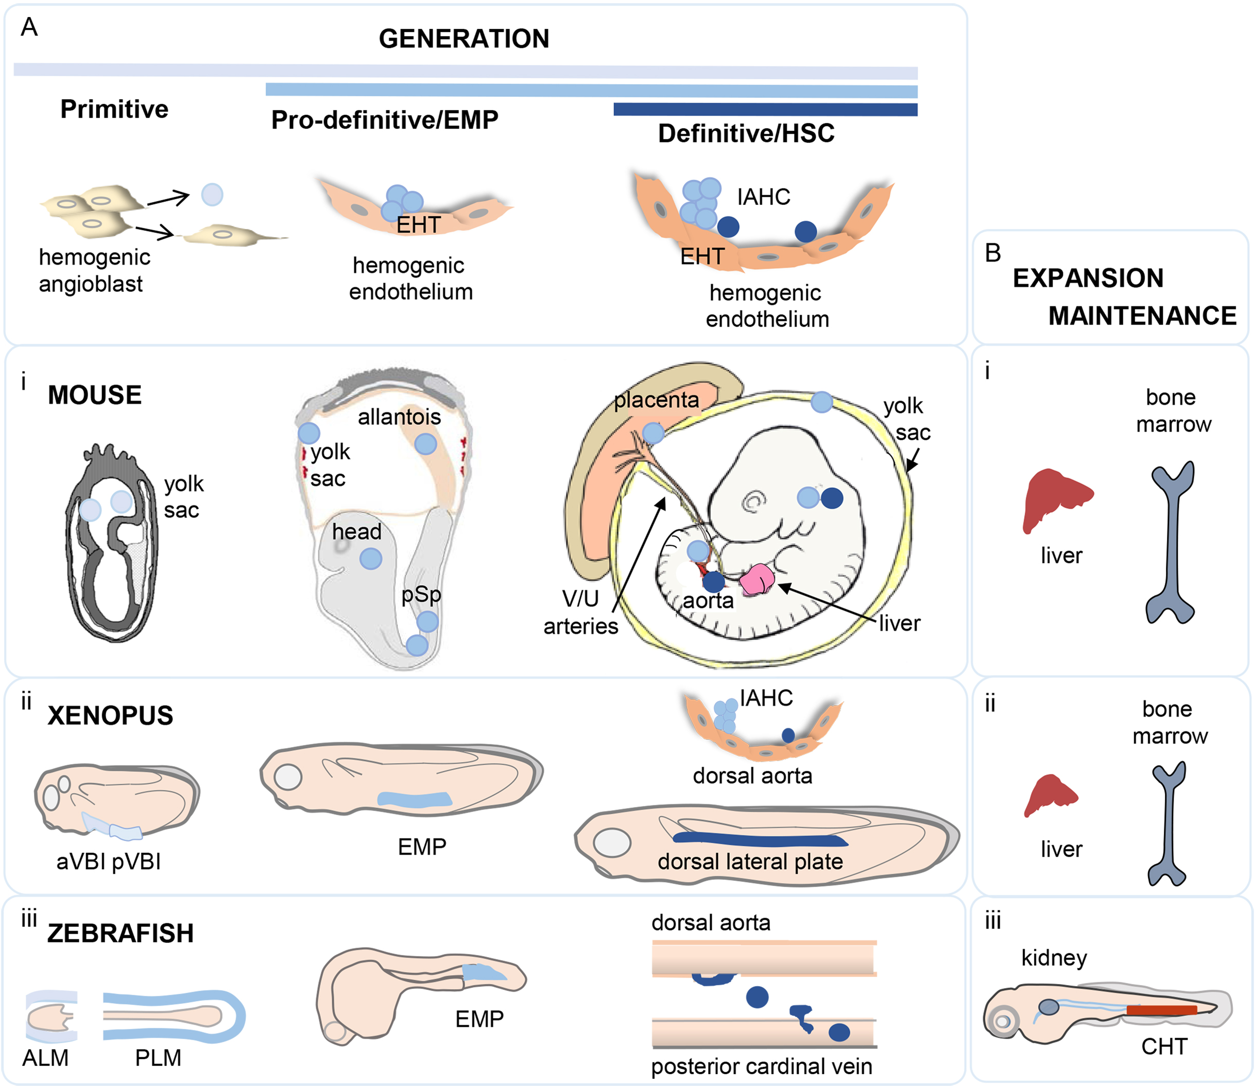
Figure 1. Stages of blood development in three vertebrate embryo models. A) Three waves of hematopoietic cell generation – primitive, pro-definitive/EMP and definitive HSC (indicated by increasing blue intensity of bars). The temporal appearance of each hematopoietic wave is related to the development shown below for i) mouse, ii) xenopus, and iii) zebrafish embryos. i) In the mouse embryo hematopoietic cells are generated from hemogenic angioblasts in the primitive wave in the yolk sac and from hemogenic endothelium in the pro-definitive and definitive stages through endothelial-to-hematopoietic-transition (EHT). Early primitive steak/neural plate at E7 (left), E8.5 head-fold (middle) and E10.5 limb-bud (right) stage embryos are shown with hematopoietic tissues and hematopoietic cell stage (by intensity of blue) indicated. pSp=para-aortic splanchnopleura; V/U=vitelline/umbilical arteries; HSC=hematopoietic stem cell; IAHC=intra-aortic hematopoietic cluster. ii) Xenopus embryo at stages 13-26 (left) with aVBI and pVBI (anterior and posterior ventral blood islands), at stage 35 with EMPs (erythroid-myeloid progenitors) and at stage 42 with the dorsal lateral plate and aorta with IAHC emerging from the aorta. iii) Zebrafish embryos at 12-24 hpf (hours post-fertilization) produce primitive hematopoietic cells from the ALM and PLM (anterior and posterior lateral mesoderm) and EMPs at beginning 24 hpf to 48 hpf. HPSC emerge extralumenally from the aortic endothelium around 30-72 hpf and migrate through the mesenchyme to the posterior cardinal vein. B) As the three waves of hematopoietic cells are generated, the primitive, pro-definitive and HSC migrate and colonize the liver of the i) mouse and ii) xenopus embryo for maturation and expansion and subsequently colonize the bone marrow for maintenance through adulthood. iii) In the zebrafish embryo, the three waves of generated hematopoietic cells migrate through the circulation to the CHT (caudal hematopoietic tissue) where they are matured and expanded, and subsequently migrate to the kidney where they are maintained in adult stages. Adapted from Ciau-Uitz et al. (Ciau-Uitz et al., 2014).
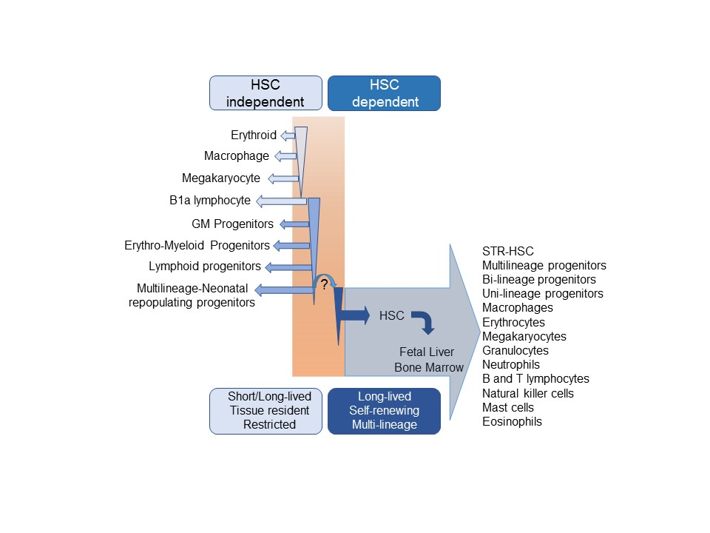
Figure 2. HSC independent and HSC dependent hematopoietic lineages. HSC independent hematopoietic lineages produced in the primitive wave and definitive progenitor wave in the early mammalian embryo are shown in the left part of the schematic. These cells are either short-lived, such as primitive erythrocytes, or long-lived, such as the tissue resident macrophages. Many of the early cells generated are restricted in hematopoietic lineage differentiation potential. The HSC-dependent phase of hematopoietic development produces the majority of the cells found in the circulation and hematopoietic tissues of adults. HSCs are long-lived, self-renewing cells, and they differentiate towards all the adult lineages listed on the right. GM=Granulocyte-macrophage; STR=short term repopulating.
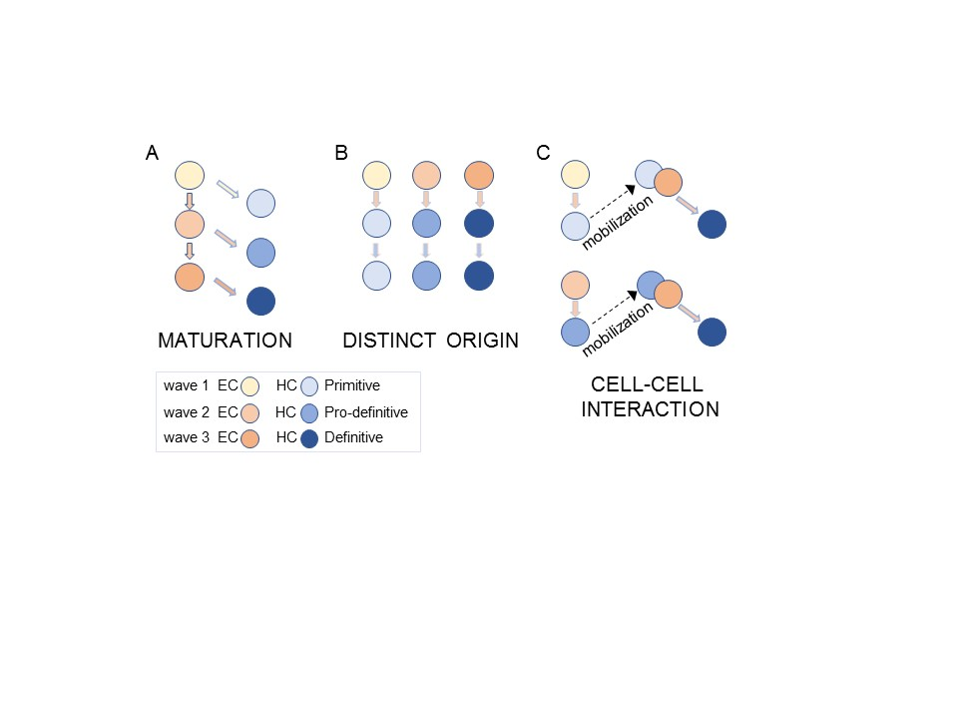
Figure 3. Models of hematopoietic lineage development. Generation of distinct wave 1, 2 and 3 hematopoietic cell types (HC; blue cells) from endothelial cells (EC; orange cells) as a result of A) the developmental maturation of hemogenic endothelial potential (light to medium to dark orange cells) or B) distinct mesodermal origins of wave 1, 2 and 3 hemogenic endothelium. C) Following wave 1 or 2 hematopoietic cell generation, these early hematopoietic cells are mobilized and interact with endothelial cells to promote development of wave 3 HSC. Blue color intensity from light to medium to dark indicates sequence of development from the primitive hematopoietic cell wave to the pro- definitive wave and then to the definitive HSC wave.

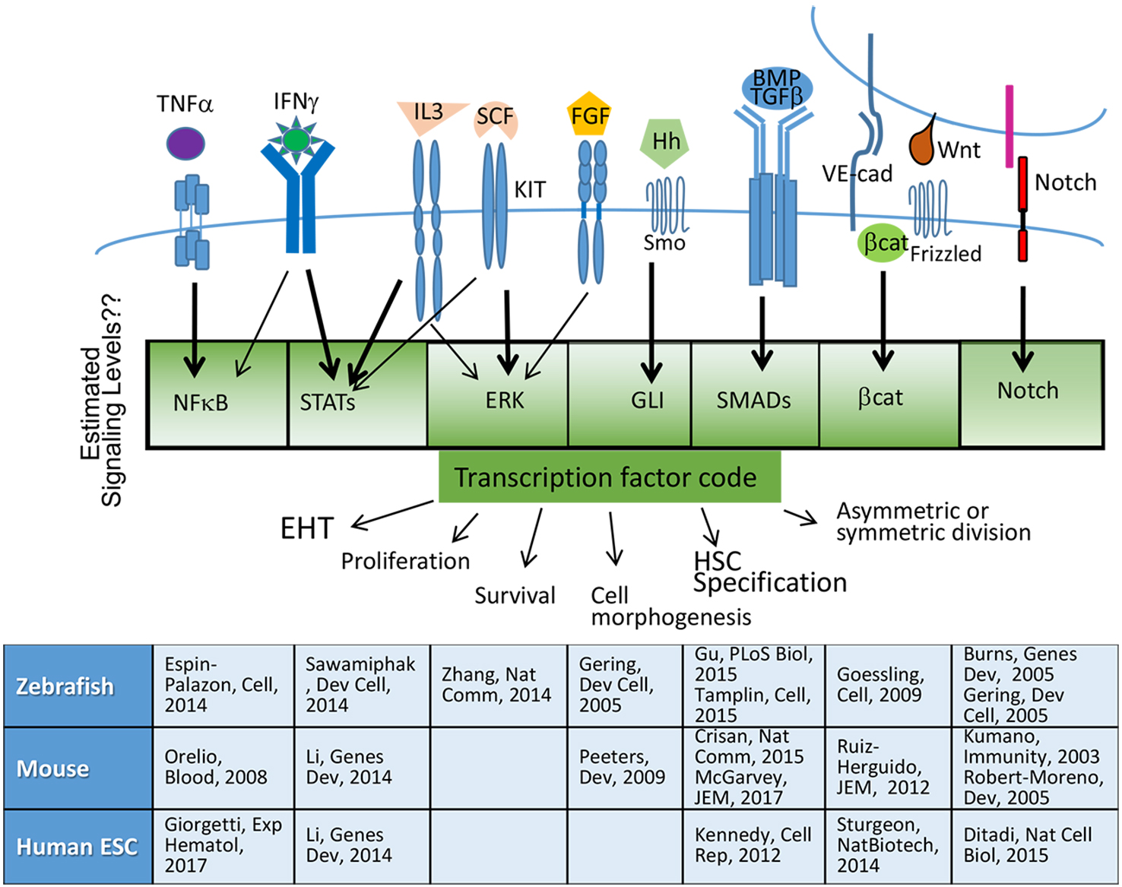

Figure 4. Signaling pathways involved in the development of the hematopoietic system. Receptors for the 10 pathways are depicted on the cell membrane with their cognate ligand. In the case of VE-cadherin, Frizzled, and Notch receptors, the ligand is expressed on the surface of the interacting cell. Intracellular signaling occurs through cytoplasmic molecules as shown in the boxed area to affect the expression of the transcription factor code that stimulates cellular processes such as EHT (endothelial-to-hematopoietic-transition) and HSC specification. Signal levels are critical in these processes and are depicted in the green gradient. References are provided for the signaling pathways described in Zebrafish, mouse, and human ESC developmental hematopoiesis.

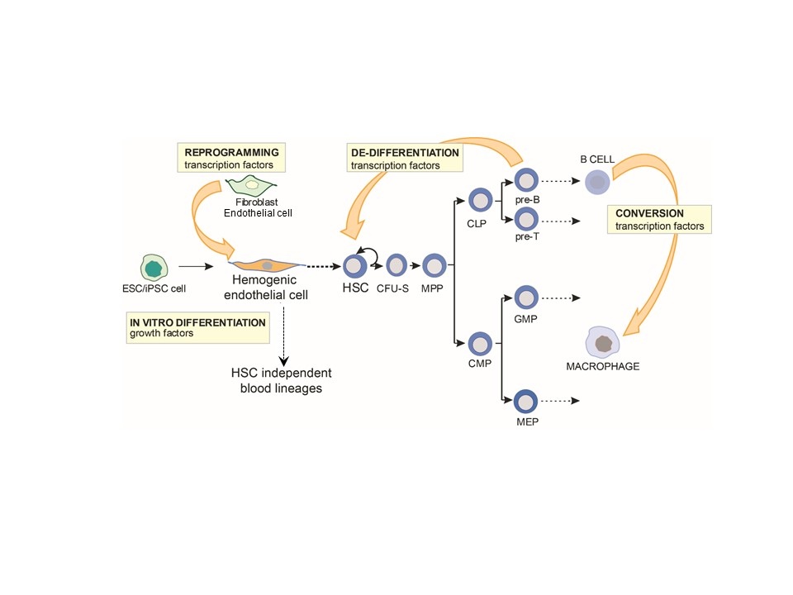Figure 5. Experimental models of hematopoietic cell induction. Culture systems involving the addition of growth factors during in vitro differentiation of non-hematopoietic cells, transcription factor-induced reprogramming of non-hematopoietic cells, de-differentiation of hematopoietic progenitors to HSCs, and transcription factor conversion of one mature lineage cell type to another unrelated hematopoietic cell type. In some cases, in vivo transplantation of cells is performed immediately following ex vivo manipulation.

