Quantifying Solvophobic Effects in Non-polar Cohesive Interactions
Lixu Yang, Catherine Adam, Scott L. Cockroft*
EaStCHEM School of Chemistry, University of Edinburgh, Joseph Black Building, David Brewster Road, Edinburgh, EH9 3FJ, UK.

Supporting Information Placeholder
ABSTRACT:
The hydrophobic effect plays a central role in determining the structure, activity and properties of biomolecules and materials. In contrast, the general manifestation of this phenomenon in other solvents -the solvophobic effect- although widely invoked, is currently poorly defined due to the lack of a universally accepted descriptor. Here we have used synthetic molecular balances to measure solvent effects on aromatic, aliphatic and fluorous non-polar interactions. Our solvent screening data combined with independent experimental measurements of supramolecular association, single-molecule folding and bulk phase transfer energies were all found to correlate well with the cohesive energy density of the solvent. Meanwhile, other measures of solvent cohesion, such as surface tension and internal pressure, gave inferior correlations. Thus, we establish cohesive energy density as a readily accessible, quantitative descriptor of solvophobic association in a range of chemical contexts.
The hydrophobic association of non-polar solutes in aqueous solution demonstrates the intrinsic role that a solvent can play in driving self-assembly processes.¹ Though the origins and defining characteristics of the hydrophobic effect are long-standing subjects of debate,^{1b,2} the minimization of solvent-exposed non-polar surface area can be most simply rationalized as arising from the out-competition of solvent-solute interactions by cohesive solute-solute interactions.^{1,3} The general manifestation of this phenomenon in other solvents can be referred to as the solvophobic effect, with solvent cohesion having both electrostatic and van der Waals dispersion contributions.⁴ The solvophobic effect has been invoked as governing the rate and outcome of chemical reactions,⁵ while also being exploited in supramolecular folding, self-assembly,⁶ and functional materials.⁷ Solvophobic effects are of unquestionable importance in certain fluorocarbon/aqueous/organic combinations,⁸ and in ionic liquids,⁹ but their role is less clear away from the immiscible extremes. For example, there have been contrasting views on whether solvophobic self-assembly requires solvents that form hydrogen-bond networks.^{4b,9-10} Furthermore, the role of solvophobic effects may be further obscured by other non-covalent interactions, particularly those whose magnitudes scale with the size of molecular surface area contacts as is the case with dispersion interactions.^{3b,6d,6f,11} As a result, most attributions of the solvophobic effect are qualitative, and only in a few notable cases are sufficient solvents examined to draw firm conclusions regarding the mechanistic origin of any observed behavior.2b,3b,5d,5e,6f,6l,6m,6o,8a,10,11a,11c,12h,18,20. Even then, there is no general agreement on the parameters that can be reliably used to identify solvophobic effects.
Here we examine the utility of different parameters for quantifying solvophobic effects in multiple classes of non-polar molecular contacts. Solvophobic effects in aromatic edge-to-face, aliphatic and fluorous interactions were measured using Wilcox torsion balances (Figures 1 to 3), and the generality of the findings tested in a range of contexts: from the unfolding of single polymer molecules (Figure 4b), to supramolecular aromatic stacking interactions (Figure 4c), and bulk phase transfer energies (Figure 4d).

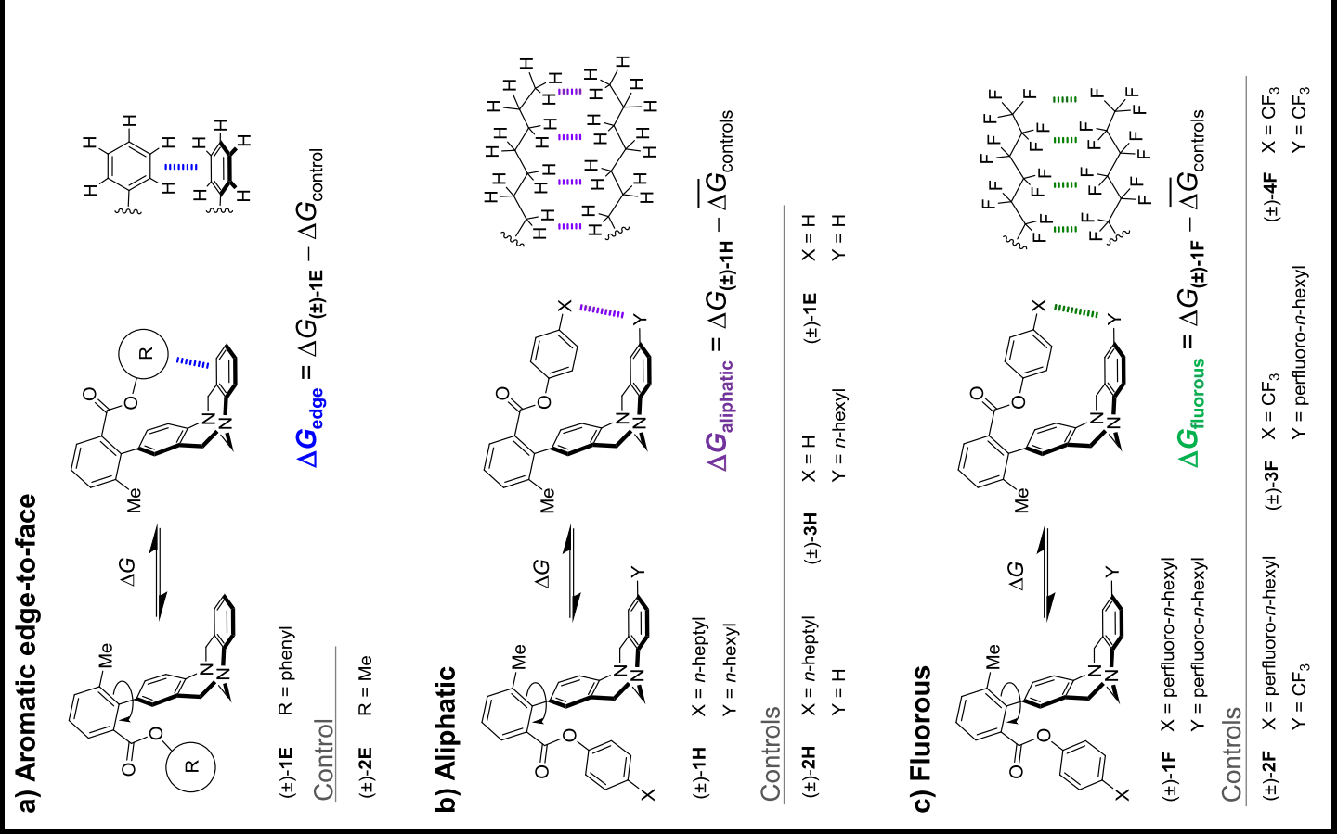
Figure 1. Wilcox molecular torsion balances showing the conformational equilibria used to measure non-covalent interactions between non-polar functional groups. ${\overline{ΔG}}_{controls}$ is the mean conformational free energy of the control balances.
The ambiguity surrounding the significance of solvophobic effects, particularly in organic solvents, can be largely attributed to the scarcity of solvent screening data. For example, in some solvents the interactions between non-polar species such as those shown on the right of Figure 1 may be too weak to overcome the entropic cost associated with bimolecular association,^{1c} while in other cases solvophobic self-association may be so strong that the compounds of interest may not even dissolve. In addition, obtaining high-quality thermodynamic data using titration-based methods in many different solvents can be a particularly time-consuming process. Synthetic molecular torsion balances provide a means of overcoming some of the challenges associated with the measurement of non-covalent interactions.^{6p,6q,12} Most molecular torsion balances possess defined folded and unfolded conformations in which functional groups are either exposed to the solvent or brought into contact. The structures shown in Figure 1 represent archetypal molecular torsion balances of the type originally derived by Wilcox and co-workers from a Tröger’s base scaffold.¹³ Since the conformational population is sensitive to the magnitude of the intramolecular interactions and the effects of the solvent, then the position of a conformational equilibrium can be used as a direct measure of non-covalent interactions and solvent effects.^{12a,14} Furthermore, rotation about the biaryl bond in the compounds shown in Figure 1 is slow on the NMR timescale (but rapid enough for equilibrium to be established in a convenient period of time). This means that the conformational free energy difference between the two conformers can be determined from a single NMR spectrum by integrating the distinct NMR peaks corresponding to each of the conformers, where ΔG = −RT ln[folded]/[unfolded]. Thus, molecular balances are particularly suited to examining the solvent effects on weak non-covalent interactions.^{6l,6m,12h}
We set out to screen for solvophobic effects on the cohesive self-association of the non-polar functional groups depicted in Figure 1. Despite numerous previous studies of aromatic edge-to-face interactions using Wilcox torsion balances, none have involved extensive solvent screens.^{6n,13,15} To date, the general finding has been that both direct substituent-aryl and polar CH-aryl interactions make the largest contributions to the interaction energy in organic solvents.^{15d} Thus, the unsubstituted Wilcox balance (±)-1E was used in the present study (Figure 1a), since any investigation of solvophobic effects on aromatic edge-to-face interactions should seek to minimize electrostatic contributions.
To account for the multiple factors contributing to the position of the conformational equilibrium in each solvent,^{12a,14} the strength of the edge-to-face interaction, ΔG_{edge} was estimated by subtracting the conformational free energy of the control compound (±)-2E (in which the aryl ring was replaced by a methyl group) from that of (±)-1E.^{13b,16} Similarly, non-polar alkyl-alkyl (ΔG_{aliphatic}) and perfluoroalkyl-perfluoroalkyl interactions (ΔG_{fluorous}) were measured in Wilcox balances (±)-1H and (±)-1F against the control compounds shown in Figure 1b-c.^{6l,6m} ΔG_{edge}, ΔG_{aliphatic}, and ΔG_{fluorous} were measured in 23 different solvents (Figure 2).
All three classes of non-polar interaction examined were found to be weak, lying in the range of +1 to −2 kJ mol^{–1}. The aromatic edge-to-face interaction measured in chloroform was similar to that previously determined in other supramolecular model systems.¹⁷ The preference for non-polar association in the aqueous and polar organic solvents compared to the apolar solvents was observed across all three data sets (Figure 2). This qualitative observation points to a role of cohesive solvent-solvent (solvophobic) effects in all three classes of non-polar association examined (aromatic edge-to-face, aliphatic and fluorous cohesion). Thus, it might be expected that parameters describing
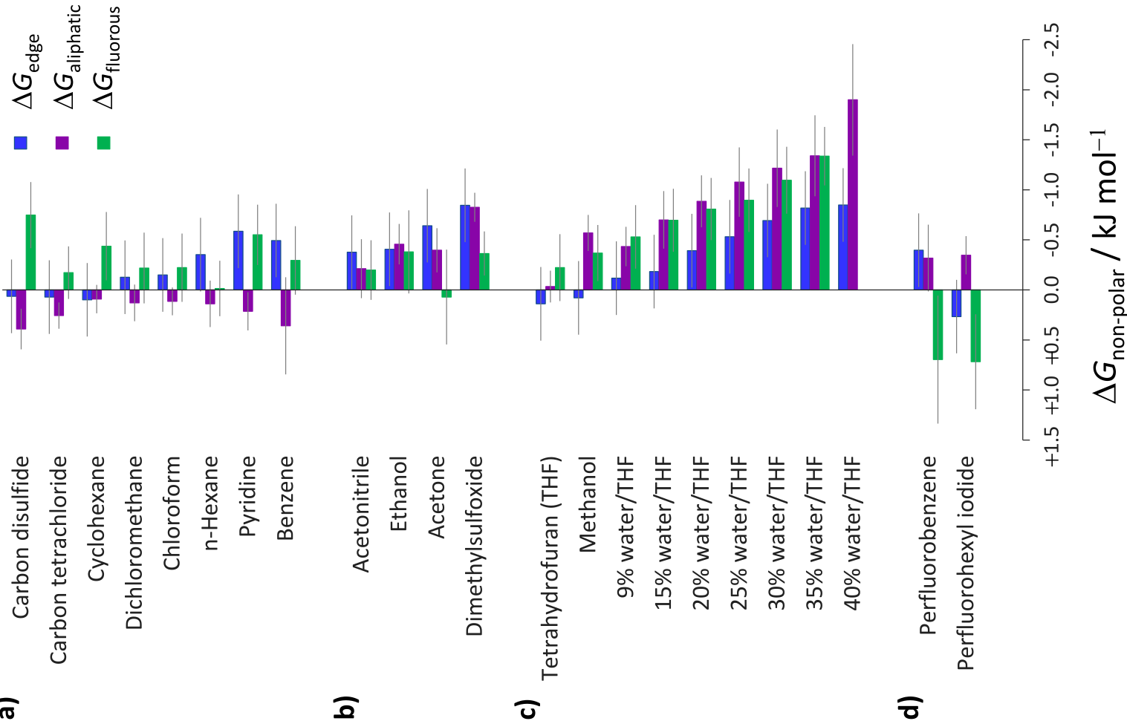
Figure 2. Bar graph showing non-polar cohesive interactions measured in a range of solvents using the compounds and equations shown in Figure 1. Deuterated solvents were used in place of all protic solvents. Solvent mixtures are quoted in v/v %. All data are tabulated in the SI.
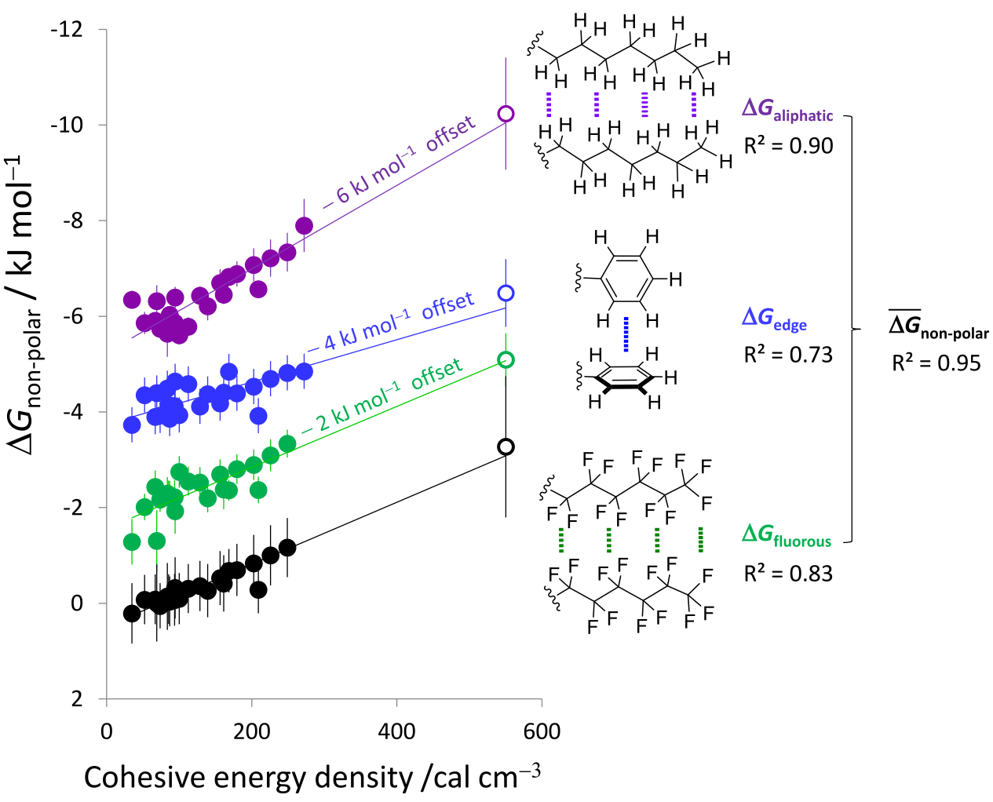
Figure 3. Correlations of ΔG_{aliphatic}, ΔG_{edge}, and ΔG_{fluorous} (colored circles), and the average of all three ΔG_{non-polar} (black circles) as the cohesive energy density of the solvent is varied. For the purpose of clarity, the plots of ΔG_{fluorous}, ΔG_{edge}, ΔG_{aliphatic} are offset by −2, −4, and −6 kJ mol⁻¹, respectively. All data are tabulated in the SI. A version of this graph in which the extrapolated water points (hollow circles) are excluded is shown in Figure S7a.
solvent-solvent cohesive interactions may be useful for quantifying solvophobic association. Several different parameters have been proposed as describing cohesive solvent interactions: cohesive tension (γ),^{3c,6o} internal pressure (P_{i}),^{3b,4a} the enthalpy of vaporization (ΔH_{vap}), cohesive energy density (ced),^{3b, 20} Hildebrand solubility parameter (δ_{H})¹⁸ and Abraham’s solvophobicity parameter (S_{p}).^{11c} Several of the parameters are related as follows:
δ_{H}² = ced = (ΔH_{vap} – RT) / V_{m}
where R is the gas constant, T is the temperature and V_{m} is the molar volume of the solvent.
Among the independent parameters describing cohesive solvent-solvent interactions, cohesive energy density provided the best correlations with the non-polar interaction energies measured in the present study (Figure 3, data are offset in 2 kJ mol^{–1} increments for purposes clarity). This plot comprises over 200 experimental measurements of conformational free energies determined for the nine molecular balances shown in Figure 1 in 23 different solvents. However, these data correlated substantially less well with alternative descriptors of solvent cohesion such as surface tension and internal pressure (Figure S6). The result supports earlier suggestions that surface tension may not be an ideal descriptor for hydrophobic effects.^{3c,19} Internal pressure has been shown to be more important in the solvation of very small solutes such as gases compared to the larger interaction interfaces examined in the present study.^{3b} Indeed, the gradients of the correlations in Figure 4a reflect the qualitative ordering of the size of the interaction interfaces.
The significant scatter associated with the correlations corresponding to individual interaction classes (colored circles in Figure 3) can be attributed to solvent-specific attenuation of dispersion and electrostatic interactions, in addition to the experimental errors associated with the measurement of very weak non-covalent interactions.^{6l} Strikingly, taking the mean interaction energy across all three classes of non-polar contact reveals a common solvophobic driving force for non-polar association, providing a correlation with R² = 0.95 (black circles in Figure 3, and R² = 0.83 with water points excluded in Figure S7), which arises due to the minimization of errors, and the cancellation of dispersion contributions across the interaction types. Interestingly, the intercepts of the correlations in Figure 3 are close to zero (~0.5 kJ mol^{–1}). Since the intercept corresponds to the situation where there is no solvophobic effect, the observation is consistent with a minimal contribution of electrostatic interactions and the generalized cancellation of dispersion forces in solution in the classes of interaction examined.^{3b, 6l, 6m, 11a,12k}
To test the generality of cohesive energy densities as a scale for describing solvophobic association (Figure 4a), we have replotted experimental data previously obtained in a range of solvents for both the collapse of single polystyrene molecules (Figure 4b)^{6o} and supramolecular aromatic stacking interactions (Figure 4c).²⁰ The data shown in Figure 4b represents the plateau force required to unfold a collapsed single polystyrene molecule in solution, which is directly proportional to the solvation free energy per monomer (ΔG).^{6o} This data had previously been plotted against solvent surface tension differences, giving a good, but notably lower quality correlation (Figure S8) than that shown in Figure 4b. Figure 4c shows a plot of experimental aromatic stacking interaction energies plotted against the cohesive energy density of the solvents examined. A subset of this data had previously been correlated against the E_{T}(30) solvent polarity scale,²¹ yielding a correlation with R² = 0.88 (Figure S9a). However, all three of the original data sets can now correlated against cohesive energy density giving R² values ranging between 0.94 and 0.97 (Figure 4c). Contrasting with the correlations in Figure 3, the different intercepts in Figure 4c can be attributed to differences in electrostatic/dispersion interactions as the stacked complex was varied. Correlations of this data against Abraham’s solvophobicity parameter, S_{p}^{11c} yielded equally pleasing correlations with R² = 0.93-0.97 (Figure S9b). As was the case for the three non-polar contacts measured using Wilcox balances, the data for aromatic stacking did not correlate well with the surface tension nor the internal pressure of the solvent (Figure S9c-d).
The general utility of cohesive energy densities in describing solvophobic effects was further demonstrated by the strong correlations with solvophobicity values, S_{p} (Figure 4d)^{11c} and phase transfer free energies of hydrocarbons from water (Figure S10a). The quality of these relationships (R² = 0.94-0.97) are notable given that cohesive energy density is directly related to the enthalpy of vaporization (see equation above),while the phase transfer energies (from which S_{p} values are determined) are often
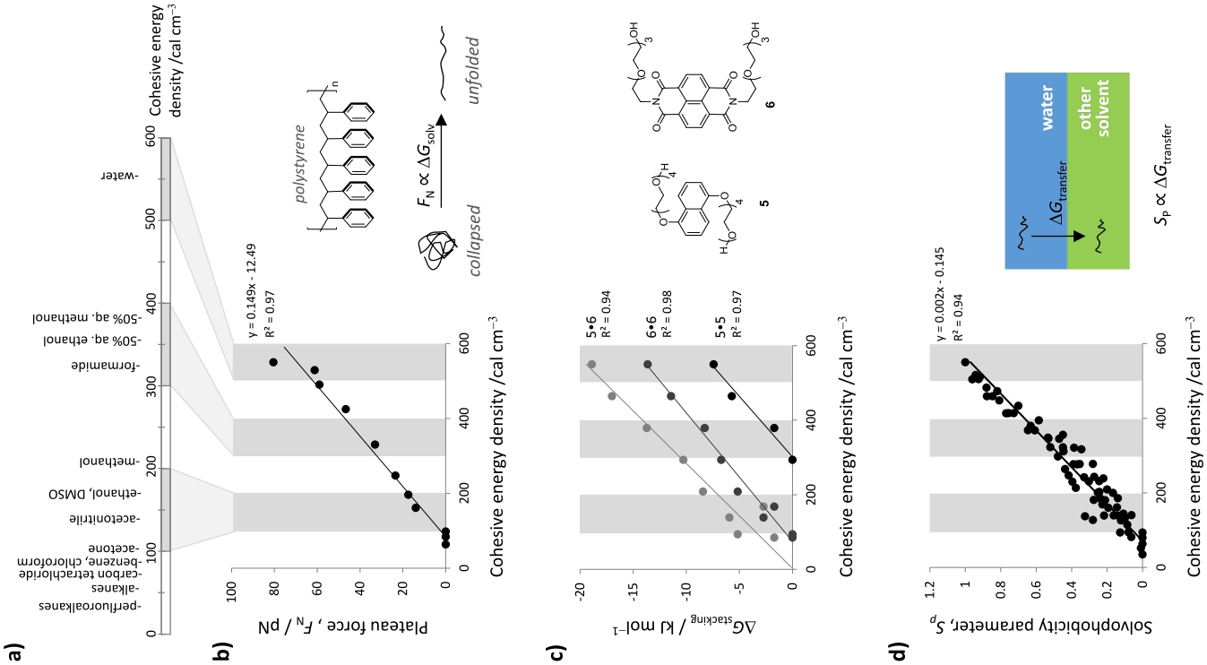
Figure 4. a) Scale of cohesive energy densities (ced) indicating the relative solvophobicities of common solvents. Solvent mixtures are quoted in v/v %. b) Previously reported plateau forces, F_{N} for unfolding single polystyrene molecules,^{6o} and c) aromatic stacking interaction energies, ΔG_{stack.}²⁰ replotted against the cohesive energy density of the solvents in which the measurements were made. d) Abraham’s solvophobicity parameter^{5e,11c} versus cohesive energy density. All plotted data are tabulated in the SI.
dominated by entropy.^{22,23} This relationship is likely to be a consequence of enthalpy-entropy compensation, and the existence of a mechanistic continuum between the two thermodynamic extremes of entropically versus enthalpically dominated solvophobic effects. Indeed, the manifestation of the hydrophobic effect at both thermodynamic extremes is well-recognized.^{1b,4b,24}
In summary, we have collated new and previously published experimental measurements of non-polar cohesive interactions to examine the utility of several quantitative solvophobic descriptors. The collated data comprised hundreds of aromatic stacking, aromatic edge-to-face, aliphatic and fluorous interaction energies measured in intramolecular, intermolecular, bulk and single-molecule contexts where solvent effects were systematically examined. All sets of solvent screening data correlated well with cohesive energy densities (the square of the Hildebrand parameter, δ_{H}²), or Abraham’s S_{p} values.²⁵ In contrast, alternative measures of solvent cohesion, such as surface tension and internal pressure provided substantially lower quality correlations. Thus, we propose that correlations of chemical properties against solvent cohesive energy densities provide a quantitative signature for characterizing solvophobic effects.
ASSOCIATED CONTENT
Supporting Information
Tables of data, additional correlations, synthetic procedures and compound characterization data are provided in the Supporting Information. This material is available free of charge via the Internet at http://pubs.acs.org.
AUTHOR INFORMATION
Corresponding Author
scott.cockroft@ed.ac.uk
Notes
The authors declare no competing financial interests.
ACKNOWLEDGMENT
We thank Pfizer Ltd. and MTEM Ltd. for studentships to C.A. and L.Y. respectively, and Nicholas Dominelli-Whiteley for assistance with compound characterization.
REFERENCES
(1) a) Granick, S.; Bae, S. C. Science 2008, 322, 1477; b) Biedermann, F.; Nau, W. M.; Schneider, H.-J. Angew. Chem. Int. Ed. 2014, 53, 11158; c) Hunter, C. A. Angew. Chem. Int. Ed. 2004, 43, 5310.
(2) a) Marmur, A. J. Am. Chem. Soc. 2000, 122, 2120; b) Abraham, M. H.; Blandamer, M. J. J. Am. Chem. Soc. 2002, 124, 7853.
(3) a) Lazaridis, T. Acc. Chem. Res. 2001, 34, 931; b) Otto, S. Chem. Sci. 2013, 4, 2953; c) Tanford, C. Proc. Natl. Acad. Sci. USA 1979, 76, 4175.
(4) a) Dack, M. R. J. Chem. Soc. Rev. 1975, 4, 211; b) Sedov, I. A.; Solomonov, B. N. J. Struct. Chem. 2013, 54, 262.
(5) a) Scherrmann, M. C.; Norsikian, S.; Lubineau, A. In Adv. Org. Synth.; Atta-ur-Rahman, Ed.; Bentham Science Publishers: 2005; Vol. 1, p 341; b) Clark, C. G.; Wenzel, R. J.; Andreitchenko, E. V.; Steffen, W.; Zenobi, R.; Müllen, K. J. Am. Chem. Soc. 2007, 129, 3292; c) Breslow, R. Acc. Chem. Res. 1991, 24, 159; d) Schneider, H.-J.; Sangwan, N. K. Angew. Chem. Int. Ed. Engl. 1987, 26, 896; e) Cativiela, C.; I. Garcia, J.; Gil, J.; M. Martinez, R.; A. Mayoral, J.; Salvatella, L.; S. Urieta, J.; M. Mainar, A.; H. Abraham, M. J. Chem. Soc., Perkin Trans. 2 1997, 653.
(6) a) Becerril, J.; Bolte, M.; Burguete, M. I.; Galindo, F.; García-España, E.; Luis, S. V.; Miravet, J. F. J. Am. Chem. Soc. 2003, 125, 6677; b) Correa, N. M.; Silber, J. J.; Riter, R. E.; Levinger, N. E. Chem. Rev. 2012, 112, 4569; c) Lahiri, S.; Thompson, J. L.; Moore, J. S. J. Am. Chem. Soc. 2000, 122, 11315; d) Schneider, H.-J. Angew. Chem. Int. Ed. 2009, 48, 3924; e) Zhao, Y.; Zhong, Z.; Ryu, E.-H. J. Am. Chem. Soc. 2007, 129, 218; f) Cram, D. J.; Choi, H. J.; Bryant, J. A.; Knobler, C. B. J. Am. Chem. Soc. 1992, 114, 7748; g) Ponnuswamy, N.; Pantoş, G. D.; Smulders, M. M. J.; Sanders, J. K. M. J. Am. Chem. Soc. 2012, 134, 566; h) Bhosale, S. V.; Adsul, M.; Shitre, G. V.; Bobe, S. R.; Bhosale, S. V.; Privér, S. H. Chem. Eur. J. 2013, 19, 7310; i) Nelson, J. C.; Saven, J. G.; Moore, J. S.; Wolynes, P. G. Science 1997, 277, 1793; j) Cho, H.; Zhao, Y. J. Am. Chem. Soc. 2010, 132, 9890; k) Yan, Z.; Moore, J. S. In Foldamers; Eds. Hecht, S., Huc, I., Wiley, Weinheim, 2007, p 75,; l) Adam, C.; Yang, L.; Cockroft, S. L. Angew. Chem. Int. Ed. 2015, 54, 1164; m) Yang, L.; Adam, C.; Nichol, G. S.; Cockroft, S. L. Nat. Chem. 2013, 5, 1006; n) Bhayana, B.; Wilcox, C. S. Angew. Chem. Int. Ed. 2007, 46, 6833; o) Li, I. T. S.; Walker, G. C. J. Am. Chem. Soc. 2010, 132, 6530; p) Newcomb, L. F.; Gellman, S. H. J. Am. Chem. Soc. 1994, 116, 4993; q) Gardner, R. R.; Christianson, L. A.; Gellman, S. H. J. Am. Chem. Soc. 1997, 119, 5041; r) Corbett, P. T.; Leclaire, J.; Vial, L.; West, K. R.; Wietor, J.-L.; Sanders, J. K. M.; Otto, S. Chem. Rev. 2006, 106, 3652; s) Safont-Sempere, M. M.; Fernández, G.; Würthner, F. Chem. Rev. 2011, 111, 5784.
(7) a) Matsukizono, H.; Kuroiwa, K.; Kimizuka, N. J. Am. Chem. Soc. 2008, 130, 5622; b) Minakata, S.; Tsuruoka, R.; Komatsu, M. J. Am. Chem. Soc. 2008, 130, 1536; c) Zhuang, J.; Wu, H.; Yang, Y.; Cao, Y. C. J. Am. Chem. Soc. 2007, 129, 14166; d) Berna, J.; Leigh, D. A.; Lubomska, M.; Mendoza, S. M.; Perez, E. M.; Rudolf, P.; Teobaldi, G.; Zerbetto, F. Nat. Mater. 2005, 4, 704; e) Arduini, A.; Bussolati, R.; Credi, A.; Secchi, A.; Silvi, S.; Semeraro, M.; Venturi, M. J. Am. Chem. Soc. 2013, 135, 9924.
(8) a) Myers, K. E.; Kumar, K. J. Am. Chem. Soc. 2000, 122, 12025; b) Kuwahara, H.; Hamada, M.; Ishikawa, Y.; Kunitake, T. J. Am. Chem. Soc. 1993, 115, 3002.
(9) Greaves, T. L.; Drummond, C. J. Chem. Soc. Rev. 2013, 42, 1096.
(10) Ray, A. Nature 1971, 231, 313.
(11) a) Hunter, C. A. Chem. Sci. 2013, 4, 834; b) Joh, N. H.; Oberai, A.; Yang, D.; Whitelegge, J. P.; Bowie, J. U. J. Am. Chem. Soc. 2009, 131, 10846; c) Abraham, M. H.; Grellier, P. L.; McGill, R. A. J. Chem. Soc., Perkin Trans. 2 1988, 339.
(12) a) Mati, I. K.; Cockroft, S. L. Chem. Soc. Rev. 2010, 39, 4195; b) Cozzi, F.; Siegel, J. S. Pure Appl. Chem. 1995, 67, 683; c) Motherwell, W. B.; Moïse, J.; Aliev, A. E.; Nič, M.; Coles, S. J.; Horton, P. N.; Hursthouse, M. B.; Chessari, G.; Hunter, C. A.; Vinter, J. G. Angew. Chem. Int. Ed. 2007, 46, 7823; d) Aliev, A. E.; Arendorf, J. R. T.; Pavlakos, I.; Moreno, R. B.; Porter, M. J.; Rzepa, H. S.; Motherwell, W. B. Angew. Chem. Int. Ed. 2015, 127, 561; e) Hwang, J.; Li, P.; Carroll, W. R.; Pellechia, P. J.; Shimizu, K. D. J. Am. Chem. Soc. 2014, 136, 14060; f) Oki, M. Acc. Chem. Res. 1990, 23, 351; g) Muchowska, K. B.; Adam, C.; Mati, I. K.; Cockroft, S. L. J. Am. Chem. Soc. 2013, 135, 9976; h) Mati, I. K.; Adam, C.; Cockroft, S. L. Chem. Sci. 2013, 4, 3965; i) Hwang, J.; Dial, B. E.; Li, P.; Kozik, M. E.; Smith, M. D.; Shimizu, K. D. Chem. Sci. 2015, 6, 4358; j) Pavlakos, I.; Arif, T.; Aliev, A. E.; Motherwell, W. B.; Tizzard, G. J.; Coles, S. J. Angew. Chem. Int. Ed. 2015, 54, 8169. k) Maier, J. M.; Li, P.; Hwang, J.; Smith, M. D.; Shimizu, K. D. J. Am. Chem. Soc. 2015, 137, 8014.
(13) a) Paliwal, S.; Geib, S.; Wilcox, C. S. J. Am. Chem. Soc. 1994, 116, 4497; b) Kim, E.-i.; Paliwal, S.; Wilcox, C. S. J. Am. Chem. Soc. 1998, 120, 11192.
(14) Cockroft, S. L.; Hunter, C. A. Chem. Soc. Rev. 2007, 36, 172.
(15) a) Hof, F.; Scofield, D. M.; Schweizer, W. B.; Diederich, F. Angew. Chem. Int. Ed. 2004, 43, 5056; b) Fischer, F. R.; Schweizer, W. B.; Diederich, F. Angew. Chem. Int. Ed. 2007, 46, 8270; c) Fischer, F. R.; Schweizer, W. B.; Diederich, F. Chem. Commun. 2008, 4031; d) Gardarsson, H.; Schweizer, W. B.; Trapp, N.; Diederich, F. Chem. Eur. J. 2014, 20, 4608; e) Ren, T.; Jin, Y.; Kim, K. S.; Kim, D. H. J. Biomol. Struct. Dyn. 1997, 15, 401; f) Nakamura, K.; Houk, K. N. Org. Lett. 1999, 1, 2049; g) Cockroft, S. L.; Hunter, C. A. Chem. Commun. 2006, 3806; h) Cockroft, S. L.; Hunter, C. A. Chem. Commun. 2009, 3961.
(16) Computational models support Wilcox’s previous assertion that the methyl group is not large or polar enough to form significant dispersive contact or CH-aryl interactions in the folded conformation, but is still large enough to block solvation of the aromatic face in a similar manner as the phenyl ester in the folded conformation (Figure S2).^{13b} Furthermore, Figure S5 is consistent with small secondary interaction differences between balances (±)-1E and (±)-2E, paricularly when compared to the variations in the alkyl/perfluoroalkyl control balances.
(17) a) Martinez, A. G.; Barcina, J. O.; Cerezo, A. D. Chem. Eur. J. 2001, 7, 1171; b) Carver, F. J.; Hunter, C. A.; Livingstone, D. J.; McCabe, J. F.;
Seward, E. M. Chem. Eur. J. 2002, 8, 2847.
(18) Hildebrand, J. H.; Scott, R. L. The Solubility of Nonelectrolytes; 3rd Ed.; Dover Publications: New York, 1964.
(19) Crothers, D. M.; Ratner, D. I. Biochemistry 1968, 7, 1823.
(20) Cubberley, M. S.; Iverson, B. L. J. Am. Chem. Soc. 2001, 123, 7560.
(21) Wheeler, S. E.; Bloom, J. W. G. J. Phys. Chem. A. 2014, 118, 6133.
(22) Frank, H. S.; Evans, M. W. J. Chem. Phys. 1945, 13, 507.
(23) Contrasting with the correlations against Gibbs energy-related properties shown in Figures 4d and S10a, there is no correlation between ced and the enthalpy of phase transfer from water (Figure S10b).
(24) a) Ben-Amotz, D.; Underwood, R. Acc. Chem. Res. 2008, 41, 957; b) Biela, A.; Nasief, N. N.; Betz, M.; Heine, A.; Hangauer, D.; Klebe, G. Angew. Chem. Int. Ed. 2013, 52, 1822; c) Meyer, E., A.; Castellano, R. K.; Diederich, F. Angew. Chem. Int. Ed. 2003, 42, 1210; d) Chen, L.-J.; Lin, S.-Y.; Huang, C.-C. J. Phys. Chem. B 1998, 102, 4350.
(25) We propose that ced is the most useful parameter for quantifying solvophobic effects since: i. Linear free energy correlations require energies (or parameters that are directly proportional to energies) to be plotted against one another [cf. the Hildebrand parameter, which has units of (energy)^{1/2}]. ii. Comprehensive data for Gibbs energies of phase transfer of standard solutes (from which Sp values are derived) are not easily sourced, while enthalpies of vaporization from which ced values are determined are widely reported (see Tables and associated references in the SI).

Table of Contents Graphic

