**Daily Energy Expenditure through the Human Life Course**

Herman Pontzer1,2†*, Yosuke Yamada3,4†, Hiroyuki Sagayama5†, Philip N. Ainslie6, Lene F. Andersen7, Liam J. Anderson6,8, Lenore Arab9, Issaad Baddou10, Kweku Bedu-Addo11, Ellen E. Blaak12, Stephane Blanc13,14, Alberto G. Bonomi15, Carlijn V.C. Bouten12, Pascal Bovet16, Maciej S. Buchowski17, Nancy F. Butte18, Stefan G. Camps12, Graeme L. Close6, Jamie A. Cooper13, Richard Cooper19, Sai Krupa Das20, Lara R. Dugas19, Ulf Ekelund21, Sonja Entringer22,23, Terrence Forrester24, Barry W. Fudge25, Annelies H Goris12, Michael Gurven26, Catherine Hambly27, Asmaa El Hamdouchi10, Marjije B. Hoos12, Sumei Hu28 , Noorjehan Joonas29, Annemiek M. Joosen12, Peter Katzmarzyk30, Kitty P. Kempen12, Misaka Kimura3, William E. Kraus31, Robert F. Kushner32, Estelle V. Lambert33, William R. Leonard34, Nader Lessan35, Corby Martin30, Anine C. Medin7,36, Erwin P. Meijer12, James C. Morehen37,6, James P. Morton6, Marian L. Neuhouser38, Theresa A. Nicklas18, Robert M. Ojiambo39,40, Kirsi H. Pietiläinen41, Yannis P. Pitsiladis42, Jacob Plange-Rhule43**, Guy Plasqui44, Ross L. Prentice38, Roberto A. Rabinovich45, Susan B. Racette46, David A. Raichlen47, Eric Ravussin30, Rebecca M. Reynolds48, Susan B. Roberts20, Albertine J. Schuit49, Anders M. Sjödin50, Eric Stice51, Samuel S. Urlacher52, Giulio Valenti12,15, Ludo M. Van Etten12, Edgar A. Van Mil53, Jonathan C. K. Wells54, George Wilson6, Brian M. Wood55,56, Jack Yanovski57, Tsukasa Yoshida4, Xueying Zhang27,28, Alexia J. Murphy-Alford58, Cornelia Loechl58, Amy H Luke59†, Jennifer Rood30†, Dale A. Schoeller60†, Klaas R. Westerterp61†, William W. Wong18†, John R. Speakman62,27,28,63*† and the IAEA DLW database consortium#.

*co-lead corresponding author

†co-corresponding author

** deceased

# see supplementary materials

1. Evolutionary Anthropology, Duke University, Durham NC, USA
2. Duke Global Health Institute, Duke University, Durham, NC, USA
3. Institute for Active Health, Kyoto University of Advanced Science, Kyoto, Japan.
4. National Institute of Health and Nutrition, National Institutes of Biomedical Innovation, Health and Nutrition, Tokyo, Japan.
5. Faculty of Health and Sport Sciences, University of Tsukuba, Ibaraki, Japan.

6 Research Institute for Sport and Exercise Sciences, Liverpool John Moores University, Liverpool, UK.

7 Department of Nutrition, Institute of Basic Medical Sciences, University of Oslo, 0317 Oslo, Norway.

8 Crewe Alexandra Football Club, Crewe, UK.

9 David Geffen School of Medicine, University of California, Los Angeles.

10 Unité Mixte de Recherche en Nutrition et Alimentation, CNESTEN- Université Ibn Tofail URAC39, Regional Designated Center of Nutrition Associated with AFRA/IAEA.

11 Department of Physiology, Kwame Nkrumah University of Science and Technology, Kumasi, Ghana.

12 Maastricht University, Maastricht, The Netherlands.

13 Nutritional Sciences, University of Wisconsin, Madison, WI, USA

14 Institut Pluridisciplinaire Hubert Curien. CNRS Université de Strasbourg, UMR7178, France.

15 Phillips Research, Eindoven, The Netherlands.

16 Institute of Social and Preventive Medicine, Lausanne University Hospital, Lausanne, Switzerland.

17 Division of Gastroenterology, Hepatology and Nutritiion, Department of Medicine, Vanderbilt University, Nashville, Tennessee, USA

18 Department of Pediatrics, Baylor College of Medicine, USDA/ARS Children's Nutrition Research Center, Houston, Texas, USA.

19 Department of Public Health Sciences, Parkinson School of Health Sciences and Public Health, Loyola University, Maywood, IL, USA.

20 Friedman School of Nutrition Science and Policy, Tufts University, 150 Harrison Ave, Boston, Massachusetts, USA

21 Department of Sport Medicine, Norwegian School of Sport Sciences, Oslo, Norway.

22 Charité – Universitätsmedizin Berlin, corporate member of Freie Universität Berlin, Humboldt-Universität zu Berlin, and Berlin Institute of Health (BIH), Institute of Medical Psychology, Berlin, Germany.

23 University of California Irvine, Irvine, California, USA.

24 Solutions for Developing Countries, University of the West Indies, Mona, Kingston, Jamaica.

25 University of Glasgow, Glasgow, UK.

26 Department of Anthropology, University of California Santa Barbara, Santa Barbara, CA, USA.

27 Institute of Biological and Environmental Sciences, University of Aberdeen, Aberdeen, UK

28 State Key Laboratory of Molecular developmental Biology, Institute of Genetics and Developmental Biology, Chinese Academy of Sciences, Beijing, China

29 Central Health Laboratory, Ministry of Health and Wellness, Mauritius.

30 Pennington Biomedical Research Center, Baton Rouge, Louisiana, USA.

31 Department of Medicine, Duke University, Durham, North Carolina, USA.

32 Northwestern University, Chicago, IL, USA.

33 Health through Physical Activity, Lifestyle and Sport Research Centre (HPALS)

Division of Exercise Science and Sports Medicine (ESSM),FIMS International Collaborating Centre of Sports Medicine, Department of Human Biology, Faculty of Health Sciences, University of Cape Town

34 Department of Anthropology, Northwestern University, Evanston, IL, USA.

35 Imperial College London Diabetes Centre, Abu Dhabi, United Arab Emirates and Imperial College London, London, United Kingdom

36 Department of Nutrition and Public Health, Faculty of Health and Sport Sciences, University of Agder, 4630 Kristiansand, Norway.

37 The FA Group, Burton-Upon-Trent, Staffordshire, UK.

38 Division of Public Health Sciences, Fred Hutchinson Cancer Research Center and School of Public Health, University of Washington, Seattle, WA, USA.

39 Moi University, Eldoret, Kenya.

40 University of Global Health Equity, Rwanda.

41 Helsinki University Central Hospital, Helsinki, Finland.

42 University of Brighton, Eastbourne, UK.

43 Department of Physiology, Kwame Nkrumah University of Science and Technology, Kumasi, Ghana

44 Department of Nutrition and Movement Sciences, Maastricht University, Maastricht, The Netherlands.

45 University of Edinburgh, Edinburgh, UK.

46 Program in Physical Therapy and Department of Medicine, Washington University School of Medicine, St. Louis, Missouri, USA.

47 Biological Sciences and Anthropology, University of Southern California, California, USA.

48 Centre for Cardiovascular Sciences, Queen's Medical Research Institute, University of Edinburgh, Edinburgh, UK.

49 University of Wageningen, Wageningen, The Netherlands.

50 Department of Nutrition, Exercise and Sports, Copenhagen University, Copenhagen, Denmark.

51 Stanford University, Stanford CA, USA.

52 Department of Anthropology, Baylor University, Waco, TX, USA.

53 Maastricht University, Maastricht and Lifestyle Medicine Center for Children, Jeroen Bosch Hospital’s-Hertogenbosch, The Netherlands.

54 Population, Policy and Practice Research and Teaching Department, UCL Great Ormond Street Institute of Child Health, London, UK.

55 University of California Los Angeles, Los Angeles, USA.

56 Max Planck Institute for Evolutionary Anthropology, Department of Human Behavior, Ecology, and Culture.

57 Growth and Obesity, Division of Intramural Research, NIH, Bethesda, MD, USA.

58 Nutritional and Health Related Environmental Studies Section, Division of Human Health, International Atomic Energy Agency, Vienna, Austria.

59 Division of Epidemiology, Department of Public Health Sciences, Loyola University School of Medicine, Maywood Illinois, USA.

60 Biotech Center and Nutritional Sciences University of Wisconsin, Madison, Wisconsin, USA.

61 Department of Human Biology, University of Maastricht, Maastricht, The Netherlands.

62 Center for Energy Metabolism and Reproduction, Shenzhen Institutes of Advanced Technology, Chinese Academy of Sciences, Shenzhen, China

63 CAS Center of Excellence in Animal Evolution and Genetics, Kunming, China.

**Abstract:** Total daily energy expenditure (“total expenditure”, MJ/d) reflects daily energy needs and is a critical variable in human health and physiology, yet it is unclear how daily expenditure changes over the life course. Here, we analyze a large, globally diverse database of total expenditure measured by the doubly labeled water method for males and females aged 8 days to 95 yr. We show that total expenditure is strongly related to fat free mass in a power-law manner and identify four distinct metabolic life stages. Fat free mass-adjusted daily expenditure accelerates rapidly in neonates (0-1yr) to ~46% above adult values at ~1 yr, declines slowly throughout childhood and adolescence (1-20 yr) to adult levels at ~20 yr, remains stable in adulthood (20-60 yr) even during pregnancy, and declines in older adults (60+ yr). These changes in total expenditure shed new light on human development and aging and should help shape nutrition and health strategies across the lifespan.

**One Sentence Summary:** Expenditure varies as we age, with four distinct metabolic life stages reflecting changes in behavior, anatomy, and tissue metabolism.

**Main Text:** All of life’s essential tasks, from development and reproduction to maintenance and movement, require energy. Total expenditure is thus fundamental to understanding both daily nutritional requirements and the body’s investment among activities. Yet we know surprisingly little about the determinants of total expenditure in humans or how it changes over the lifespan. Most large (n>1,000) analyses of human energy expenditure have been limited to basal expenditure, the metabolic rate at rest (*1*), which accounts for only a portion (usually ~50-70%) of total expenditure, or have estimated total expenditure from basal expenditure and daily physical activity (*2-5*). Measurements of total expenditure in humans during daily life, outside of the laboratory, became possible in the 1980’s with the advancement of the doubly labeled water method , but doubly labeled water studies to date have been limited in sample size (n < 600), geographic and socioeconomic representation, and/or age (*6-9*).

Body composition, size, and physical activity change over the life course, often in concert, making it difficult to parse the determinants of energy expenditure. Total expenditure increases with age as children grow (*10*), but the relative effects of increasing physical activity (*11-13*) and age-related changes in tissue-specific metabolic rates, as have been reported for the brain (*14*), are unclear. Total and basal expenditure increase from childhood through puberty, but much of this increase is attributable to increased fat free mass, and the role of endocrine or other effects is uncertain (*15*). The decline in total expenditure beginning in the sixth decade of life corresponds with a decline in fat free mass (*9*) and “physical activity level”, PAL (the ratio of total/basal expenditure), but may also reflect age-related reductions in organ metabolism.

We investigated the effects of age, body composition, and sex on total expenditure and its components, using a large (n = 6,421; 64% female), geographically and economical diverse (n = 29 countries) database of doubly labeled water measurements for subjects aged eight days to 95 years (*16*), calculating total expenditure from isotopic measurements using a single, validated equation for all subjects (*17*). Basal expenditure, measured *via* indirect calorimetry, was available for a n = 2,008 subjects, and we augmented the dataset with additional published meaures of basal expenditure in neonates and doubly labeled water-mesaured total expenditure in pregnant and post-partum women (Methods; Table S1).

We found that both total and basal expenditure increased with fat free mass in a power-law manner (TEE= 0.677FFM0.708, r2=0.83 Figures 1, S1, S2, Table S1). Thus, body size, particularly fat free mass, accounted for most (83%) of the variation in daily expenditure, requiring us to adjust for body size in subsequent analyses of expenditure across subjects and cohorts to isolate potential effects of age, sex, and other factors. Notably, analyses indicated an exponent <1, meaning that the ratio of energy expenditure/mass does not adequately control for body size because the ratio inherently trends lower for larger individuals (Figure S1 (*18*)). Instead, we used regression analysis to control for body size (*18*). A general linear model with *ln*-transformed values of energy expenditure (total or basal), fat free mass, and fat mass in adults 20 – 60 y (Table S2) was used to calculate residual energy expenditures for each subject. We converted these residuals to “adjusted” expenditures for clarity in discussing age-related changes: 100% indicates an expenditure that matches the expected value given the subject’s fat free mass and fat mass, 120% indicates an expenditure 20% above expected, *etc*. (Methods). Using this approach, we also calculated the portion of adjusted total expenditure attributed to basal expenditure (Figure 2D; Methods). Segmented regression analysis of (Methods) revealed four distinct phases of adjusted (or residual) total and basal expenditure over the lifespan.

*Neonates (0 to 1 y)*: Neonates in the first month of life had size-adjusted energy expenditures similar to adults, with adjusted total expenditure of 99.0 ± 17.2% (n = 35) and adjusted basal expenditure of 78.1 ± 15.0% (n = 34; Figure 2). Both measures increased rapidly in the first year. In segmented regression analysis, adjusted total expenditure rose 84.7 ± 7.2% per year from birth to a break point at 0.7 years (95% CI: 0.6, 0.8); a similar rise (75.5 ± 5.6%) and break point (1.0 y, 95% CI: 0.9, 1.1) were evident in adjusted basal expenditure (Table S4). For subjects between 9 and 15 months, adjusted total and basal expenditures were nearly ~50% elevated compared to adults (Figure 2).

*Juveniles (1 to 20 y)*: Total and basal expenditure, along with fat free mass, continued to increase with age throughout childhood and adolescence (Figure 1), but body size-adjusted expenditures steadily declined. Adjusted total expenditure declined at a rate of -2.8 ± 0.1% per year from 147.8 ± 22.6% for subjects 1 – 2 y (n = 102) to 102.7 ± 18.1% for subjects 20 – 25 y (n = 314; Tables S2, S4). Segmented regression analysis identified a breakpoint in adjusted total expenditure at 20.5 y (95% CI: 19.8, 21.2), after which it plateaued at adult levels (Figure 2). A similar decline (-3.8 ± 0.2% per year) and break point (18.0 y, 95% CI: 16.8, 19.2) were evident in adjusted basal expenditure (Figure 2, Text S1, Table S4). No pubertal increases in adjusted total or basal expenditure were evident among subjects 10 – 15 y. In multivariate regression for subjects 1 to 20 y, males had a higher total expenditure and adjusted total expenditure (Tables S2, S3), but sex had no detectable effect on the rate of decline in adjusted total expenditure with age (sex:age interaction p=0.30).

*Adults (20 to 60 y)*: Total and basal expenditure and fat free mass were all stable from age 20 to 60 (Figure 1, 2; Tables S1, S2; Text S1). Sex had no effect on total expenditure in multivariate models with fat free mass and fat mass, nor in analyses of adjusted total expenditure (Tables S2, S4). Adjusted total and basal expenditures were stable even during pregnancy, the elevation in unadjusted expenditures matching those expected from the gain in mothers’ fat free mass and fat mass (Figure 2C). Segmented regression analysis identified a break point at 63.0 y (95% CI: 60.1, 65.9), after which adjusted TEE begins to decline. This break point was somewhat earlier for adjusted basal expenditure (46.5, 95% CI: 40.6, 52.4), but the relatively small number of basal measures for 45 – 65 y (Figure 2D) reduces our precision in determining this break point.

*Older adults (>60 y)*: At ~60 y, total and basal expenditure begin to decline, along with fat free mass and fat mass (Figures 1, S3, Table S1). Declines in expenditure are not only a function of reduced fat free mass and fat mass, however. Adjusted total expenditure declined by -0.7 ± 0.1% per year, and adjusted basal expendiure fell at a similar rates (Figure 2, Figure S3, Text S1, Table S4). For subjects in their nineties, adjusted TEE was ~26% below that of middle-aged adults.

In addition to providing empirical measures and predictive equations for total expenditure from infancy to old age (Tables S1, S2), our analyses bring to light major changes in metabolic rate across the life course. To begin, we can infer fetal metabolic rates from maternal measures during pregnancy: if body size-adjusted expenditures were elevated in the fetus, then adjusted expenditures for pregnant mothers, particularly late in pregnancy when the fetus accounts for a substantial portion of a mother’s weight, would be likewise elevated. Instead, the stability of adjusted total and basal expenditures at ~100% during pregnancy (Figure 2B) indicates that the growing fetus maintains a fat free mass- and fat mass-adjusted metabolic rate similar to adults, which is consistent with adjusted expenditures of neonates (both ~100%; Figure 2) in the first weeks after birth. Total and basal expenditures, both absolute and size-adjusted values, then accelerate rapidly over the first year. This early period of metabolic acceleration corresponds to a critical period in early development in which growth often falters in nutritionally-stressed populations (*19*). Increasing energy demands could be a contributing factor.

After rapid acceleration in total and basal expenditure during the first year, adjusted expenditures progressively decline thereafter, reaching adult levels at ~20 yr. Elevated adjusted expenditures in this life stage may reflect the metabolic demands of growth and development. Adult expenditures, adjusted for body size and composition, are remarkably stable, even during pregnancy and post-partum. Declining metabolic rates in older adults could increase the risk of weight gain. However, neither fat mass nor percentage increased in this period (Figure S3), consistent with the hypothesis that energy intake is coupled to expenditure (*20*).

Following previous studies (*21-25*), we calculated the effect of organ size on basal expenditure over the lifespan (Methods). At rest, the tissue-specific metabolic rates (Watts/gram) of the heart, liver, brain, and kidneys are much greater than those of the muscles and other lean tissue or fat (*21-25*). Organs with a high tissue-specific metabolic rate, particularly the brain and liver, account for a greater proportion of fat free mass in young individuals, and thus organ-based basal expenditure, estimated from organ size and tissue-specific metabolic rate, follows a power-law relationship with fat free mass, roughly consistent with observed basal expenditures (Methods, Figure S6). Still, observed basal expenditure exceeded organ-based estimates by ~30% in early life (1 – 20 y) and was ~20% lower than organ-based estimates in subjects over 60 y (Figure S6), consistent with previous work indicating that tissue-specific metabolic rates are elevated in children and adolescents (*22, 24*) and reduced in older adults (*21, 23, 25*).

We investigated the contributions of daily physical activity and changes in tissue-specific metabolic rate to total and basal expenditure using a simple model with two components: activity and basal expenditure (Figure 3; Meethods). Activity expenditure was modeled as a function of physical activity and body mass, assuming activity costs are proportional to weight, and could either remain constant at adult levels over the lifespan or follow the trajectory of daily physical activity measured *via* accelerometry, peaking at 5 – 10 y and declining thereafter (*11, 26, 27*) (Figure 3). Similarly, basal expenditure was modeled as a power function of fat free mass (consistent with organ-based BEE estimates; Methods) multiplied by a “tissue specific metabolism” term, which could either remain constant at adult levels across the lifespan or follow the trajectory observed in adjusted basal expenditure (Figure 2). For each scenario, total expenditure was modeled as the sum of activity and basal expenditure (Methods).

Models that hold physical activity or tissue-specific metabolic rates constant over the lifespan do not reproduce the observed patterns of age-related change in absolute or adjusted measures of total or basal expenditure (Figure 3). Only when age-related changes in physical activity and tissue-specific metabolism are included does model output match observed expenditures, indicating that variation in both physical activity and tissue-specific metabolism contribute to total expenditure and its components across the lifespan. Elevated tissue-specific metabolism in early life may be related to growth or development (*22, 24*). Conversely, reduced expenditures in later life may reflect a decline in organ level metabolism (*23, 25, 28*).

Metabolic models of life history commonly assume continuity in tissue-specific metabolism over the life course, with cellular metabolic rates increasing in a power-law manner (Energy = *a*Massb) and the energy available for growth during the juvenile period made available for reproduction in adults (*29, 30*). Measures of humans here challenge this view, with size adjusted metabolism elevated ~50% in childhood compared to adults (including pregnant females), and ~25% lower in the oldest subjects. It remains to be determined whether these fluctuations occur in other species. In addition to affecting energy balance, nutritional needs, and body weight, these metabolic changes present a potential target for clinical investigation into the kinetics of disease, pharmaceutical activity, and healing, processes intimately related to metabolic rate. Further, there is considerable metabolic variation among individuals, with TEE and its components varying more than ± 20% even when controlling for fat free mass, fat mass, sex, and age (Figure 1, 2, Table S2). Elucidating the processes underlying metabolic changes across the life course and variation among individuals may help reveal the roles of metabolic variation in health and disease.

**Acknowledgements**

The DLW database, which can be found at https://doubly-labelled-water-database.iaea.org/home or https://www.dlwdatabase.org/, is generously supported by the IAEA, Taiyo Nippon Sanso and, SERCON. We are grateful to these companies for their support and especially to Takashi Oono for his tremendous efforts at fund raising on our behalf. The authors also gratefully acknowledge funding from the US National Science Foundation (BCS-1824466) awarded to Herman Pontzer. The funders played no role in the content of this manuscript.

**Conflict of interest**

The authors have no conflicts of interest to declare.

**Data Availability**

All data used in these analyses is freely available via the IAEA Doubly Labelled Water Database (https://doubly-labelled-water-database.iaea.org/home or https://www.dlwdatabase.org/).

**References**

1. C. J. Henry, Basal metabolic rate studies in humans: measurement and development of new equations. *Public Health Nutr* **8**, 1133-1152 (2005).

2. FAO, Human energy requirements: report of a joint FAO/ WHO/UNU Expert Consultation. *Food Nutr Bull* **26**, 166 (2005).

3. K. R. Westerterp, J. O. de Boer, W. H. M. Saris, P. F. M. Schoffelen, F. ten Hoor, Measurement of energy expenditure using doubly labelled water. *Int J Sport Med* **5**, S74-75 (1984).

4. P. D. Klein *et al.*, Calorimetric validation of the doubly-labelled water method for determination of energy expenditure in man. *Hum Nutr Clin Nutr* **38**, 95-106 (1984).

5. J. R. Speakman, *Doubly Labelled Water: Theory and Practice*. (Chapman and Hall, London, 1997).

6. A. E. Black, W. A. Coward, T. J. Cole, A. M. Prentice, Human energy expenditure in affluent societies: an analysis of 574 doubly-labelled water measurements. *Eur J Clin Nutr* **50**, 72-92 (1996).

7. L. R. Dugas *et al.*, Energy expenditure in adults living in developing compared with industrialized countries: a meta-analysis of doubly labeled water studies. *Am J Clin Nutr* **93**, 427-441 (2011).

8. H. Pontzer *et al.*, Constrained Total Energy Expenditure and Metabolic Adaptation to Physical Activity in Adult Humans. *Curr Biol* **26**, 410-417 (2016).

9. J. R. Speakman, K. R. Westerterp, Associations between energy demands, physical activity, and body composition in adult humans between 18 and 96 y of age. *Am J Clin Nutr* **92**, 826-834 (2010).

10. N. F. Butte, Fat intake of children in relation to energy requirements. *Am J Clin Nutr* **72**, 1246s-1252s (2000).

11. D. L. Wolff-Hughes, D. R. Bassett, E. C. Fitzhugh, Population-referenced percentiles for waist-worn accelerometer-derived total activity counts in U.S. youth: 2003 - 2006 NHANES. *PLoS One* **9**, e115915 (2014).

12. E. A. Schmutz *et al.*, Physical activity and sedentary behavior in preschoolers: a longitudinal assessment of trajectories and determinants. *Int J Behav Nutr Phys Act* **15**, 35 (2018).

13. J. A. Hnatiuk, K. E. Lamb, N. D. Ridgers, J. Salmon, K. D. Hesketh, Changes in volume and bouts of physical activity and sedentary time across early childhood: a longitudinal study. *Int J Behav Nutr Phys Act* **16**, 42 (2019).

14. C. W. Kuzawa *et al.*, Metabolic costs and evolutionary implications of human brain development. *Proc Natl Acad Sci U S A* **111**, 13010-13015 (2014).

15. H. L. Cheng, M. Amatoury, K. Steinbeck, Energy expenditure and intake during puberty in healthy nonobese adolescents: a systematic review. *Am J Clin Nutr* **104**, 1061-1074 (2016).

16. J. R. Speakman *et al.*, The International Atomic Energy Agency International Doubly Labelled Water Database: Aims, Scope and Procedures. *Ann Nutr Metab* **75**, 114-118 (2019).

17. J. R. Speakman *et al.*, A standard calculation methodology for human doubly labeled water studies. *Cell Rep Med* **2**, 100203 (2021).

18. D. B. Allison, F. Paultre, M. I. Goran, E. T. Poehlman, S. B. Heymsfield, Statistical considerations regarding the use of ratios to adjust data. *Int J Obes Relat Metab Disord* **19**, 644-652 (1995).

19. H. Alderman, D. Headey, The timing of growth faltering has important implications for observational analyses of the underlying determinants of nutrition outcomes. *PLoS One* **13**, e0195904 (2018).

20. J. E. Blundell *et al.*, The drive to eat in homo sapiens: Energy expenditure drives energy intake. *Physiol Behav* **219**, 112846 (2020).

21. D. Gallagher, A. Allen, Z. Wang, S. B. Heymsfield, N. Krasnow, Smaller organ tissue mass in the elderly fails to explain lower resting metabolic rate. *Ann N Y Acad Sci* **904**, 449-455 (2000).

22. A. Hsu *et al.*, Larger mass of high-metabolic-rate organs does not explain higher resting energy expenditure in children. *Am J Clin Nutr* **77**, 1506-1511 (2003).

23. Z. Wang *et al.*, Specific metabolic rates of major organs and tissues across adulthood: evaluation by mechanistic model of resting energy expenditure. *Am J Clin Nutr* **92**, 1369-1377 (2010).

24. Z. Wang *et al.*, A cellular level approach to predicting resting energy expenditure: Evaluation of applicability in adolescents. *Am J Hum Biol* **22**, 476-483 (2010).

25. Z. Wang, S. Heshka, S. B. Heymsfield, W. Shen, D. Gallagher, A cellular-level approach to predicting resting energy expenditure across the adult years. *Am J Clin Nutr* **81**, 799-806 (2005).

26. D. L. Wolff-Hughes, E. C. Fitzhugh, D. R. Bassett, J. R. Churilla, Waist-Worn Actigraphy: Population-Referenced Percentiles for Total Activity Counts in U.S. Adults. *J Phys Act Health* **12**, 447-453 (2015).

27. Y. Aoyagi, S. Park, S. Cho, R. J. Shephard, Objectively measured habitual physical activity and sleep-related phenomena in 1645 people aged 1-91 years: The Nakanojo Community Study. *Prev Med Rep* **11**, 180-186 (2018).

28. Y. Yamada *et al.*, Extracellular water may mask actual muscle atrophy during aging. *J Gerontol A Biol Sci Med Sci* **65**, 510-516 (2010).

29. G. B. West, J. H. Brown, B. J. Enquist, A general model for ontogenetic growth. *Nature* **413**, 628-631 (2001).

30. J. H. Brown, J. F. Gillooly, A. P. Allen, V. M. Savage, G. B. West, Toward a metabolic theory of ecology. *Ecology* **85**, 1771-1789 (2004).

31. R. D. Montgomery, Changes in the basal metabolic rate of the malnourished infant and their relation to body composition. *J Clin Invest* **41**, 1653-1663 (1962).

32. O. G. Brooke, T. Cocks, Resting metabolic rate in malnourished babies in relation to total body potassium. *Acta Paediatr Scand* **63**, 817-825 (1974).

33. N. F. Butte *et al.*, Energy requirements derived from total energy expenditure and energy deposition during the first 2 y of life. *Am J Clin Nutr* **72**, 1558-1569 (2000).

34. M. Hernández-Triana *et al.*, Total energy expenditure by the doubly-labeled water method in rural preschool children in Cuba. *Food Nutr Bull* **23**, 76-81 (2002).

35. S. S. Summer, J. M. Pratt, E. A. Koch, J. B. Anderson, Testing a novel method for measuring sleeping metabolic rate in neonates. *Respir Care* **59**, 1095-1100 (2014).

36. N. F. Butte *et al.*, Energy expenditure and deposition of breast-fed and formula-fed infants during early infancy. *Pediatr Res* **28**, 631-640 (1990).

37. L. A. Gilmore *et al.*, Energy Intake and Energy Expenditure for Determining Excess Weight Gain in Pregnant Women. *Obstet Gynecol* **127**, 884-892 (2016).

38. G. R. Goldberg *et al.*, Longitudinal assessment of energy expenditure in pregnancy by the doubly labeled water method. *Am J Clin Nutr* **57**, 494-505 (1993).

39. N. F. Butte, W. W. Wong, M. S. Treuth, K. J. Ellis, E. O'Brian Smith, Energy requirements during pregnancy based on total energy expenditure and energy deposition. *Am J Clin Nutr* **79**, 1078-1087 (2004).

40. J. B. Weir, New methods for calculating metabolic rate with special reference to protein metabolism. *J Physiol* **109**, 1-9 (1949).

41. R. C. Team, *R: A language and environment for statistical computing. R Foundation for Statistical Computing*. (Vienna, Austria, 2020).

42. V. M. R. Muggeo, . Segmented: an R package to fit regression models with broken-line relationships. *R News* **8/1**, 20-25 (2008).

43. M. Elia, in *Physiology, Stress, and Malnutrition,* J. M. Kinney, H. N. Tucker, Eds. (Raven Press, Philadelphia, 1997), pp. 383-411.

44. M. A. Holliday, D. Potter, A. Jarrah, S. Bearg, The relation of metabolic rate to body weight and organ size. *Pediatr Res* **1**, 185-195 (1967).

45. M. A. Holliday, Metabolic rate and organ size during growth from infancy to maturity and during late gastation and early infancy. *Pediatrics* **47**, Suppl 2:169+ (1971).

46. D. K. Molina *et al.*, Organ Weight Reference Ranges for Ages 0 to 12 Years. *Am J Forensic Med Pathol* **40**, 318-328 (2019).

47. M. Sawabe *et al.*, Standard organ weights among elderly Japanese who died in hospital, including 50 centenarians. *Pathol Int* **56**, 315-323 (2006).

48. S. Kwon, K. Honegger, M. Mason, Daily Physical Activity Among Toddlers: Hip and Wrist Accelerometer Assessments. *Int J Environ Res Public Health* **16**, (2019).

49. E. R. Hager *et al.*, Toddler physical activity study: laboratory and community studies to evaluate accelerometer validity and correlates. *BMC Public Health* **16**, 936 (2016).

50. P. Silva *et al.*, Lifespan snapshot of physical activity assessed by accelerometry in Porto. *J Phys Act Health* **8**, 352-360 (2011).

51. A. Doherty *et al.*, Large Scale Population Assessment of Physical Activity Using Wrist Worn Accelerometers: The UK Biobank Study. *PLoS One* **12**, e0169649 (2017).

52. P. S. Blair *et al.*, Childhood sleep duration and associated demographic characteristics in an English cohort. *Sleep* **35**, 353-360 (2012).

53. J. Kohyama, J. A. Mindell, A. Sadeh, Sleep characteristics of young children in Japan: internet study and comparison with other Asian countries. *Pediatr Int* **53**, 649-655 (2011).

54. I. Iglowstein, O. G. Jenni, L. Molinari, R. H. Largo, Sleep duration from infancy to adolescence: reference values and generational trends. *Pediatrics* **111**, 302-307 (2003).

55. P. Brambilla *et al.*, Sleep habits and pattern in 1-14 years old children and relationship with video devices use and evening and night child activities. *Ital J Pediatr* **43**, 7 (2017).

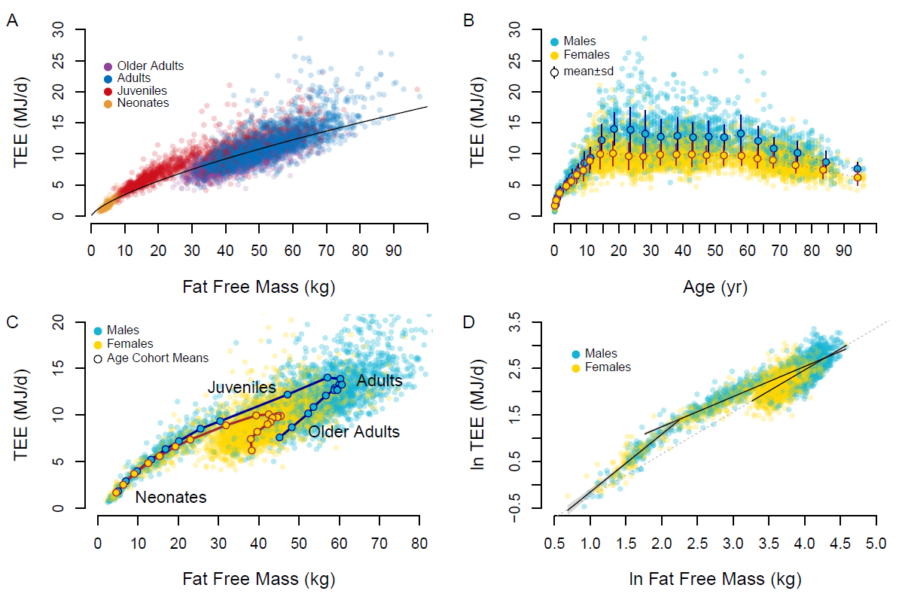

**Figure 1.** **A.** Total expenditure (TEE) increases with fat free mass in a power-law manner, but age groups cluster about the trend line differently. **B.** Total expenditure rises in childhood, is stable through adulthood, and declines in older adults. Means±sd for age-sex cohorts are shown. **C.** Age-sex cohort means show a distinct progression of total expenditure and fat free mass over the life course. **D.** Neonate, juveniles, and adults exhibit distinct relationships between fat free mass and expenditure. The dashed line, extrapolated from the regression for adults, approximates the regression used to calculate adjusted total expenditure.

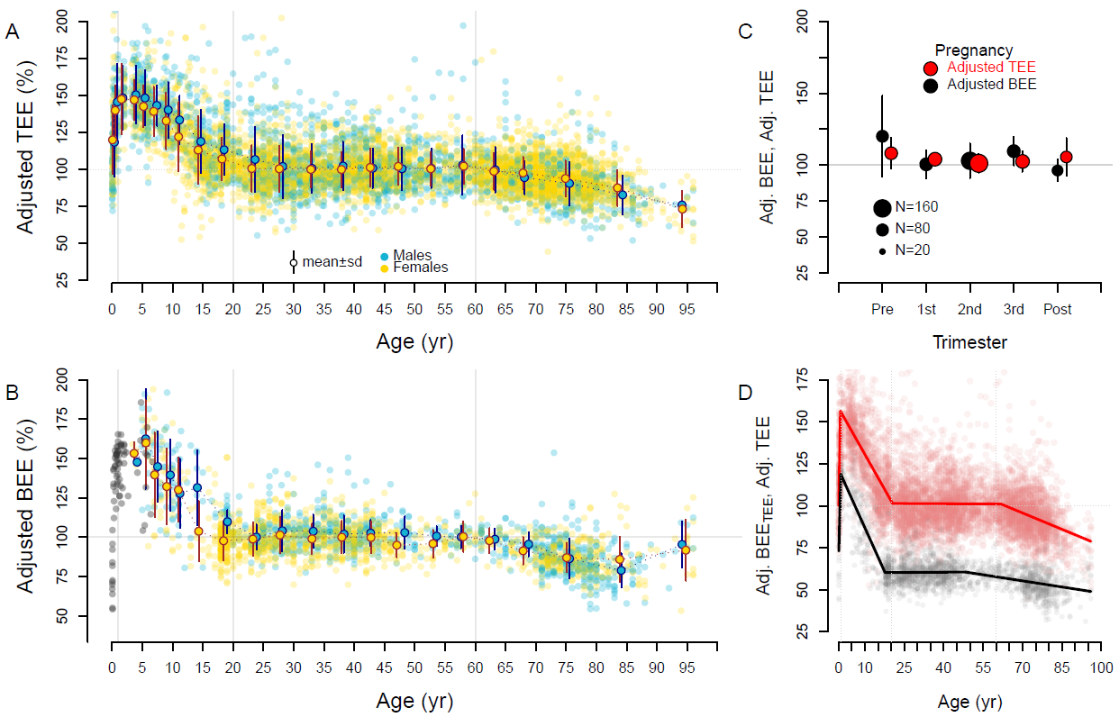

**Figure 2.** Fat free mass- and fat mass-adjusted expenditures over the life course. Individual subjects and age-sex cohort mean ± SD are shown. For both total (Adj. TEE) (**A**) and basal (Adj. BEE) expenditure (**B**), adjusted expenditures begin near adult levels (~100%) but quickly climb to ~150% in the first year. Adjusted expenditures decline to adult levels ~20y, then decline again in older adults. Basal expenditures for infants and children not in the doubly labeled water database are shown in gray. **C.** Pregnant mothers exhibit adjusted total and basal expenditures similar to non-reproducing adults (Pre: prior to pregnancy; Post: 27 weeks post-partum). **D**. Segmented regression analysis of adjusted total (red) and adjusted basal expenditure (calculated as a portion of total; Adj. BEETEE; black) indicates a peak at ~1 y, adult levels at ~20 y, and decline at ~60 y (see text).



**Figure 3.** Modeling the contribution of physical activity and tissue-specific metabolism to daily expenditures. **A.** Observed total (TEE, red), basal (BEE, black), and activity (AEE, gray) expenditures (Table S1) show age-related variation with respect to fat free mass (see Figure 1C) that is also evident in adjusted values (Table S3; see Figure 2D). **B.** These age effects do not emerge in models assuming constant physical activity (PA, green) and tissue-specific metabolic rate (TM, black) across the life course. **C.** When physical activity and tissue-specific metabolism follow the life course trajectories evident from accelerometry and adjusted basal expenditure, respectively, model output is similar to observed expenditures.

Supplementary Materials:

Pontzer et al. *Daily Energy Expenditure through the Human Life Course*

**Contents:**

Materials and Methods

1. Doubly Labeled Water Database
2. Basal Expenditure, Activity Expenditure, and PAL
3. Predictive Models for TEE, BEE, AEE, and PAL
4. Adjusted TEE, Adjusted BEE, and Adjusted BEETEE
5. Segmented Regression Analysis
6. Organ Size and BEE
7. Modeling the Effects of PA and Cellular Metabolism
8. Physical Activity, Activity Expenditure and PAL
9. The IAEA DLW database consortium

Figures S1-S10

Tables S1-S4

**Material and Methods**

1. Doubly Labeled Water Database

Data were taken from IAEA Doubly Labelled Water (DLW) Database, version 3.1, completed April, 2020 (*16*). This version of the database comprises 6,743 measurements of total expenditure using the doubly labeled water method. Of these, a total of 6,421 had valid data for total expenditure, fat free mass, fat mass, sex, and age. These 6,421 measurements were used in this analysis. This dataset was augmented with published basal expenditure measurements for n=136 neonates and infants (*31-36*) that included fat free mass and fat mass. Malnourished or preterm infants were excluded. For sources that provided cohort means rather than individual subject measurements (*33, 36*) means were entered as single values into the dataset without reweighting to reflect sample size. This approach resulted in 77 measures of basal expenditure, fat free mass, and fat mass for n=136 subjects. We also added to the dataset published basal and total expenditure measurements of n=141 women before, during, and after pregnancy (*37-39*) that included fat free mass and fat mass. These measurements were grouped as pre-pregnancy, 1st trimester, 2nd trimester, 3rd trimester, and post-partum for analysis.

In the doubly labeled water method (*5*), subjects were administered a precisely measured dose of water enriched in 2H2O and H218O. The subject’s body water pool is thus enriched in deuterium (2H) and 18O. The initial increase in body water enrichment from pre-dose values is used to calculate the size of the body water pool, measured as the dilution space for deuterium (Nd) and 18O (No). These isotopes are then depleted from the body water pool over time: both isotopes are depleted *via* water loss, whereas 18O is also lost *via* carbon dioxide production. Subtracting the rate (%/d) of deuterium depletion (kd) from the rate of 18O depletion (ko), and multiplying the size of the body water pool (derived from Nd and No) provided the rate of carbon doxide production, rCO2. Entries in the DLW database include the original k and N values for each subject, which were then used to calculate CO2 using a common equation that has been validated in subjects across the lifespan (*17*). The rate of CO2 production, along with each subject’s reported food quotient, was then used to calculate energy expenditure (MJ/d) using the Weir equation (*40*). We used the food quotients reported in the original studies to calculate total energy expenditure from rCO2 for each subject.

The size of the body water pool, determined from Nd and No, was used to establish FFM, using hydration constants for fat free mass taken from empirical studies. Other anthropometric variables (age, height, body mass, sex) were measured using standard protocols. Fat mass was calculated as (body mass) – (fat free mass).

1. Basal Expenditure, Activity Expenditure, and Physical Activityl Level (PAL)

A total of 2,008 subjects in the database had associated basal expenditure, measured *via* respirometry. For these subjects, we analyzed basal expenditure, activity expenditure, and “physical activity level” (PAL). Activity expenditure was calculated as [0.9(total expenditure) – (basal expenditure)] which subtracts basal expenditure and the assumed thermic effect of food [estimated at 0.1(total expenditure)] from total expenditure. The PAL ratio was calculated as (total expenditure)/(basal expenditure). As noted above, the basal expenditure dataset was augmented with measurements from neonates and infants, but these additional measures do not have associated total expenditure and could not be used to calculate activity expenditure or PAL.

1. Predictive Models for Total, Basal, and Activity Expenditures and PAL

We used general linear models to regress measures of energy expenditure against anthropometric variables. We used the base package in R version 4.0.3 (*41*) for all analyses. General linear models were implemented using the lm function. These models were used to develop predictive equations for total expenditure for clinical and research applications, and to determine the relative contribution of different variables to total expenditure and its components. Given the marked changes in metabolic rate over the lifespan (Figure 1, Figure 2) we calculated these models separately for each life history stage: infants (0 – 1 y), juveniles (1 – 20 y), adults (20 – 60 y), and older adults (60+ y). These age ranges were identified using segmented regression analysis. Results of these models are shown in Table S2.

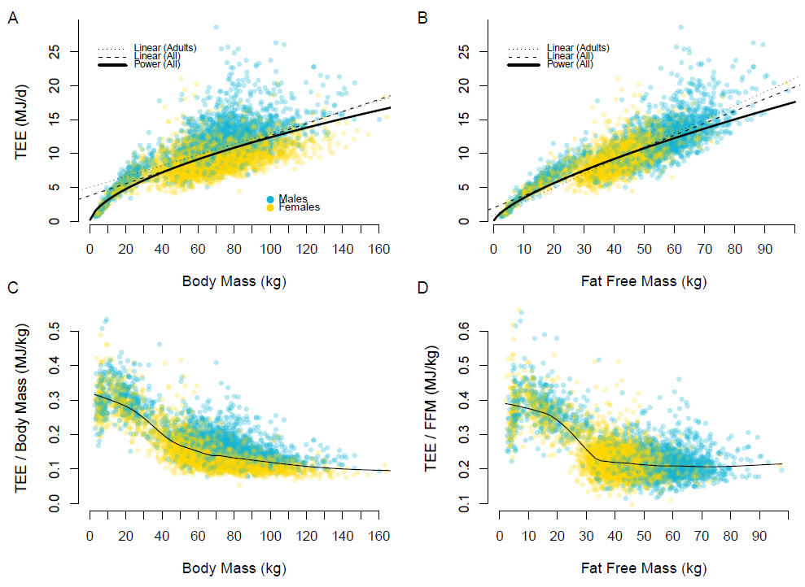

**Figure S1.** Total expenditure (TEE) increases with body size in a power-law manner. For the entire dataset (n = 6,407): **A.** the power-law regression for total body mass (*ln*TEE = 0.593 ± 0.004 *ln*Mass – 0.214 ± 0.018, p < 0.001, adj. r2 = 0.73, model std. err. = 0.223, df = 6419) is less predictive than the regression for **B.** fat free mass (*ln*TEE = 0.708 ± 0.004 *ln*FFM – 0.391 ± 0.015, p < 0.001, adj. r2 = 0.83, model std. err. = 0.176, df = 6419). For both body mass and fat free mass regressions, power-law regressions outperform linear models, particularly at the smallest body sizes. For all models, for both body mass and fat free mass, children have elevated total expenditure, clustering above the trend line. Children also exhibit elevated basal and activity expenditures (Figure S2). Power-law regressions have an exponent < 1.0, and linear regressions (dashed: linear regression through all data; dotted: linear regression through adults only) have a positive intercept, indicating that simple ratios of **C.** (total expenditure)/(body mass) or **D.** (total expenditure)/(fat free mass) do not adequately control for differences in body size (*18*) as smaller individuals will tend to have higher ratios. Lines in **C** and **D** are lowess with span 1/6. In body mass regressions (panel **A**, power and linear models) and the ratio of (total expenditure)/(body mass) (**C**), adult males cluster above the trend line while females cluster below due to sex differences in body composition. In contrast, males and females fit the fat free mass regressions (**B**) and ratio (**D**) equally well.

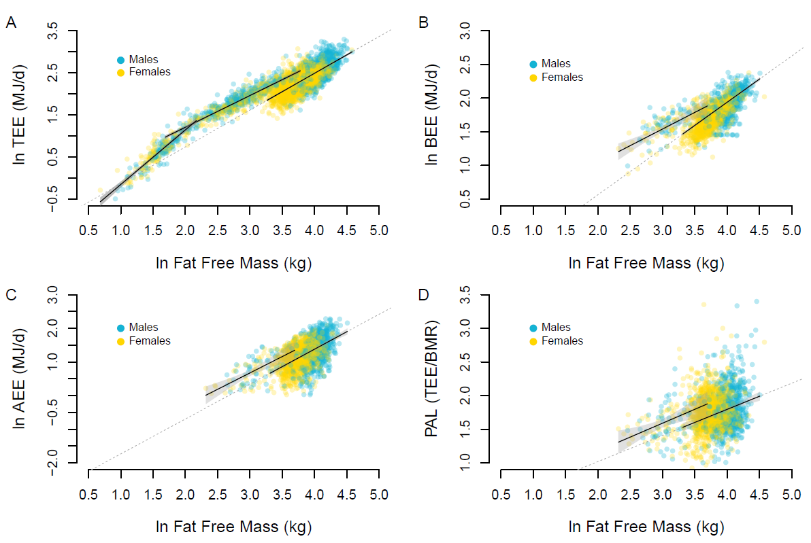

**Figure S2.** Infants and children exhibit different relationships between fat free mass and expenditure and the PAL ratio. **A:** For total expenditure (TEE), regressions for infants (age <1 y, left regression line) and adults (right regression line) intersect for neonates, at the smallest body size. However, the slopes differ, with the infants’ regression and 95% CI (gray region) falling outside of that for adults (age 20 – 60 y, extrapolated dashed line). Juvelines (age 1 – 20 y, middle regression line) are elevated, with a regression outside the 95% CI of adults. Juvenile (1 – 20 y) regressions (with 95%CI) are also elevated for basal expenditure (BEE) (**B**), activity expenditure (AEE) (**C**), and PAL (**D**) compared to adults (20 – 60 y). Sex differences in expenditure (**A-D**) are attributable to differences in fat free mass. Note that total and basal expenditures are measured directly. Activity expenditure is calculated as (0.9TEE – BEE), and PAL is calculated as (TEE/BEE); see Methods.



**Figure S3.** Changes in body composition over the lifespan: **A.** Body mass; **B.** Fat free mass; **C.** Fat Mass; and **D.** Body fat percentage.

1. Adjusted Expenditures

We used general linear models with fat free mass and fat mass in adults (20 – 60 y) to calculate adjusted total expenditure and adjusted basal expenditure. The 20 – 60 y age range was used as the basis for analyses because segmented regression analysis consistently identified this period as stable with respect to size-adjusted total expenditure (see below).

We used models 2 and 5 in Table S2, which have the form *ln*(Expenditure)~*ln*(FFM) + *ln*(Fat Mass) and were implemented using the lm function in base R version 4.0.3 (*41*). We used *ln*-transformed variables due to the inherent power-law relationship between body size and both total and basal expenditure (ref. *2*; see Figure 1, Figure S1). Predicted values for each subject, given their fat free mass and fat mass, were calculated from the model using the pred() function; these *ln*-transformed values were converted back into MJ as exp(Predicted). Residuals for each subject were calculated as (Observed – Predicted) expenditure, and were then used to calculate adjusted expenditures as:

Adjusted Expenditure = 1 + Residual / Predicted [1]

The advantage of expressing residuals as a percentage of the predicted value is that it allows us to compare residuals across the range of age and body size in the dataset. Raw residuals (MJ) do not permit direct comparison because the relationship between size and expenditure is heteroscedastic; the magnitude of residuals increases with size (see Figure S1). Ln-transformed residuals (*ln*MJ) avoid this problem but are more difficult to interpret. Adjusted expenditures, used here, provide an easily interpretable measure of deviation from expected values. An adjusted expenditure value of 100% indicates that a subject’s observed total or basal expenditure matches the value predicted for their fat free mass and fat mass, based on the general linear model derived for adults. An adjusted expenditure of 120% indicates an observed total or basal expenditure value that exceeds the predicted value for their fat free mass and fat mass by 20%. Similarly, an adjusted expenditure of 80% means the subject’s measured expenditure was 20% lower than predicted for their fat free mass and fat mass using the adult model. Adjusted total expenditure and adjusted basal expenditure values for each age-sex cohort are given in Table S3. Within each metabolic life history stage we used general linear models (lm function in R) to investigate the effects of sex and age on adjusted total and basal expenditure.

This same approach was used to calculate adjusted basal expenditure as a proportion of total expenditure (Figure 2D), hereafter termed adjusted BEETEE. ResidualBEE-TEE, the deviation of observed basal expenditure from the adult total expenditure regression (eq. 2 in Table S2), was calculatedas (Observed Basal Expenditure – Predicted Total Expenditure) and then used to calculate adjusted BEETEE as

Adjusted BEETEE = 1 + ResidualBEE-TEE / Predicted Total Expenditure [2]

When adjusted BEETEE = 80%, observed basal expenditure is equal to 80% of predicted total expenditure given the subject’s fat free mass and fat mass. Adjusted BEETEE is equivalent to adjusted basal expenditure (Figure S4) but provides some analytical advantages. The derivation of adjusted BEETEE approach applies identical manipulations to observed total expenditure and observed basal expenditure and therefore maintains them in directly comparable units. The ratio of (adjusted total expenditure)/(adjusted basal expenditure) is identical to the PAL ratio of (total expenditure)/(basal expenditure), and the difference (0.9adjusted total expenditure– adjusted basal expenditure) is proportional to activity expenditure (Figure S4). Plotting adjusted total expenditure and adjusted BEETEE over the lifespan (Figure 2D) therefore shows both the relative magnitudes of total and basal expenditure and their relationship to one another in comparable units.

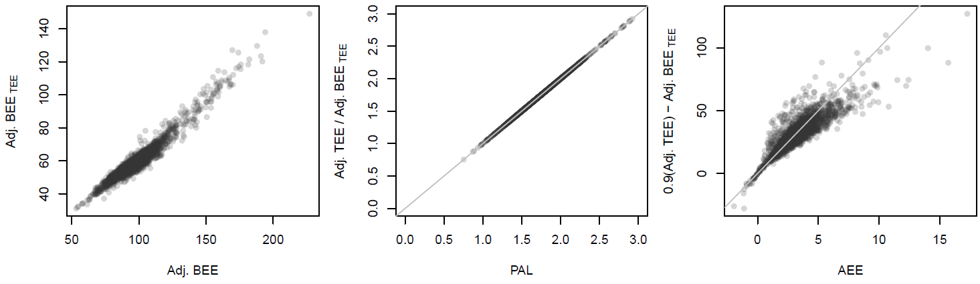

**Figure S4.** Left: Adjusted BEETEE corresponds strongly to adjusted basal expenditure (Adj. BEE). Center: The ratio of adjusted total expenditure (adj. TEE) to adjusted BEETEE is identical to the PAL ratio. Right: The difference (0.9adjusted total expenditure – adjusted BEETEE) is proportional to activity energy expenditure (AEE). Gray lines: center panel: y = x, right panel: y = 10x.

1. Segmented Regression Analysis

We used segmented regression analysis to determine the change points in the relationship between adjusted expenditure and age. We used the Segmented (version 1.1-0) package in R (*42*). For adjusted total expenditure, we examined a range of models with 0 to 5 change points, using the npsi= term in the segmented() function. This approach does not specify the location or value of change points, only the number of them. Each increase in the number of change points from 0 to 3 improved the model adj. R2 and standard error considerably. Increasing the number of change points further to 4 or 5 did not improve the model, and the additional change points identifed by the segmented() function fell near the change points for the 3-change point model. We therefore selected the 3-change point model as the best fit for adjusted total expenditure in this dataset. Segmented regression results are shown in Table S4. A similar 3-change point segmented regression approach was conducted for adjusted basal expenditure (Figure S4) and adjusted BEETEE (Figure 2D). We note that the decline in adjusted basal expenditure and adjusted BEETEE in older adults begins earlier (as identified by segmented regression analysis) than does the decline in adjusted total expenditure among older adults. However, this difference may reflect the relative paucity of basal expenditure measurements for subjects 40 – 60 y. Additional measurements are needed to determine whether the decline in basal expenditure does in fact begin earlier than the decline in total expedinture. Here, we view the timing as essentially coincident and interpret the change point in adjusted total expenditure (~60 y), which is determined with a greater number of measurements, as more accurate and reliable.

Having established that 3 break points provided the best fit for this dataset, we examined whether changes in the age range used to calculate adjusted total energy expenditure affected the age break-points identified by segmented regression. When the age range used to calculate adjusted expenditure was set at 20 – 60 y, the set of break point (95% CI) was: 0.69 (0.61-0.76), 20.46 (19.77-21.15), 62.99 (60.14-65.85). When the age range was expanded to 15 – 70 y, break points determined through segmented regression were effectively unchanged: 0.69 (0.62 – 0.76), 21.40 (20.60-22.19), 61.32 (58.60-64.03). Break points were also unchanged when the initial age range for adjusted expenditure was limited to 30 – 50 y: 0.69 (0.62-0.77), 20.56 (19.84-21.27), 62.85 (59.97-65.74).

**A B**

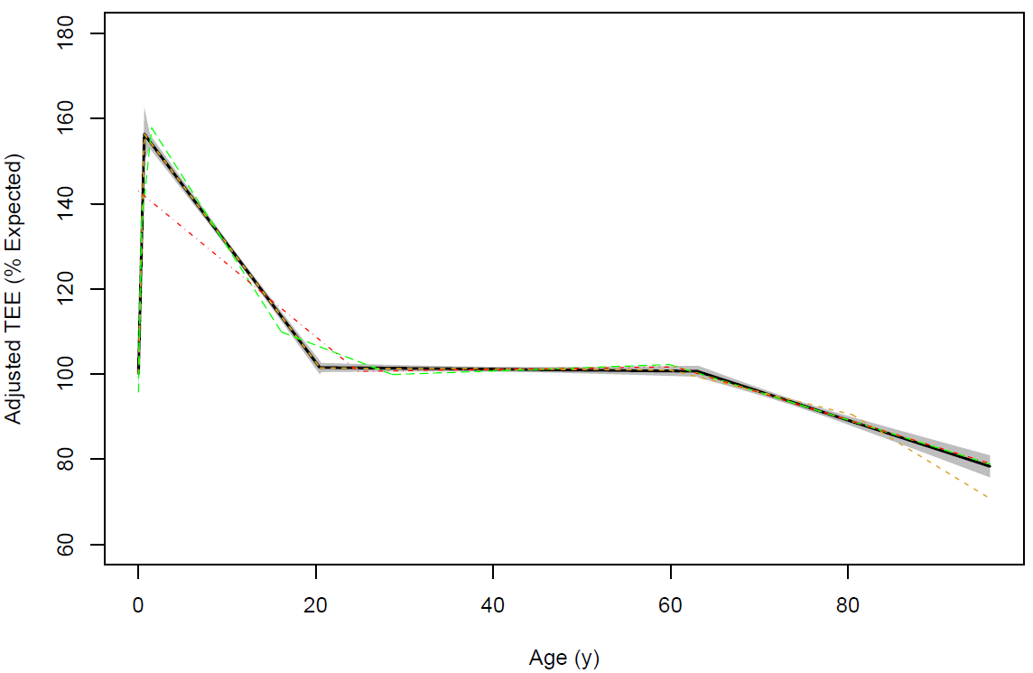 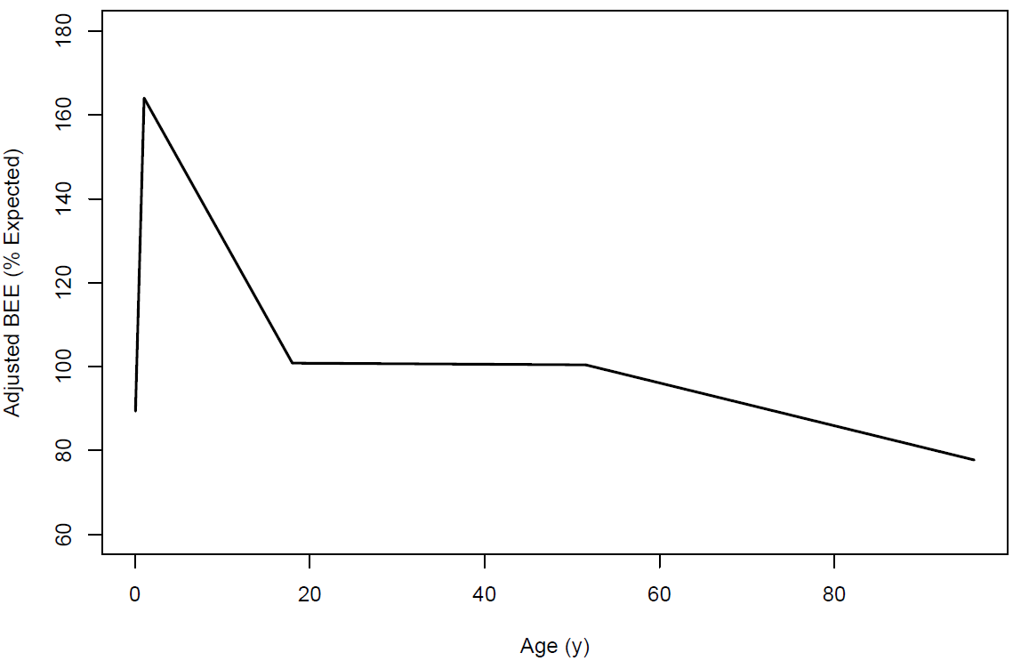

**Figure S5.** Segmented regression analysis of adjusted TEE (**A**) and adjusted BEE (**B**). In both panels, the black line and gray shaded confidence region depicts the 3 change-point regression. For adjusted TEE, segmented regressions are also shown for 2 change points (red), 4 change points (yellow), and 5 change points (green). Segmented regression statistics are given in Table S4.

1. Organ Size and Basal Expenditure

Measuring the metabolic rate of individual organs is notoriously challenging, and the available data come from only a small number of studies. The available data indicate that organs differ markedly in their mass-specific metabolic rates at rest (*43*). The heart (1848 kJ kg-1 d-1), liver (840 kJ kg-1 d-1), brain (1008 kJ kg-1 d-1), and kidneys (1848 kJ kg-1 d-1) have much greater mass-specific metabolic rates at rest than do muscle (55 kJ kg-1 d-1), other lean tissue (50 kJ kg-1 d-1), and fat (19 kJ kg-1 d-1). Consequently, the heart, liver, brain, and kidneys combined account for ~60% of basal expenditure in adults (*21, 22, 44, 45*). In infants and children, these metabolically active organs constitute a larger proportion of body mass. The whole body mass-specific basal expenditure [i.e., (basal expenditure)/(body mass), or (basal expenditure)/(fat free mass)] for infants and children is therefore expected to be greater than adults’ due to the greater proportion of metabolically active organs early in life adults (*21, 22, 44, 45*). Similarly, reduced organ sizes in elderly subjects may result in declining basal expenditure (*21*).

To examine this effect of organ size on basal expenditure in our dataset, we used published references for organ size to determine the mass of the metabolically active organs (heart, liver, brain, and kidneys) as a percentage of body mass or fat free mass for subjects 0 – 12 y (*22, 44-46*), 15 to 60 y (*21, 22*), and 60 to 100 y (*21, 47*). We used these relationships to estimate the combined mass of the metabolically active organs (heart, liver, brain, kidneys) for each subject in our dataset. We then subtracted the mass of the metabolically active organs from measured fat free mass to calculate the mass of “other fat free mass”. These two measures, along with measured fat mass, provided a three-compartment model for each subject: metabolically active organs, other fat free mass, and fat (Figure S6A).

Following previous studies (*21-25*), we assigned mass-specific metabolic rates to each compartment and estimated basal expenditure for each subject. We used reported mass-specific metabolic rates for the heart, liver, brain, and kidneys (see above; (*43*)) and age-related changes in the proportions of these organs for subjects 0 – 12 y (*22, 46*), 15 to 60 y (*21-25*), and 60 to 100 y (*21, 23, 25, 47*) to calculate an age-based weighted mass-specific metabolic rate for the metabolically active organ compartment. We averaged the mass-specific metabolic rates of resting muscle and other lean tissue (see above; (*21, 22*)) and assigned a value of 52.5 kJ kg-1 d-1 to “other fat free mass”, and we used a mass-specific metabolic rate of 19 kJ kg-1 d-1 for fat.

Results are shown in Figure S6. Due to the greater proportion of metabolically active organs in early life, the estimated basal expenditure from the three-compartment model follows a power-law relationship with FFM (using age cohort means, BEE= 0.38 FFM0.75; Figure S6B) that is similar to that calculated from observed basal expenditure in our dataset (see Table S2 and *7. Modeling the Effects of Physical Activity and Tissue Specific Metabolism*, below). Estimated BEE from the three-compartment model produced mass-specific metabolic rates that are considerably higher for infants and children than for adults and roughly consistent with observed age-related changes in (basal expenditure)/(fat free mass) (Figure S6C). Thus, changes in organ size can account for much of the variation in basal expenditure across the lifespan observed in our dataset.

Nonetheless, observed basal expenditure was ~30% greater early in life, and ~20% lower in older adults, than estimated basal expenditure from the three-compartment model (Figure S6D). The departures from estimated basal expenditure suggest that the mass-specific metabolic rates of one or more organ compartments are considerably higher early in life, and lower late in life, than they are in middle-aged adults, consistent with previous assessments (*21-25*). It is notable, in this context, that observed basal expenditure for neonates is nearly identical to basal expenditure estimated from the three-comparment model, which assumes adult-like tissue metabolic rates (Figure S6B,C,D). Observed basal expenditure for neonates is thus consistent with the hypothesis that the mass-specific metabolic rates of their organs are similar to those of other adults, specifically the mother.

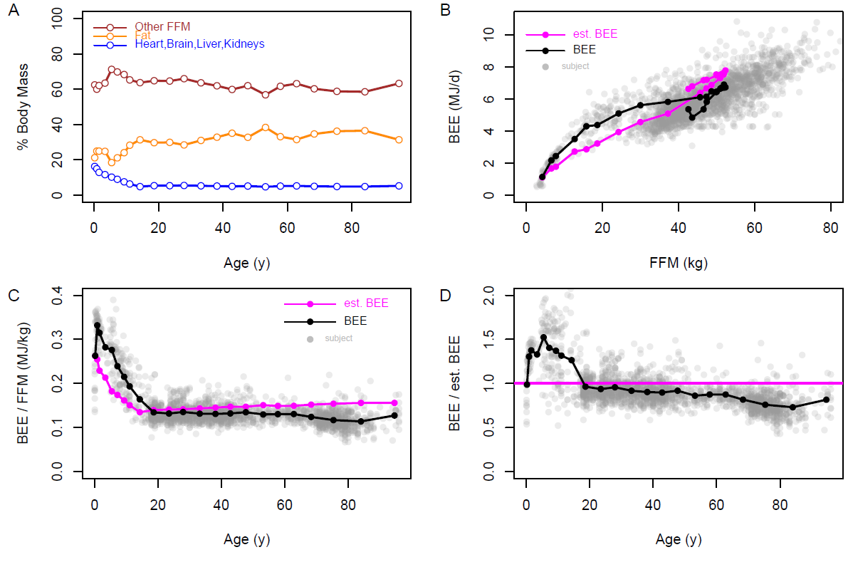

**Figure S6.** **Organ sizes and BEE.** **A.** The relative proportions of metabolically active organs (heart, brain, liver, kidneys), other fat free mass (FFM), and fat changes over the life course. Age cohort means are shown. **B.** Consequently, estimated basal expenditure (BEE) from the three-compartment model increases with fat free mass (FFM) in a manner similar to observed basal expenditure, with **C.** greater whole body mass-specific basal expenditure (BEE/FFM) early in life. **D.** Observed basal expenditure is ~30% greater early in life, and ~20% lower after age 60 y, than estimated basal expenditure from the three-compartment model (shown as the ratio of BEE/est.BEE). In panels **B**, **C**, and **D**, age-cohort means for observed (black) and estimated (magenta) basal expenditure are shown.

1. Modeling the Effects of Physical Activity and Tissue Specific Metabolism

We constructed two simple models to examine the contributions of physical activity and variation in tissue metabolic rate to total and basal expenditure. In the simplest version, we used the observed relationship between basal expenditure and tat free mass for all adults 20 – 60 y determined from linear regression of *ln*(basal expenditure) and *ln*(fat free mass) (untransformed regression equation: basal expenditure = 0.32 (fat free mass)0.75, adj. r2 = 0.60, df = 1684, p < 0.0001) to model basal expenditure as

Basal expenditure = 0.32 TMage (fat free mass)0.75 [3]

The TMage term is tissue metabolic rate, a multiplier between 0 and 2 reflecting a relative increase (TMage > 1.0) or decrease (TMage < 1.0) in organ metabolic rate relative that expected from the power-law regression for adults. Note that, even when TMage = 1.0, smaller individuals are expected to exhibit greater mass-specific basal expenditure (that is, a greater basal expenditure per kg body weight) due to the power-law relationship between basal expenditure and fat free mass. Further, we note that the power-law relationship between basal expenditure and fat free mass for adults is similar to that produced when estimating basal expenditure from organ sizes (see *Organ Size and Basal Expenditure*, above). Thus, variation in TMage reflects modeled changes in tissue metabolic rate *in addition* to power-law scaling effects, and also, in effect, in addition to changes in basal expenditure due to age-related changes in organ size and proportion. To model variation in organ activity over the lifespan, we either 1) maintained TMage at adult levels (TMage = 1.0) over the entire lifespan, or 2) had TMage follow the trajectory of adjusted basal expenditure with age (Figure S8).

To incorporate effects of fat mass into the model, we constructed a second version of the model in which basal expenditure was modeled following the observed relationship with FFM and fat mass for adults 20 – 60 y,

Basal expenditure = 0.32 TMage (fat free mass)0.7544 (fat mass)0.0003 [4]

As with the fat free mass model (eq. 3), we either maintained TMage at 1.0 over the life span or modeled it using the trajectory of adjusted basal expenditure.

Activity expenditure was modeled as a function of physical activity and body mass assuming larger indivduals expend more energy during activity. We began with activity expenditure, calculated as [0.9(total expenditure) – (basal expenditure)] as described above. The observed ratio of (activity expenditure)/(fat free mass) for adults 20 – 60 y was 0.07 MJ d-1 kg-1. We therefore modeled activity expenditure as

Activity expenditure = 0.07 PAage (fat free mass) [5]

To incorporate effects of fat mass, we constructed a second version using the ratio of (activity expenditure)/(body weight) for adults 20 – 60y,

Activity expenditure = 0.04 PAage (body weight) [6]

In both equations, PAage represents the level of physical activity relative to the mean value for 20 – 60 y adults. PAage could either remain constant at adult levels (PAage=1.0) over the lifespan or follow the trajectory of physical activity measured *via* accelerometry, which peaks between 5 – 10 y, declines rapidly through adolescence, and then declines more slowly beginning at ~40 y (*11-13, 26, 27, 48-51*). Different measures of physical activity (*e.g*., moderate and vigorous PA, mean counts per min., total accelerometry counts) exhibit somewhat different trajectories over the lifespan, but the patterns are strongly correlated; all measures show the greatest activity at 5-10 y and declining activity in older adults (Figure S7). We chose total accelerometry counts (*11, 26*), which sum all movement per 24-hour period, to model age-related changes in PAage. We chose total counts because activity energy expenditure should reflect the summed cost of all activity, not only activity at moderate and vigorous intensities. Further, the amplitude of change in moderate and vigorous activity over the lifespan is considerably larger than the observed changes in adjusted total expenditure or adjusted activity expenditure (Figure S10). Determining the relative contributions of different measures of physical activity to total expenditure is beyond the scope of the simple modeling approach here and remains an important task for future research.

**A.** **B**. 

**Figure S7.** Modeling physical activity across the lifespan. **A.** Across studies and countries, accelerometer-measured physical activity rises through infancy and early childhood, peaking between 5 and 10y before declining to adult levels in the teenage years (*11-13, 26, 27, 48-51*). Physical activity declines again, more slowly, in older adults. The onset of decline in older adults varies somewhat across studies, beginning between ~40 y and ~60 y. Here, physical activity is shown as minutes/day of moderate and vigorous physical activity. Other measures (*e.g*., total accelerometer counts; mean counts/min, vector magnitude) follow a similar pattern of physical activity over the life span (*11, 26*). **B.** The increase in physical activity from 0 to ~10 y is mirrored by the steady decline in total daily sleep duration during this period (*52-55*).



**Figure S8.** Results of the fat free mass model. Observed expenditures exhibit a marked age effect on the relationship between expenditure and fat free mass that is evident in both absolute (Figure 1C) and adjusted (Figure 2D) measures. **A.** If physical activity (PA) and cellular metabolism (TM) remain constant at adult levels, age effects do not emerge from the model. **B.** When only TM varies, age effects emerge for total expenditure (TEE) and basal expenditure (BEE), but not activity expenditure (AEE; gray arrow). **C.** Conversely, if only physical activity varies age effects emerge for AEE and TEE but not BEE (black arrows). Adjusted TEE also peaks later in childhood and declines earlier in adulthood (red arrows) than observed. **D.** Varying both PA and TM gives model outputs similar to observed expenditures.



**Figure S9.** Results of the fat free mass and fat mass model. Model outputs are similar to those of the fat free mass model (Figure S8). The scenario that best matches the observed relationships between fat free mass, age, and expenditure is D, in which AEE is influenced by age-related variation in both physical activity and cellular metabolism. Abbreviations as in Fig S8.

8. Physical Activity, Activity Expenditure and PAL

To further interrogate our simple model of expenditure and the contribution of physical activity, we examined the agreement between accelerometery-measured physical activity, adjusted activity expenditure, and modeled PAL over the lifespan. First, as noted in our discussion of the simple expenditure model (see above; Figures 3, S8, S9), moderate and vigorous physical activity and total accelerometry counts show a similar shape profile when plotted against age, but moderate and vigorous physical activity shows a greater amplitude of change over the lifespan (Figure S10). Moderate and vigorous physical activity reach a peak ~4-times greater than the mean values observed for 20 – 30 y men and women, far greater than the amplitude of change in adjusted total expenditure.

We used adjusted total and basal expenditures to model activity expenditure and PAL over the lifespan for comparison with published accelerometry measures of physical activity. Modeling activity expenditure and PAL was preferable because our dataset has no subjects less than 3 y with measures of both total and basal expenditure, and only 4 subjects under the age of 6 y with both measures (Table S1). Using values of adjusted total expenditure and adjusted BEETEE (basal expenditure expressed as a percentage of total expenditure) for age cohorts from Table S3 enabled us to model activity expenditure and PAL for this critical early period of development, in which both physical activity and expenditure change substantially. We modeled adjusted activity expenditure as [(adjusted total expenditure) – (adjusted BEETEE)] and PAL as [(adjusted total expenditure) / (adjusted BEETEE)], which as we show in Figure S4 corelate strongly with unadjusted measures of activity expenditure and PAL, respectively.

Modeled adjusted activity expenditure and PAL showed a somewhat different pattern of change over the lifecoure than either total counts or moderate and vigorous activity measured via accelerometry (Figure S10). Modeled activity expenditure was most similar to total counts, rising through childhood, peaking between 10 and 20 y before falling to a stable adult level; the adult level was stable from ~30 – 75 y before declining (Figure S10). Modeled PAL rose unevenly from birth through age 20, then remained largely stable thereafter.

The agreement, and lack thereof, between the pattern of accelerometry-measured physical activity and modeled activity expenditure and PAL must be assessed with caution. These measures are from different samples; we do not have paired accelerometry and energy expenditure measures in the present dataset. The life course pattern of accelerometry-measured physical activity, particularly total counts, is broadly consistent with that of modeled activity expenditure. However, more work is clearly needed to determine the effects of physical activity and other factors to variation in activity expenditure and PAL over the lifecourse.

**9.IAEA DLW database consortium**

This group authorship contains the names of people whose data were contributed into the database by the analysis laboratory but they later could not be traced, or they did not respond to emails to assent inclusion among the authorship. The list also includes some researchers who did not assent inclusion because they felt their contribution was not sufficient to merit authorship

**Dr Stefan Branth**

University of Uppsala, Uppsala, Sweden

**Dr Niels C. De Bruin**

Erasmus University, Rotterdam, The Netherlands

**Dr Lisa H. Colbert**

Kinesiology, University of Wisconsin, Madison, WI,

**Dr Alice E. Dutman**

TNO Quality of Life, Zeist, The Netherlands

**Dr Simon D. Eaton,**

University college London, London, UK

**Dr Cara Ebbeling**

Boston Children's Hospital, Boston, Massachusetts, USA.

**Dr Sölve Elmståhl**

Lund University, Lund, Sweden

**Dr Mikael Fogelholm**

Dept of Food and Nutrition, Helsinki, Finland

**Dr Tamara Harris**

Aging, NIH, Bethesda, MD,

**Dr Rik Heijligenberg**

Academic Medical Center of Amsterdam University, Amsterdam, The Netherlands

**Dr Hans U. Jorgensen**

Bispebjerg Hospital, Copenhagen, Denmark

**Dr Christel L. Larsson**

University of Gothenburg, Gothenburg, Sweden

**Dr David S. Ludwig**

Boston Children's Hospital, Boston, Massachusetts, USA.

**Dr Margaret McCloskey**

Royal Belfast Hospital for Sick Children, Belfast, Northern Ireland

**Dr Gerwin A. Meijer**

Maastricht University, Maastricht, The Netherlands

**Dr Daphne L. Pannemans**

Maastricht University, Maastricht, The Netherlands

**Dr Renaat M. Philippaerts**

Katholic University Leuven, Leuven, Belgium

**Dr John J. Reilly**

Universoty of Strathclyde, Glasgow, UK

**Dr Elisabet M. Rothenberg**

Göteborg University, Göteborg, Sweden

**Dr Sabine Schulz**

University of Maastricht, Maastricht, The Netherlands

**Dr Amy Subar**

Epidemiology and Genomics, Division of Cancer Control, NIH, Bethesda, MD,

**Dr Minna Tanskanen**

University of Jyväskilä, Jyväskilä, Finland

**Dr Ricardo Uauy**

Institute of Nutrition and Food Technology (INTA), University of Chile, Santiago Chile.

**Dr Rita Van den Berg-Emons**

Maastricht University, Maastricht, The Netherlands

**Dr Wim G. Van Gemert**

Maastricht University, Maastricht, The Netherlands

**Dr Erica J. Velthuis-te Wierik**

TNO Nutrition and Food Research Institute, Zeist, The Netherlands

**Dr Wilhelmine W. Verboeket-van de Venne**

Maastricht University, Maastricht, The Netherlands

**Dr Jeanine A. Verbunt**

Maastricht University, Maastricht, The Netherlands

A B

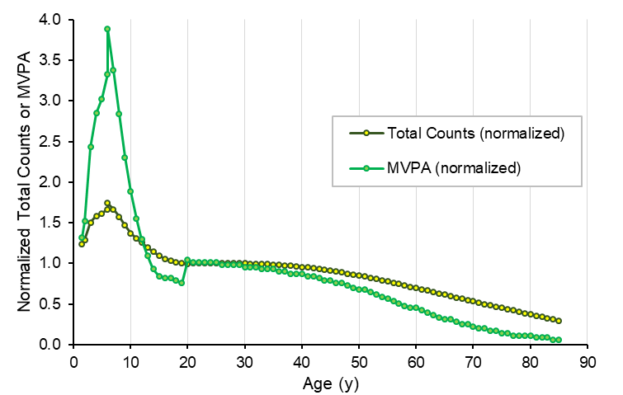 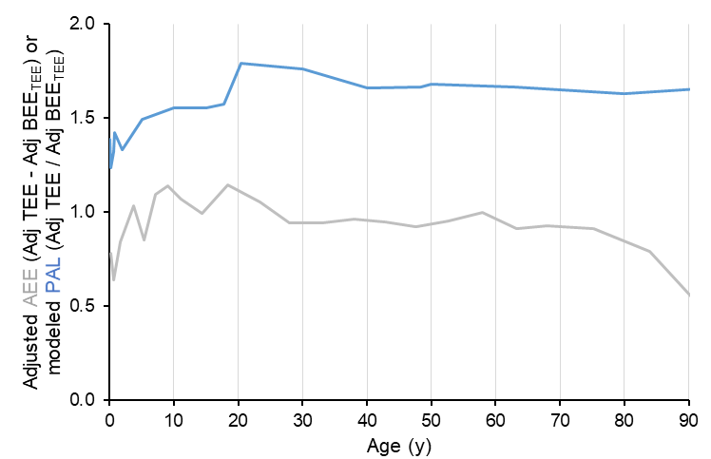

**Figure S10. A.** Physical activity measured via accelerometry from published analyses (*11-13, 26, 27, 48-51*) and **B.** modeled activity expenditure and PAL calculated from cohort means for adjusted total expenditure and adjusted BEETEE in Table S3. Accelerometry measures and modeled activity expenditure are normalized to mean values for 20 – 30 y subjects.

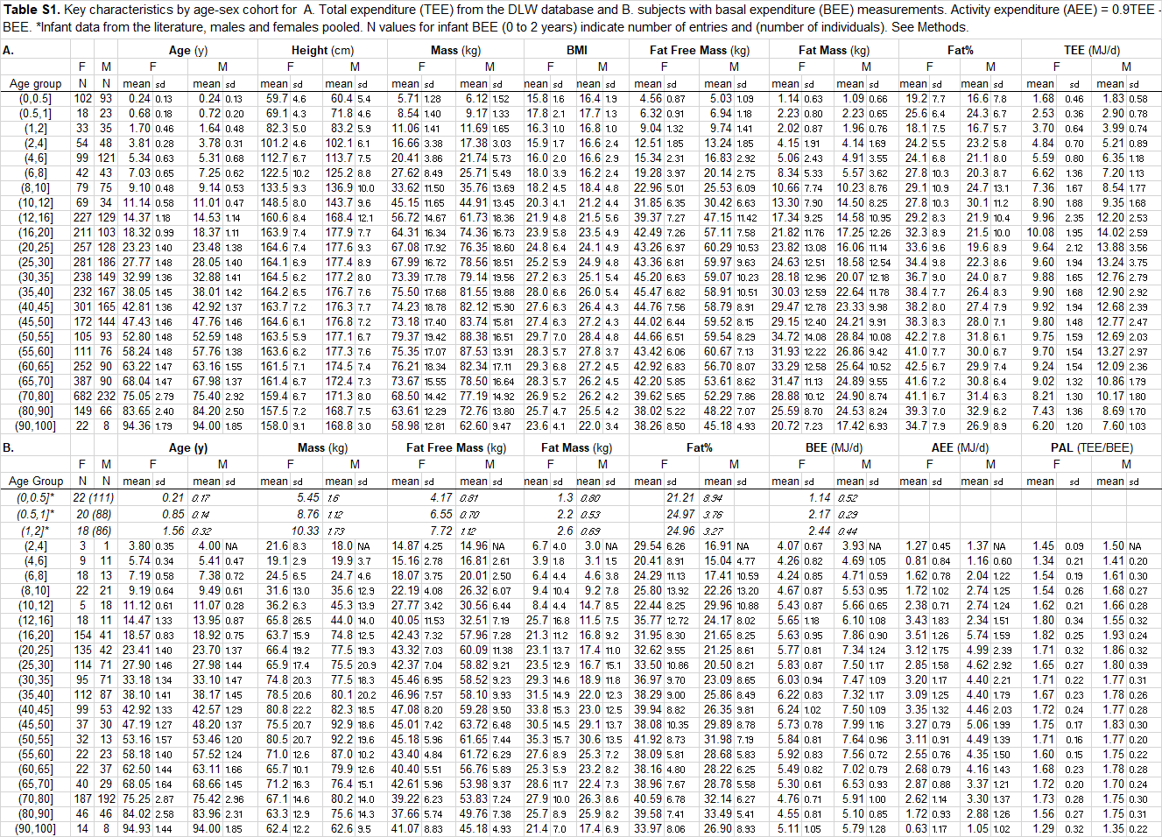





**Table S4.** Segmented Regression Analyses

|  |  |  |  |  |  |  |  |
| --- | --- | --- | --- | --- | --- | --- | --- |
| **adjTEE** | **Segments** | |  |  | **Break Points** | |  |
|  | *beta* | *SE* | *CI_lower* | *CI_upper* | *Estimate* | *CI_lower* | *CI_upper* |
|  | 84.70 | 7.15 | 70.69 | 98.71 | 0.69 | 0.61 | 0.76 |
|  | -2.77 | 0.07 | -2.91 | -2.63 | 20.46 | 19.77 | 21.15 |
|  | -0.02 | 0.02 | -0.07 | 0.03 | 62.99 | 60.13 | 65.85 |
|  | -0.68 | 0.06 | -0.79 | -0.57 |  |  |  |
|  |  |  |  |  |  |  |  |
| **adjBEE** | **Segments** | |  |  | **Break Points** | |  |
|  | *beta* | *SE* | *CI_lower* | *CI_upper* | *Estimate* | *CI_lower* | *CI_upper* |
|  | 75.51 | 5.59 | 64.55 | 86.46 | 1.04 | 0.94 | 1.14 |
|  | -3.75 | 0.22 | -4.17 | -3.33 | 18.00 | 16.82 | 19.18 |
|  | 0.02 | 0.05 | -0.07 | 0.12 | 46.46 | 40.57 | 52.35 |
|  | -0.45 | 0.04 | -0.53 | -0.37 |  |  |  |