Standards for Detecting, Interpreting and Reporting NCCT Markers of ICH Expansion

Andrea Morotti, MD*; Gregoire Boulouis, MD, MSc*; Dar Dowlatshahi, MD, PhD;
Qi Li, MD, PhD; Christen D. Barras, MD, PhD; Candice Delcourt, MD, PhD; Zhiyuan Yu, MD; Jun Zheng, MD; Zien Zhou, MD; Richard I. Aviv, MBChB; Ashkan Shoamanesh, MD, FRCPC;
Peter B. Sporns, MD, MHBA; Jonathan Rosand, MD, MSc; Steven M. Greenberg, MD, PhD; Rustam Al-Shahi Salman, MD, PhD, FRCP; Adnan I. Qureshi, MD; Andrew M. Demchuk, MD;
Craig S. Anderson, MD, PhD; Joshua N. Goldstein, MD, PhD; Andreas Charidimou, MD, PhD
International NCCT ICH Study Group

AFFILIATIONS
Department of Neurology and Neurorehabilitation, IRCCS Mondino Foundation, Pavia, Italy (AM).
Department of Neuroradiology, Université Paris Descartes, INSERM S894, DHU Neurovasc, Centre Hospitalier Sainte-Anne, Paris, France (GB).
Department of Medicine (Neurology), University of Ottawa, Ottawa Hospital Research Institute, Ottawa, Canada (DD).
Department of Neurology, The First Affiliated Hospital of Chongqing Medical University, Chongqing, China (QL)
South Australian Health and Medical Research Institute, Adelaide, Australia; Department of Radiology,
Royal Adelaide Hospital and The University of Adelaide, Adelaide, Australia (CDB).
Department of Neurology, Royal Prince Alfred Hospital, Sydney Health Partners, The University of Sydney, Sydney, New South Wales, Australia (CD, CSA)
The George Institute for Global Health, Faculty of Medicine, The University of New South Wales, Sydney, New South Wales, Australia (CD, CSA, ZZ).
Department of Neurosurgery, West China Hospital, Sichuan University, Chengdu, Sichuan 610041, China (ZY, JZ).
Department of Radiology, Ren Ji Hospital, School of Medicine, Shanghai Jiao Tong University, Shanghai, China (ZZ).
Division of Neuroradiology and Department of Medical Imaging, Sunnybrook Health Sciences Centre, University of Toronto, Toronto, Canada (RIA).
Division of Neurology, McMaster University / Population Health Research Institute, Hamilton, Canada (AS).
Institute of Clinical Radiology, University of Muenster, Germany (PS).
J. P. Kistler Stroke Research Center, Massachusetts General Hospital, Harvard Medical School, Boston. (JR, SMG, JNG, AC).
Division of Neurocritical Care and Emergency Neurology, Department of Neurology, Massachusetts General Hospital, Harvard Medical School, Boston (JR, JNG).
Henry and Allison McCance Center for Brain Health, Massachusetts General Hospital, Boston (JR).
Centre for Clinical Brain Sciences, University of Edinburgh, Edinburgh, UK (RA-SS)
Zeenat Qureshi Stroke Research Center, University of Minnesota, Minneapolis (AIQ).
Department of Clinical Neurosciences, Department of Radiology, Hotchkiss Brain Institute, University of Calgary, Calgary, Canada (AMD).
Department of Emergency Medicine, Massachusetts General Hospital, Harvard Medical School, Boston (JNG).

* Equal contribution

Corresponding author:
Andrea Morotti, MD
Department of Neurology and Neurorehabilitation
IRCCS Mondino Foundation
Via Mondino 2, 27100, Pavia, Italy
Phone: 00390382501460
Email: andrea.morotti85@gmail.com

Running Head: NCCT markers of ICH expansion
Search Terms: intracerebral hemorrhage, non-contrast CT, hypodensities, blend sign, swirl sign, black hole sign, satellite sign, island sign, hematoma expansion, stroke

Manuscript type: Review

Title word count: 11

Title character count: 81

Running head word count: 5

Running head character count: 29

Abstract word count: 100

Text word Count: 4435

Number of references: 78

Figures: 2

Tables: 4

Supplementary material: study quality with risk of bias assessment and training material.

ABSTRACT
Significant hematoma expansion (HE) affects one-fifth of people within 24 hours after acute intracerebral hemorrhage (ICH) and its prevention is an appealing treatment target. Although the CT-Angiography spot sign predicts HE, only a minority of ICH patients receives contrast injection. Conversely, non-contrast CT (NCCT) is used to diagnose nearly all ICH, so NCCT markers represent a widely-available alternative for prediction of HE. However, different NCCT signs describe similar features, with lack of consensus on the optimal image acquisition protocol, assessment, terminology and diagnostic criteria. In this review we propose practical guidelines for detecting, interpreting and reporting NCCT predictors of HE.

INTRODUCTION
Spontaneous intracerebral hemorrhage (ICH) remains a major cause of morbidity and mortality worldwide.^{1,2} Unlike acute ischemic stroke, few interventions have been shown conclusively to improve clinical outcome after ICH.^{3,4} Amongst therapeutic targets, limiting significant hemorrhage expansion (HE) is an appealing goal in ICH acute care.⁵ Several lines of evidence converge to suggest that HE following admission is a potentially preventable independent predictor of early neurological deterioration and worse long-term outcomes.^{6,7} However, randomized clinical trials (RCT) using interventions to reduce HE have not been successful in providing a definitive therapy with significant impact on the extent of bleeding and functional outcome.^{8–11} Hitherto, many RCT employed an inclusive, unselected “all-comers” approach, where the intervention was applied regardless of HE risk. The overall estimate of treatment effect represented large heterogeneous populations,⁵ an approach which permits investigation of heterogeneity of treatment effect by baseline predicted risk of HE (e.g. by spot sign presence/absence). This highlights the importance of easy-to-use and widely available prediction models to stratify HE risk, to either target recruitment to selective RCTs, or investigate treatment effect modification. The spot sign provides a small improvement in the discrimination of a HE prediction model based on four simple clinical predictors (ICH volume, time since ICH onset, and antiplatelet/anticoagulant use).¹²Around 11-25% of ICH patients undergo CT angiography (CTA) during the acute phase in a RCT in high income countries,^{10,13} but very few if any patients will undergo this test in low-middle income countries. In this context, several non-contrast CT (NCCT) markers may be alternatives to the CTA spot sign to add discrimination to simple models for HE prediction.^{12,14} While many NCCT aspects of acute ICH have been shown to be associated with HE and poor outcome, there is no consensus on the methodology and diagnostic criteria to identify these markers, representing a major gap in the field. Furthermore, most of the currently available prediction models incorporating NCCT markers have not been externally validated, making it difficult to appreciate the incremental diagnostic value of every new sign.^{15,16} Therefore, we sought to comprehensively review the available evidence regarding NCCT markers and HE, propose and harmonize relevant terminology, and provide clear systematic guidelines for detection, interpretation and reporting of NCCT markers of HE in future research studies. Although the majority of ICH patients experience some degree of hematoma enlargement, in this review the term HE is used referring to significant (>33% and/or >6 mL) hemorrhage growth.

METHODS

Authors Selection
Potential contributors were identified by the coordinating team (AM, GB, JNG, AC) based on previous collaborations, known expertise in acute ICH imaging and a systematic literature review, as described in the supplemental material, where we also provided a systematic appraisal of quality and risk of bias of the currently available evidence. First and last authors of all relevant papers on the topic were contacted. The coordinating team drafted and circulated a study proposal and coauthors were contacted by email and asked to participate in February 2018. The expert panel formulating the recommendations was finalized in April 2018. Three additional coauthors were identified in October 2018, (AS, PS, RA-SS) and acted as internal reviewers of the consensus output.

Consensus modified Delphi method
Working groups comprised of 2-4 coauthor teams were allocated specific subsections to draft, based on their most relevant expertise. After receiving sections drafts, the coordinating team built tables summarizing key aspects of consensus. A modified Delphi approach was then implemented to reach consensus.^{17,18} All contributors were asked to vote (agreement/disagreement) on every point of the tables, providing feedback and comments for improvement, especially in case of disagreement. Points that reached an agreement >80% were approved and included in the present guideline. Conversely, topics that did not reach an 80% agreement were revised by the responsible authors following feedback provided by the study group. A second round of consensus voting was performed asking all participants to rate the updated points that were not approved in the previous round. After a total of two rounds of voting all the recommendations were approved with a >90% agreement. The coordinating team drafted and circulated the final version of the manuscript and participants were asked to provide comments, disclosures and other relevant information. All coauthors approved the revised version of the paper in June 2019.

IMAGE ACQUISITION
There is no consensus on the optimal acquisition parameters for NCCT markers detection, and NCCT acquisition protocols are inconsistently reported across publications. However, contrary to CTA acquisition parameters for spot sign detection, there is no evidence that NCCT acquisition parameters influence NCCT markers detection. Therefore, image acquisition should achieve the best balance possible between dose reduction and image quality as recommended by international guidelines^{19–21}.
The majority of NCCT markers have been reported on standard 5-mm thickness axial slices and hence can be derived from sequential axial acquisitions. Swirl sign should be observed on axial and coronal planes. Thinner slices (3-mm) and coronal/sagittal reconstructions may help to distinguish hypodensities from partial volume effect.

TERMINOLOGY AND DIAGNOSTIC CRITERIA
Figure 1 shows an illustrative image of all the NCCT markers described below and table 1 summarizes the suggested diagnostic criteria for each marker.

Heterogeneous Density
Heterogeneous density of ICH is defined along an incremental continuum depicted on a five-point visual analog scale.²² For descriptive purposes, ICH are described as ‘heterogeneous’ when there are at least three foci of hypodensity within the hyperdense hematoma, assessed on the axial slice showing the largest cross-sectional area of hematoma (Barras density scale of III,IV and V).

Swirl Sign
The swirl sign can be defined as the presence of one or more rounded, streak-like or irregular regions of hypoattenuation or isoattenuation (compared to the attenuation of brain parenchyma) within the hemorrhage.^{23,24} The swirl sign is not necessarily encapsulated within the bleeding margins and can connect with the surrounding brain structures. The identification of a swirl sign is based on visual inspection of the scan and does not require quantified attenuation values of the hypodense region. This sign should be observed on axial and coronal images.

Hypodensities
Hypodensities are defined as any hypodense region (compared with the surrounding acute blood) encapsulated within the hemorrhage and lacking a clear connection with the brain parenchyma around the bleeding.^{25,26} Hypodensities can have any shape and dimension with clear-cut or poorly defined margins. Their detection should rely on visual inspection of axial NCCT images and does not require objective quantification of the attenuation values in HU. There is no evidence that greater density reduction or specific patterns of hypodensities correlate with HE.²⁵ When a hypodense region is identified, the rater should follow its course through all the available NCCT slices to exclude the presence of a connection with areas surrounding the hemorrhage. When the rater cannot rule out a connection between the hypodensity and the surface of the hemorrhage using axial NCCT images, coronal and sagittal reconstruction should be used in the differential diagnosis and distinguish true hypodensities from partial volume effect.

Black Hole Sign
The Black hole sign is defined as a relatively hypoattenuating area encapsulated within a hyperattenuating hematoma.^{27,28} The rater should identify a well-defined margin between the 2 regions and a density difference of at least 28 Hounsfield units. The hypoattenuating area (black hole) should not connect with the hematoma outer surface and can have any dimension and morphology. Of note, hypodense regions inside the hemorrhage with blurred unclear margins do not qualify as black holes. The rater should draw two ROIs to obtain an accurate measure of the density difference between the hypodense area and the surrounding hyperattenuating hemorrhage. The ROI in the hypodense region presumed to be a black hole sign should be delineated to cover the largest surface possible. The density measure of the hemorrhage containing a possible black hole should be obtained with a ROI placed in the most hyperattenuating area. The two ROIs should be placed in the same axial CT slice.

Blend sign
The blend sign is defined as a relatively hypoattenuating area next to a hyperattenuating area of the hematoma, with a well-defined margin between the two regions and a density difference of at least 18 Hounsfield units.^{29–32} This density difference can be measured in a single point of each area or drawing a ROI of any size to automatically calculate the average density measured in HU. The relatively hypoattenuating area should not be encapsulated by the hyperattenuating region and can have any shape and dimension. The two regions with different density have to be easily recognizable with direct visual inspection of the scan without image zooming.

Fluid Level
A fluid sedimentation level is the presence of at least one distinct area of ICH containing an area of low CT attenuation (hypodense to the brain) above and high CT attenuation (hyperdense compared to the brain) below a discrete straight line of separation, irrespective of its density appearance.^{33,34} The presence of a fluid level can be assessed with visual inspection of axial NCCT images without a quantification of the attenuation difference between the two regions.

Irregular Shape
Irregularity of shape in ICH is defined along an incremental continuum of hematoma margin irregularity, depicted on a five point visual analog shape scale.^{22,35} In the original article introducing this sign, irregular shape was defined as the presence of 2 or more irregularities at the edge of a hematoma, joined or separate.²² This parameter is assessed on the axial slice showing the largest hematoma cross-sectional area. Irregular ICH are defined as those with ratings on the Barras shape scale of III, IV or V.

Island Sign
The island sign consists of (1) ≥3 scattered small hematomas all separated from the main hematoma or (2) ≥4 small hematomas some or all of which may be connected with the main hemorrhage on one axial slice of hematoma.^{36–38} The scattered small hematomas (separate islands) can have a round or oval morphology and are disconnected from the main hematoma. The small hematomas that connect with the main hematoma (connected islands) should be bubble-like or sprout-like but cannot be lobulated, otherwise it may be confused with margins irregularity.

Satellite Sign
The satellite sign depicts a hyperdense small hematoma (maximum diameter <10 mm) that is clearly separated from the main hemorrhage in at least one CT slice.³⁹ The satellite sign has to be close to the main hematoma (maximum distance 20 mm) and can have any shape. Intraventricular hemorrhage (IVH) or subarachnoid extension of the main hematoma do not qualify as satellite sign. Satellite sign should not be confused with multiple simultaneous spontaneous hemorrhages seen in 1-2% of ICH cases, usually located in bilateral deep structures.⁴⁰

Overlap between different signs
The nomenclature and overlap between different ICH shape and density features is illustrated through a Venn diagram in figure 2.

Overlap between ICH density features
- All swirl signs that are not connected with the brain parenchyma surrounding the hemorrhage qualify also for hypodensities.
- All black hole signs are also swirl signs and hypodensities. The inverse may not be true because hypoattenuating regions encapsulated in the hemorrhage are hypodensities positive but do not qualify as black hole signs if the density difference between the hypodense region and the surrounding hemorrhage does not reach the 28 HU cutoff. Likewise, hypodense regions that connect with the outer surface are swirl positive but cannot be defined as black hole signs.
- Fluid levels that are encapsulated in the hemorrhage without any connection with hematoma margins also qualify as hypodensities.
- Fluid levels can be considered blend sign positive as long as the density difference between the two regions reaches the 18 HU threshold proposed for blend sign detection.
- Hemorrhages with one or two hypodense regions have homogeneous density (Barras grade I or II) whereas patients with at least 3 hypodensities (irrespectively from size or degree of hypoattenuation) qualify as heterogeneous according to Barras (Barras Grade > III).
- Hemorrhages having just a blend sign should be categorized as homogeneous density (Barras I-II with two regions of different attenuation). The same applies for fluid level.

Potential overlap between ICH shape features
- Hemorrhages with just one satellite sign are categorized as regular shape (Barras grade II) whereas hemorrhages with at least two satellites qualify as irregularly shaped hematomas (Barras grade> III).
- ICH shape variation with the Barras scale has to be evaluated on the largest axial NCCT slice. Therefore satellite signs identified on other slices should not be considered when grading ICH shape according to Barras scale.
- Island signs always qualify as irregular shape according to Barras (Barras grade> III for presence of at least three regions of irregularity in shape).
- Hemorrhages with at least three satellite signs are also considered island sign positive.
- Island sign positive ICH do not necessarily have satellite signs as wells. Diagnostic criteria for satellite sign require a clear separation from the main hemorrhage whereas multiple small hematomas that are connected and originate from the main hemorrhage may qualify as island sign.

INTERPRETATION

Pathophysiology
The CT imaging appearance of an ICH varies according to a number of factors that include the degree of hematoma “maturity” (e.g. bleeding at the time of image acquisition, time since blood extravasation) and other biological factors such as hematocrit and protein concentration.⁴¹ Acute bleedings are, however, almost constantly seen as hyperattenuating areas by comparison to the adjacent brain tissue, driven by the presence of intact globin within the extravasated red blood cells trapped in the hemorrhage.⁴²
The most commonly accepted model for HE is the avalanche model: the initial vessel rupture is responsible for peripheral vessels shearing that rupture secondarily and maintain an active source of bleeding.⁴³ In this model, the CT appearance of the hemorrhage results from a matrix of acute and subacute blood. Fresh blood coexists with a more subacute clot resulting in higher hemorrhage heterogeneity. Hyper-attenuating regions constitute more stable bleed areas and lower attenuating regions more immature areas, potentially explaining the higher prevalence of density heterogeneity in cases with subsequent HE. This sequential model is also supported by the observation that growing hemorrhages commonly assume irregular shape and can expand in different axial directions over time.⁴⁴ Irregular hemorrhages may therefore be at an intermediate stage of maturity, with persisting bleeding or increased intrahemorrhage pressure favoring the bulging of the hematoma into surrounding brain structures. An alternative HE model is ongoing bleeding from the original source. The continuous bleeding from a single source follows a path of least resistance within and surrounding the hematoma which could also produce some of the various NCCT markers.⁴⁵

Association with ICH expansion and clinical outcomes
The association between NCCT signs and HE has been described in observational studies, RCT populations and meta-analyses based on summary data^{25,46–51}. Table 2 illustrates the prevalence and test characteristics of different NCCT markers of HE. For clinical translation and use of NCCT markers, in addition to a strong independent association with HE,^{22,49} a relationship with clinical outcomes needs to be demonstrated. Some NCCT ICH features predictive of mortality and poor functional outcome have been described in observational ICH cohorts and in two large clinical trial populations (ATACH-II and INTERACT2). ^{26,49,51} The emerging picture is therefore that NCCT markers might be reliable predictors of HE and poor outcome in ICH, but with different effect size and strength of association.
Some limitations should be considered when interpreting the currently available evidence. First, most of the NCCT markers have been reported in single center cohorts with relatively small sample size. Second, different definitions of HE and poor prognosis have been used. Third, some studies excluded patients with ICH occurring during oral anticoagulant treatment and restricted the study population to subjects receiving a NCCT within 6 hours from onset. Fourth, several NCCT signs lack prospective validation and assessment of their inter and intra-rater reliability. Fifth, few studies compared the diagnostic performance of NCCT markers and it remains difficult to appreciate the added value of every newly described sign. Finally, it remains to be determined whether NCCT markers provide additional diagnostic value compared to the currently available models to predict HE and unfavorable outcome.^{52,53}

Relationship with the CT angiography Spot Sign
The relationship between the CTA spot sign and NCCT markers remains poorly characterized. Hypodensities and spot sign are more common in patients with large hemorrhages, coagulopathy and shorter time from onset to NCCT suggesting that these markers may reflect the same biological process.⁵⁴ However, in a large retrospective single-center study the simultaneous presence of these markers was uncommon (less than 1 in 5 patients) and when included together in a logistic regression model, both hypodensities and spot sign remained independently associated with HE.⁵⁴ Conversely, Sporns and colleagues showed that a significant proportion of blend sign positive patients also showed evidence of a spot sign.⁵⁵ In summary, the limited available evidence suggests that there is some correlation between spot sign and NCCT markers but the direction and strength of this association may be different across NCCT signs. Spot sign may be further refined by evaluation with multiphase CTA. The more arterial the pattern of spot sign presentation, the greater the frequency of HE.⁵⁶ The presence of early spot sign (<23 seconds after contrast injection) is a strong independent predictor of HE and this redefined early-occurring spot sign maintained a higher specificity for HE (91% vs 74%).⁵⁷ Time resolved CTA can also be evaluated for progressive enhancing foci ("dynamic spot sign") that enlarges over time on successive phases.⁵⁸ No studies comparing NCCT markers with early-appearing or dynamic spot signs has been performed.
Few studies compared the diagnostic performance of NCCT markers and spot sign for HE prediction.^{30,59,60} Validated NCCT-based scores to predict HE had a discriminative ability non-inferior to the CTA spot sign^{61,62}. However, given the great heterogeneity in terminology, diagnostic criteria, HE definition, NCCT and CTA acquisition protocol^{63,64}, a clear superiority of one approach over the others cannot be established at this stage. NCCT markers are not supposed to completely replace the CTA spot sign and there is preliminary evidence that a combined analysis of hypodensities and spot sign provides additional yield in the stratification of HE⁵⁴. Further studies are needed to 1) compare the diagnostic performance of NCCT markers and spot sign and 2) explore whether the integration of these radiological markers improves the discriminative ability of the currently available models to predict HE.¹²

Implications for clinical practice and future trials
NCCT is a reliable and widely available alternative to CTA for HE risk stratification⁶⁵. Subjects with NCCT markers of HE are more likely to experience clinical deterioration and therefore closer neurological monitoring may be warranted. The lack of these NCCT signs may thus identify patients at lower risk of unfavorable clinical evolution, being more suitable for admission to general neurology wards, especially in settings with limited intensive care resources. Of note, CTA is a good screening tool for detection of vascular malformations in clinical practice and therefore ICH patients may receive iodine contrast to rule out a secondary cause of the bleeding⁶⁶. In this case, CTA analysis for spot sign detection may provide useful information in the identification of patients at high risk of experiencing HE and clinical deterioration. Accurate estimation of ICH prognosis remains an unmet need and NCCT markers may provide clinicians⁶⁷ with more insights into the natural history and long term consequences of the disease. However, the currently available evidence does not justify and support an extensive evaluation of NCCT ICH features in everyday clinical practice. From a therapeutic point of view, there is no evidence so far that subjects having NCCT signs derive benefit from anti-expansion therapies.⁴⁹ NCCT markers may guide patients’ selection for future RCT targeting HE, as described in the priorities for future research section. Finally, time is brain in ICH as HE is a very early event in the natural history of the disease. Rapid prehospital diagnosis and treatment of ICH through mobile stroke units equipped with NCCT seems a feasible approach⁶⁸. Conversely there are no data on CTA, feasibility, safety and diagnostic yield in the pre-hospital setting.

REPORTING STANDARDS

Reporting on NCCT Markers in the acute phase of ICH
NCCT markers of HE fall into two broad categories: a) density and b) shape variations, with an important degree of overlap amongst them in each category (Figure 2). Given the simplicity of the descriptors used to define NCCT markers, unified terminology will be critical for future research studies. We propose the following guidelines for NCCT markers rating and reporting:
- Categorize the NCCT marker as being an ICH shape feature or an ICH density feature.
- Provide a comparative analysis with existing markers in the descriptors category and compare new findings with existing literature.
- Report the methodology of training for every rater involved in NCCT scans evaluation. We suggest using the illustrative cases provided in the supplemental material for the raters’ training. These images may also be kept as reference templates during NCCT analysis.
- Clarify whether the raters are blinded to the outcome of interest.
- Clarify how disagreements are handled in case of multiple raters analyzing the same scans, and in this case quantify and report the inter- and intra-rater reliability.
- Provide details about NCCT acquisition protocol, adherence to the imaging recommendations and parameters described in the dedicated section of this manuscript.

Reporting an association with Hematoma Expansion

Intraparenchymal component
It has been shown that HE is associated with worse clinical course, regardless of how expansion or poor outcome are defined.⁶ However, to promote reproducibility across studies and harmonize the reporting of HE, we recommend the following points when reporting ICH volume evolution over time (e.g. hemorrhage stability or expansion/growth on longitudinal imaging):
- Hemorrhage volume should be ideally assessed using a semi-automated planimetric method, because the error margin of ellipsoid volume approximations (ABC/2 method) is too important relative to the hemorrhage volume change to be used in studies assessing hemorrhage growth.⁶⁹
- Hemorrhage volume growth should be expressed in absolute and relative values, that is the absolute/relative increase in follow up hemorrhage volume by comparison to the baseline imaging (_{Follow-up}Volume – _{Baseline}Volume, in cube centimeters and [_{Follow-up}Volume – _{Baseline}Volume]/_{Baseline}Volume, in %).
- The following dichotomous cut offs, having been most commonly used to define a clinically relevant hemorrhage growth, and therefore should be used in studies reporting hemorrhage growth : increase in 6mL, 12.5 mL, 33%.⁶
- A combined relative/absolute cut-off such as >6mL and/or >33%”⁶ is ideal to better consider hemorrhage volume increases in smaller (relative growth) and larger (absolute growth) ICH.
- We recommend that studies reporting HE should select one primary metric (absolute/relative/combined) and explore other definitions of HE as secondary outcomes of interest.⁶
- The ideal timing for assessing HE is unknown, however since HE is more common before 24 h, we recommend a minimum of 24 h before repeat imaging to assess final hemorrhage volume (if the patient is clinically stable); conversely, since edema and hemorrhage changes potentially influencing planimetric measurements begin to develop early after onset,⁷⁰ we recommend that patients should not be re-scanned after 72 h with purpose of detecting HE.

Intraventricular component
The presence and development of IVH poses additional challenges. IVH can distort anatomical landmarks and obscure the boundaries between parenchymal and ventricular hematomas, thereby contributing to measurement error.⁷¹ Furthermore, decompression of a parenchymal hematoma into the ventricular space can mask HE if only the parenchymal component is measured and reported, thereby underestimating the predictive performance of a radiological marker.⁷² For these reasons, outcome reporting should include the absolute total intracranial hematoma volume increase (parenchymal+ventricular), and where possible, the absolute increase of the respective parenchymal and ventricular components. An arbitrary cut-off of >2 mL has been used to define IVH growth⁷³ but the ideal threshold for IVH expansion remains to be determined.
The recommended standards for detection of NCCT markers and reporting an association with HE are summarized in Table 3.

CONCLUSION AND PRIORITIES FOR FUTURE RESEARCH
Although based on several studies with an overall low level of evidence and important limitations, our standards for detecting, reporting and interpreting NCCT markers of HE are intended as the first step to harmonize terminology, definitions and imaging rating methods. We encourage other clinical researchers in the field to consider these standards in the design of future studies on HE. Our critical next step would be to select, among almost a dozen markers already published with different definitions and findings, the 2-3 most clinically useful. We recommend to measure the diagnostic performance of NCCT markers using prediction models (model discrimination and calibration)⁷⁴, and accuracy diagnostic statistics (sensitivity, specificity etc.).^{75,76} In particular, future studies should test the ability of NCCT signs to improve the discrimination of currently available models, based on simple and rapidly available predictors (ICH volume, NCCT timing, antiplatelet and anticoagulant treatment).¹² Future studies should also prospectively evaluate the inter and intra-rater reliability of NCCT markers.
This approach, in combination with the current standards will allow cross-study comparisons and accelerate clinical translation of new findings in the acute ICH field. Standardized approaches could enable individual patient-data meta-analyses of RCT, which are increasingly needed to obtain the sample sizes necessary. We hereby invite other researchers to join us in this effort.
As a first step, previous RCT of expansion therapies should look back at NCCT scans and see if there is data on any findings that modify the effects of treatments. The currently available studies using the spot sign to select patients more likely to benefit from hemostatic treatment or intensive blood pressure lowering were underpowered because of recruitment challenges (STOP-IT, NCT00810888; SPOTLIGHT, NCT01359202)¹³. Therefore, a plausible next step may be a new trial using NCCT markers to guide therapy. Another exciting opportunity to optimize the use of NCCT markers is through artificial intelligence.^{77,78} Artificial intelligence algorithms may analyze NCCT and develop machine learning algorithms to predict HE.
Finally, the standards suggested in our paper, were developed on the basis of consensus from an expert panel of clinical researchers, active in the field, using a standardized approach. However, this is a rapidly evolving area, and some of our recommendations are based on evidence from small studies, and occasionally less validated findings. The fact that there are so many NCCT markers suggests that a signal for a significant association with HE is there, but more work is essential to clarify this, refine and validate these standards. As more data become available we will undertake periodic revisions and refinement of NCCT consensus standards. The proposed priorities for future efforts are summarized in Table 4. In the meanwhile, these standards and recommendations might facilitate a more consistent approach to the identification of NCCT markers in acute ICH patients in research studies and clinical practice.

ACKNOWLEDGMENTS
Dar Dowlatshahi is supported by a Heart and Stroke Foundation of Canada Clinician-Scientist Award. Qi Li is supported by grants from National Key Research and Development Program of China (No. 2018YFC1312200, No.2018YFC1312203), the National Health and Family Planning Commission of Chongqing (Grant No. 2017MSXM014), China Association for Science and Technology Young Talent Project (Grant No. 2017QNRC001). Zien Zhou holds a Scientia PhD Scholarship from the University of New South Wales, Sydney (2018-2022). The PREDICT study was funded by a unrestricted grant from NovoNordisk Canada.
The funding source did not have any involvement in study design, data collection, analysis, and interpretation; writing of the manuscript; or decision to submit the study for publication.

AUTHOR CONTRIBUTIONS

AM, GB, JNG and AC contributed to the conception and design of the study.

AM, GB, DD and AC drafted the manuscript and figures.

All Authors contributed to the acquisition and analysis of data.

POTENTIAL CONFLICTS OF INTEREST
None.

REFERENCES
1. Qureshi AI, Mendelow AD, Hanley DF. Intracerebral haemorrhage. Lancet 2009;373(9675):1632–1644.
2. Feigin VL, Krishnamurthi R V, Parmar P, et al. Update on the Global Burden of Ischemic and Hemorrhagic Stroke in 1990-2013: The GBD 2013 Study. Neuroepidemiology 2015;45(3):161–76.
3. Hemphill JC, Greenberg SM, Anderson CS, et al. Guidelines for the Management of Spontaneous Intracerebral Hemorrhage: A Guideline for Healthcare Professionals From the American Heart Association/American Stroke Association. Stroke. 2015;46(7):2032–60.
4. Steiner T, Al-Shahi Salman R, Beer R, et al. European Stroke Organisation (ESO) guidelines for the management of spontaneous intracerebral hemorrhage. Int. J. Stroke 2014;9:840–855.
5. Steiner T, Bösel J. Options to restrict hematoma expansion after spontaneous intracerebral hemorrhage. Stroke 2010;41(2):402–409.
6. Dowlatshahi D, Demchuk a. M, Flaherty ML, et al. Defining hematoma expansion in intracerebral hemorrhage: Relationship with patient outcomes. Neurology 2011;76(14):1238–1244.
7. Demchuk AM, Dowlatshahi D, Rodriguez-Luna D, et al. Prediction of haematoma growth and outcome in patients with intracerebral haemorrhage using the CT-angiography spot sign (PREDICT): A prospective observational study. Lancet Neurol. 2012;11(4):307–314.
8. Qureshi AI, Palesch YY, Barsan WG, et al. Intensive Blood-Pressure Lowering in Patients with Acute Cerebral Hemorrhage. N Engl J Med. 2016;375(11):1033-43.
9. Anderson CS, Heeley E, Huang Y, et al. Rapid Blood-Pressure Lowering in Patients with Acute Intracerebral Hemorrhage. N. Engl. J. Med. 2013;368(25):2355–2365.
10. Sprigg N, Flaherty K, Appleton JP, et al. Tranexamic acid for hyperacute primary IntraCerebral Haemorrhage (TICH-2): an international randomised, placebo-controlled, phase 3 superiority trial. Lancet. 2018;391(10135):2107-2115.
11. Mayer S a, Brun NC, Begtrup K, et al. Efficacy and safety of recombinant activated factor VII for acute intracerebral hemorrhage. N. Engl. J. Med. 2008;358(20):2127–2137.
12. Al-Shahi Salman R, Frantzias J, Lee RJ, et al. Absolute risk and predictors of the growth of acute spontaneous intracerebral haemorrhage: a systematic review and meta-analysis of individual patient data. Lancet Neurol. 2018;17(10):885–894.
13. Morotti A, Brouwers HB, Romero JM, et al. Intensive Blood Pressure Reduction and Spot Sign in Intracerebral Hemorrhage: A Secondary Analysis of a Randomized Clinical Trial. JAMA Neurol. 2017;74(8):950–960.
14. Boulouis G, Morotti A, Charidimou A, et al. Noncontrast Computed Tomography Markers of Intracerebral Hemorrhage Expansion. Stroke 2017;48(4):1120–1125.
15. Morotti A, Dowlatshahi D, Boulouis G, et al. Predicting Intracerebral Hemorrhage Expansion With Noncontrast Computed Tomography: The BAT score. Stroke. 2018;49(5):1163-1169.
16. Yao X, Xu Y, Siwila-Sackman E, et al. The HEP Score: A Nomogram-Derived Hematoma Expansion Prediction Scale. Neurocrit Care. 2015;23(2):179-87.
17. Jones J, Hunter D. Consensus methods for medical and health services research. BMJ 1995;311(7001):376–80.
18. Black N, Murphy M, Lamping D, et al. Consensus Development Methods: A Review of Best Practice in Creating Clinical Guidelines. J. Health Serv. Res. Policy 1999;4(4):236–248.
19. Smith a. B, Dillon WP, Gould R, Wintermark M. Radiation dose-reduction strategies for neuroradiology CT protocols. Am. J. Neuroradiol. 2007;28(9):1628–1632.
20. American College of Radiology. Acr–Asnr–Spr Practice Parameter for the Performance and Interpretation of Cervicocerebral Computed Tomography Angiography (Cta). 2015; 1076: 1–14.
21. Anderson CS, Huang Y, Wang JG, et al. Intensive blood pressure reduction in acute cerebral haemorrhage trial (INTERACT): a randomised pilot trial. Lancet Neurol. 2008;7(5):391–399.
22. Barras CD, Tress BM, Christensen S, et al. Density and shape as CT predictors of intracerebral hemorrhage growth. Stroke 2009;40(4):1325–1331.
23. Selariu E, Zia E, Brizzi M, Abul-Kasim K. Swirl sign in intracerebral haemorrhage: definition, prevalence, reliability and prognostic value. BMC Neurol. 2012;12(1):109.
24. Ng D, Churilov L, Mitchell P, et al. The CT Swirl Sign Is Associated with Hematoma Expansion in Intracerebral Hemorrhage. Am. J. Neuroradiol. 2018;39(2):232–237.
25. Boulouis G, Morotti A, Brouwers HB, et al. Association Between Hypodensities Detected by Computed Tomography and Hematoma Expansion in Patients With Intracerebral Hemorrhage. JAMA Neurol. 2016;73(8):961-8.
26. Boulouis G, Morotti A, Brouwers HB, et al. Noncontrast Computed Tomography Hypodensities Predict Poor Outcome in Intracerebral Hemorrhage Patients. Stroke. 2016;47(10):2511-6.
27. Li R, Yang M. A comparative study of the blend sign and the black hole sign on CT as a predictor of hematoma expansion in spontaneous intracerebral hemorrhage. Biosci. Trends 2017;11(6):682–687.
28. Li Q, Zhang G, Xiong X, et al. Black hole sign: Novel imaging marker that predicts hematoma growth in patients with intracerebral hemorrhage. Stroke 2016;47(7):1777–1781.
29. Li Q, Zhang G, Huang Y-J, et al. Blend Sign on Computed Tomography: Novel and Reliable Predictor for Early Hematoma Growth in Patients with Intracerebral Hemorrhage. Stroke. 2015;46(8):2119-23.
30. Zheng J, Yu Z, Xu Z, et al. The Accuracy of the Spot Sign and the Blend Sign for Predicting Hematoma Expansion in Patients with Spontaneous Intracerebral Hemorrhage. Med. Sci. Monit. 2017;23:2250–2257.
31. Li Q, Yang W-S, Wang X-C, et al. Blend sign predicts poor outcome in patients with intracerebral hemorrhage. PLoS One 2017;12(8):e0183082.
32. Wu G, Shen Z, Wang L, et al. Post-operative re-bleeding in patients with hypertensive ICH is closely associated with the CT blend sign. BMC Neurol. 2017;17(1):131.
33. Pfleger MJ, Hardee EP, Contant CF, Hayman LA. Sensitivity and specificity of fluid-blood levels for coagulopathy in acute intracerebral hematomas. AJNR. Am. J. Neuroradiol. 1994;15(2):217–23.
34. Sato S, Delcourt C, Zhang S, et al. Determinants and Prognostic Significance of Hematoma Sedimentation Levels in Acute Intracerebral Hemorrhage. Cerebrovasc. Dis. 2016;41(1–2):80–6.
35. Blacquiere D, Demchuk AM, Al-Hazzaa M, et al. Intracerebral Hematoma Morphologic Appearance on Noncontrast Computed Tomography Predicts Significant Hematoma Expansion. Stroke 2015;46(11):3111–3116.
36. Li Q, Liu QJ, Yang WS, et al. Island sign: An imaging predictor for early hematoma expansion and poor outcome in patients with intracerebral hemorrhage. Stroke 2017;48(11):3019–3025.
37. Zhang F, Li H, Qian J, et al. Hyperglycemia Is Associated with Island Sign in Patients with Intracerebral Hemorrhage. World Neurosurg. 2018;119:e703-e709.
38. Zhang F, Li H, Qian J, et al. Island Sign Predicts Long-Term Poor Outcome and Mortality in Patients with Intracerebral Hemorrhage. World Neurosurg. 2018 Dec;120:e304-e312.
39. Yu Z, Zheng J, Ali H, et al. Significance of satellite sign and spot sign in predicting hematoma expansion in spontaneous intracerebral hemorrhage. Clin. Neurol. Neurosurg. 2017;162:67–71.
40. Seo J-S, Nam T-K, Kwon J-T, Park Y-S. Multiple spontaneous simultaneous intracerebral hemorrhages. J. Cerebrovasc. Endovasc. Neurosurg. 2014;16(2):104–11.
41. New PF, Aronow S. Attenuation measurements of whole blood and blood fractions in computed tomography. Radiology 1976;121(3 Pt. 1):635–40.
42. Majidi S, Rahim B, Gilani SI, et al. CT Evolution of Hematoma and Surrounding Hypodensity in a Cadaveric Model of Intracerebral Hemorrhage. J. Neuroimaging 2016;26(3):346–350.
43. Schlunk F, Greenberg SM. The Pathophysiology of Intracerebral Hemorrhage Formation and Expansion. Transl. Stroke Res. 2015;6(4):257–263.
44. Boulouis G, Dumas A, Betensky RA, et al. Anatomic Pattern of Intracerebral Hemorrhage Expansion: Relation to CT Angiography Spot Sign and Hematoma Center. Stroke 2014;45(4):1154–1156.
45. Dowlatshahi D, Hogan MJ, Sharma M, et al. Ongoing bleeding in acute intracerebral haemorrhage. Lancet 2013;381(9861):152.
46. Yu Z, Zheng J, Ma L, et al. Predictive Validity of Hypodensities on Noncontrast Computed Tomography for Hematoma Growth in Intracerebral Hemorrhage: a Meta-Analysis. World Neurosurg. 2019;123:e639–e645.
47. Zhang D, Chen J, Xue Q, et al. Heterogeneity Signs on Noncontrast Computed Tomography Predict Hematoma Expansion after Intracerebral Hemorrhage: A Meta-Analysis. Biomed Res. Int. 2018;2018:1–9.
48. Yu Z, Zheng J, Xu Z, et al. Accuracy of Shape Irregularity and Density Heterogeneity on Noncontrast Computed Tomography for Predicting Hematoma Expansion in Spontaneous Intracerebral Hemorrhage: A Systematic Review and Meta-Analysis. World Neurosurg. 2017;108:347–355.
49. Morotti A, Boulouis G, Romero JM, et al. Blood pressure reduction and noncontrast CT markers of intracerebral hemorrhage expansion. Neurology 2017;89(6):548–554.
50. Yu Z, Zheng J, Ma L, et al. The predictive accuracy of the black hole sign and the spot sign for hematoma expansion in patients with spontaneous intracerebral hemorrhage. Neurol. Sci. 2017;38(9):1591–1597.
51. Delcourt C, Zhang S, Arima H, et al. Significance of Hematoma Shape and Density in Intracerebral Hemorrhage The Intensive Blood Pressure Reduction in Acute Intracerebral Hemorrhage Trial Study. Stroke 2016;47(5):1227–1232.
52. Hemphill JC, Bonovich DC, Besmertis L, et al. The ICH score: a simple, reliable grading scale for intracerebral hemorrhage. Stroke. 2001;32(4):891–7.
53. Rost NS, Smith EE, Chang Y, et al. Prediction of functional outcome in patients with primary intracerebral hemorrhage: The FUNC score. Stroke 2008;39(8):2304–2309.
54. Morotti A, Boulouis G, Charidimou A, et al. Integration of Computed Tomographic Angiography Spot Sign and Noncontrast Computed Tomographic Hypodensities to Predict Hematoma Expansion. Stroke 2018;49(9):2067–2073.
55. Sporns PB, Schwake M, Schmidt R, et al. Computed Tomographic Blend Sign Is Associated With Computed Tomographic Angiography Spot Sign and Predicts Secondary Neurological Deterioration After Intracerebral Hemorrhage. Stroke 2017;48(1):131–135.
56. Rodriguez-Luna D, Coscojuela P, Rodriguez-Villatoro N, et al. Multiphase CT Angiography Improves Prediction of Intracerebral Hemorrhage Expansion. Radiology 2017;285(3):932–940.
57. Wang B, Yan S, Xu M, et al. Timing of Occurrence Is the Most Important Characteristic of Spot Sign. Stroke 2016;47(5):1233–1238.
58. Sun S-J, Gao P-Y, Sui B-B, et al. "Dynamic spot sign" on CT perfusion source images predicts haematoma expansion in acute intracerebral haemorrhage. Eur Radiol. 2013;23(7):1846-54.
59. Sporns PB, Schwake M, Kemmling A, et al. Comparison of Spot Sign, Blend Sign and Black Hole Sign for Outcome Prediction in Patients with Intracerebral Hemorrhage. J. Stroke 2017;19(3):333–339.
60. Yu Z, Ma L, Zheng J, et al. Comparison of hematoma density heterogeneity and ultraearly hematoma growth in predicting hematoma expansion in patients with spontaneous intracerebral hemorrhage. J. Neurol. Sci. 2017;379:44–48.
61. Yu Z, Zheng J, Xia F, et al. BAT Score Versus Spot Sign in Predicting Intracerebral Hemorrhage Expansion. World Neurosurg. 2019 Mar 4. pii: S1878-8750(19)30548-0. doi: 10.1016/j.wneu.2019.02.125. [Epub ahead of print].
62. Yogendrakumar V, Ramsay T, Fergusson DA, et al. Independent Validation of the Hematoma Expansion Prediction Score: A Non-contrast Score Equivalent in Accuracy to the Spot Sign. Neurocrit Care. 2019 May 23. doi: 10.1007/s12028-019-00740-5. [Epub ahead of print].
63. Morotti A, Romero JM, Jessel MJ, et al. Effect of CTA Tube Current on Spot Sign Detection and Accuracy for Prediction of Intracerebral Hemorrhage Expansion. AJNR Am J Neuroradiol. 2016;37(10):1781-1786.
64. Boulouis G, Charidimou A, Morotti A. Consensus needed for noncontrast CT markers in intracerebral hemorrhage. Am. J. Neuroradiol. 2018;39(6).
65. Dowlatshahi D, Morotti A, Al-Ajlan FS, et al. Interrater and Intrarater Measurement Reliability of Noncontrast Computed Tomography Predictors of Intracerebral Hemorrhage Expansion. Stroke 2019;50(5):1260–1262.
66. Hilkens NA, van Asch CJJ, Werring DJ, et al. Predicting the presence of macrovascular causes in non-traumatic intracerebral haemorrhage: the DIAGRAM prediction score. J Neurol Neurosurg Psychiatry. 2018;89(7):674-679.
67. Hemorrhagic Stroke Academia Industry (HEADS) Roundtable Participants. Unmet Needs and Challenges in Clinical Research of Intracerebral Hemorrhage. Stroke. 2018;49(5):1299-1307.
8. Fassbender K, Grotta JC, Walter S, et al. Mobile stroke units for prehospital thrombolysis, triage, and beyond: benefits and challenges. Lancet Neurol. 2017;16(3):227–237.
69. Huttner HB, Steiner T, Hartmann M, et al. Comparison of ABC/2 estimation technique to computer-assisted planimetric analysis in warfarin-related intracerebral parenchymal hemorrhage. Stroke 2006;37(2):404–8.
70. Murthy SB, Moradiya Y, Dawson J, et al. Perihematomal Edema and Functional Outcomes in Intracerebral Hemorrhage: Influence of Hematoma Volume and Location. Stroke 2015;46(11):3088–3092.
71. Dowlatshahi D, Kosior JC, Idris S, et al. Planimetric hematoma measurement in patients with intraventricular hemorrhage: is total volume a preferred target for reliable analysis? Stroke 2012;43(7):1961–3.
72. Dowlatshahi D, Deshpande A, Aviv RI, et al. Do Intracerebral Hemorrhage Nonexpanders Actually Expand Into the Ventricular Space? Stroke 2018;49(1):201–203.
73. Steiner T, Diringer MN, Schneider D, et al. Dynamics of intraventricular hemorrhage in patients with spontaneous intracerebral hemorrhage: risk factors, clinical impact, and effect of hemostatic therapy with recombinant activated factor VII. Neurosurgery 2006;59(4):767–73.
74. Steyerberg EW, Vickers AJ, Cook NR, et al. Assessing the performance of prediction models: a framework for traditional and novel measures. Epidemiology 2010;21(1):128–38.
75. Altman DG, Bland JM. Diagnostic tests 2: Predictive values. BMJ 1994;309(6947):102.
76. Altman DG, Bland JM. Diagnostic tests. 1: Sensitivity and specificity. BMJ 1994;308(6943):1552.
77. Hosny A, Parmar C, Quackenbush J, et al. Artificial intelligence in radiology. Nat. Rev. Cancer 2018;18(8):500–510.
78. Stead WW. Clinical Implications and Challenges of Artificial Intelligence and Deep Learning. JAMA 2018;320(11):1107.

FIGURES

Figure 1.
Title. Representative examples of NCCT markers of ICH expansion.
Legend
- Regular shape (grade I) and homogeneous density (grade I).
- Irregular shape (grade V) and heterogeneous density (grade V). Swirl sign (arrow).
- Island sign (all arrows), satellite sign (black arrow only).
- Fluid level (arrow).
- Blend sign (arrow).
- Hypodensities (all arrows), swirl sign (all arrows), black hole sign (dashed arrow only).

Figure 2.
Title. Venn Diagram of the potential overlap between the shape and density NCCT features of acute ICH.
Legend. NCCT indicates non contrast CT; ICH intracerebral hemorrhage.

TABLES
Table 1. Diagnostic Criteria for NCCT markers
DENSITY MARKERS
Heterogeneous Density | At least 3 foci of hypoattenuation compared with the surrounding hematoma, evaluated on the axial NCCT slice showing largest ICH area. (Barras density scale III, IV or V).
Swirl Sign | Rounded, streak-like or irregular region of hypo or isoattenuation compared with the brain parenchyma. Does not have to be encapsulated in the ICH.
Hypodensity | Any hypodense region strictly encapsulated within the hemorrhage with any shape, size and density. Does not require density measurement.
Black Hole Sign | Hypoattenuating area with a density difference > 28 HU compared with the surrounding hematoma. No connection with surface outside the hematoma.
Blend Sign | Relatively hypoattenuating area next to a hyperattenuating area of the hematoma, with a well-defined margin and a density difference >18 HU between the two areas.
Fluid Level | Presence of one distinct hypoattenuating area (hypodense to the brain) above and one hyperattenuating area (hyperdense to the brain) below a discrete straight line of separation, irrespective of its density appearance.
SHAPE MARKERS
Irregular Shape | 2 or more focal hematoma margin irregularities, joined or separate from the hematoma edge, evaluated on the axial NCCT slice showing the largest ICH area (Barras shape scale III, IV, V ).
Island Sign | At least 3 scattered small hematomas all separate from the main ICH or at least 4 small hematomas some or all of which may connect with the ICH
Satellite Sign | A small hematoma (diameter <10 mm) separate from the main hemorrhage in at least one slice and distinct from main hematoma by 1-20 mm separation.

NCCT indicates non-contrast computed tomography; HU Hounsfield units; ICH intracerebral hemorrhage.

Table 2. Test Characteristics of NCCT markers of ICH expansion
NCCT marker | Prevalence, n (%) | ICH expansion | Sensitivity | Specificity | PPV | NPV
Hypodensities
Boulouis et al 2016 | 321/1029 (31) | >33% or >6mL | 0.62 | 0.77 | 0.40 | 0.89
Morotti et al 2017 | 264/989 (27) | >33% | 0.40 | 0.78 | 0.33 | 0.83
Black Hole Sign
Li et al 2017 | 38/228 (17) | >33% or >12.5 mL | 0.34 | 0.90 | 0.58 | 0.77
Li et al 2015 | 30/206 (15) | >33% or >12.5 mL | 0.32 | 0.94 | 0.73 | 0.73
Yu et al 2017 | 29/129 (23) | >33% or >12.5 mL | 0.44 | 0.85 | 0.48 | 0.82
Swirl Sign
Boulouis et al 2016 | 207/1029 (20) | >33% or >6mL | 0.62 | 0.16 | 0.16 | 0.62
Morotti et al 2017 | 203/989 (21) | >33% | 0.33 | 0.83 | 0.34 | 0.82
Connor et al 2015 | 33/71 (46) | >33% or >6mL | 0.67 | 0.62 | 0.42 | 0.82
Blend sign
Boulouis et al 2016 | 141/1029 (14) | >33% or >6mL | 0.15 | 0.87 | 0.23 | 0.80
Morotti et al 2017 | 86/989 (9) | >33% | 0.13 | 0.93 | 0.33 | 0.80
Li et al 2017 | 46/228 (20) | >33% or >12.5 mL | 0.43 | 0.89 | 0.61 | 0.80
Li et al 2015 | 29 /172 (17) | >33% or >12.5 mL | 0.39 | 0.96 | 0.83 | 0.74
Zheng et al 2016 | 22/115 (19) | >33% or >12.5 mL | 0.43 | 0.89 | 0.55 | 0.83
Wu et al 2017 | 13/63 (21) | >33% | 0.39 | 0.94 | 0.85 | 0.66
Irregular Shape
Boulouis et al 2016 * | 502/1029 (49) | >33% or >6mL | 0.66 | 0.56 | 0.28 | 0.87
Morotti et al 2017 * | 390/989 (39) | >33% | 0.49 | 0.64 | 0.27 | 0.82
Blacquiere et al. 2015 ** | 178/311 (57) | >33% or >6mL | 0.69 | 0.46 | 0.35 | 0.78
Heterogeneous Density
Boulouis et al 2016 * | 282/1029 (27) | >33% or >6mL | 0.50 | 0.78 | 0.37 | 0.86
Morotti et al 2017 * | 310/989 (31) | >33% | 0.44 | 0.72 | 0.30 | 0.83
Blacquiere et al. 2015 ** | 100 /311 (32) | >33% or >6mL | 0.44 | 0.72 | 0.40 | 0.76
Yu et al 2017 * | 40/137 (29) | >33% or >12.5 mL | 0.56 | 0.71 | 0.40 | 0.83
Fluid Level
Blacquiere et al. 2015 | 22/311 (7) | >33% or >6mL | 0.15 | 0.94 | 0.50 | 0.73
Satellite Sign
Yu et al 2017 | 58/153 (39) | >33% or >12.5 mL | 0.60 | 0.69 | 0.38 | 0.84
Island Sign
Li et al 2017 | 41/252 (16) | >33% or >6 mL | 0.45 | 0.98 | 0.92 | 0.77
Huang et al 2018 | 61/226 (23) | >33% or >6 mL | 0.48 | 0.92 | 0.54 | 0.68
Zheng et al 2018 | 33/165 (20) | >33% or >12.5 mL | 0.46 | 0.89 | 0.58 | 0.83
Zhang et al 2018 | 81/322 (25) | >33% or >12.5 mL | 0.45 | 0.88 | 0.70 | 0.71
Zhang et al 2018 | 32/187 (17) | >33% or >12.5 mL | 0.49 | 0.98 | 0.94 | 0.80
ICH indicates intracerebral hemorrhage; NCCT, non-contrast CT; PPV positive predictive value; NPV, negative predictive value. * Barras Grade > III. ** Barras Grade > IV.
Table 3. Reporting Standards for Future Research Studies
IDENTIFICATION OF NCCT MARKERS
Categorize the NCCT marker as being an ICH shape feature or an ICH density feature.
Provide a comparative analysis with existing literature.
Report the training duration and methodology of every rater
Clarify whether the raters were blinded to the outcome of interest.
In case of multiple raters measure and report the inter- and intra-rater reliability and clarify how disagreements in imaging analysis were adjudicated.
Provide details about the NCCT acquisition protocol.
REPORTING AN ASSOCIATION WITH HEMATOMA EXPANSION
Measure ICH volume with a semi-automated planimetric method.
Calculate ICH volume growth as absolute and relative values compared with baseline volume.
Use the following thresholds for clinically relevant ICH growth: > 6 mL, > 12.5 mL and > 33%.
For a dichotomized definition of ICH expansion combine relative and absolute metrics: ICH. growth > 6 mL and/or > 33% / ICH growth > 12.5 mL and/or > 33%.
Select one definition of ICH expansion (absolute, relative or combined) as the primary outcome of interest and test other definitions in secondary analyses.
Assess ICH expansion with a follow up scan at 24 to 72 h from symptom onset.
Measure also the extent of total intracranial hemorrhage growth (parenchymal + ventricular bleeding).
Report the absolute increase of the parenchymal and ventricular components.

NCCT indicates non-contrast computed tomography; ICH, intracerebral hemorrhage; IVH, intraventricular hemorrhage.

Table 4. Priorities for Future Research
Investigate whether NCCT markers can improve the discriminative ability of currently available prediction models.
Prospective validation of all NCCT markers and assessment of inter and intra-rater reliability.
Research into the pathophysiological mechanisms underlying NCCT markers
Compare the diagnostic performance of different NCCT markers.
Compare NCCT markers with the both single phase CTA spot sign and temporal based early appearing and/or dynamic CTA spot signs.
Integrate different NCCT markers and CTA spot sign.
Measure the performance of NCCT markers using prediction statistics (model discrimination and calibration) and diagnostic accuracy statistics (sensitivity, specificity, positive and negative predictive values, positive and negative likelihood ratios).
Retrospective analysis of previous trials targeting ICH expansion, to investigate whether the presence of some NCCT markers identify those patients more likely to benefit.
Use NCCT markers to select patients for future clinical trials.
Development and validation of artificial intelligence and machine learning tools to predict expansion based on NCCT images.
Perform individual patient-data meta-analyses.
Periodic update of the NCCT markers consensus standards.

ICH indicates intracerebral hemorrhage; NCCT, non-contrast CT; CTA, CT angiography.

Standards for Detecting, Interpreting and Reporting NCCT markers of ICH expansion

SUPPLEMENTAL MATERIAL

Table 1. Systematic appraisal of study quality and risk of bias ¹
Study / Criterion | 1 | 2 | 3 | 4 | 5 | 6 | 7 | 8 | 9 | 10 | 11 | 12 | 13 | 14 | 15 | 16 | 17 | Overall
Kim et al. 2008 ² | Y | Y | U | Y | Y | Y | Y | Y | Y | Y | Y | U | U | Y | Y | Y | N | Unclear
Barras et al. 2009 ³ | Y | Y | U | Y | Y | Y | Y | Y | Y | Y | Y | U | U | Y | Y | Y | N | Low
Selariu et al. 2012 ⁴ | Y | Y | U | Y | Y | Y | Y | Y | Y | Y | Y | U | U | Y | Y | Y | N | Unclear
Galbois et al. 2013 ⁵ | Y | Y | U | Y | Y | Y | Y | Y | Y | Y | Y | U | U | Y | Y | Y | N | Unclear
Takeda et al. 2013 ⁶ | Y | Y | U | Y | Y | Y | Y | Y | Y | Y | Y | U | U | Y | Y | Y | N | Unclear
Gökçe et al. 2014 ⁷ | Y | Y | U | Y | Y | Y | Y | Y | Y | Y | Y | U | U | Y | Y | Y | N | Unclear
Blacquiere et al. 2015 ⁸ | Y | Y | U | Y | Y | Y | Y | Y | Y | Y | Y | U | Y | Y | Y | Y | N | Low
Connor et al. 2015 ⁹ | Y | Y | U | Y | Y | Y | Y | Y | Y | Y | Y | U | U | Y | Y | Y | N | Unclear
Li et al. 2015 ¹⁰ | Y | Y | U | Y | Y | Y | Y | Y | Y | Y | Y | U | U | Y | Y | Y | N | Unclear
Yao et al. 2015 ¹¹ | Y | Y | U | Y | Y | Y | Y | Y | Y | Y | Y | Y | U | Y | Y | Y | N | Unclear
Boulouis et al. 2016 ¹² | Y | Y | U | Y | Y | Y | Y | Y | Y | Y | Y | Y | U | Y | Y | Y | N | Unclear
Boulouis et al. 2016 ¹³ | Y | Y | U | Y | Y | Y | Y | Y | Y | Y | Y | Y | U | Y | Y | Y | N | Unclear
Delcourt et al. 2016 ¹⁴ | Y | Y | U | Y | Y | Y | Y | Y | Y | Y | Y | Y | U | Y | Y | Y | N | Low
Li et al. 2016 ¹⁵ | Y | Y | U | Y | Y | Y | Y | Y | Y | Y | Y | U | U | Y | Y | Y | N | Unclear
Li and Yang 2017 ¹⁶ | Y | Y | U | Y | Y | Y | Y | Y | Y | Y | Y | U | U | Y | Y | Y | N | Unclear
Li et al. 2017 ¹⁷ | Y | Y | U | Y | Y | Y | Y | Y | Y | Y | Y | U | U | Y | Y | Y | N | Low
Morotti et al. 2017 ¹⁸ | Y | Y | U | Y | Y | Y | Y | Y | Y | Y | Y | Y | Y | Y | Y | Y | N | Unclear
Ng et al. 2017 ¹⁹ | Y | Y | U | Y | Y | Y | Y | Y | Y | Y | Y | U | U | Y | Y | Y | N | Unclear
Sporns et al. 2017 ²⁰ | Y | Y | U | Y | Y | Y | Y | Y | Y | Y | Y | U | U | Y | Y | Y | N | Unclear
Yu et al. 2017 ²¹ | Y | Y | U | Y | Y | Y | Y | Y | Y | Y | Y | U | U | Y | Y | Y | N | Unclear
Yu et al. 2017 ²² | Y | Y | U | Y | Y | Y | Y | Y | Y | Y | Y | U | U | Y | Y | Y | N | Unclear
Zheng et al. 2017 ²³ | Y | Y | U | Y | Y | Y | Y | Y | Y | Y | Y | U | U | Y | Y | Y | N | Unclear
Morotti et al. 2018 ²⁴ | Y | Y | U | Y | Y | Y | Y | Y | Y | Y | Y | Y | Y | Y | Y | Y | N | Low
Morotti et al. 2018 ²⁵ | Y | Y | U | Y | Y | Y | Y | Y | Y | Y | Y | Y | U | Y | Y | Y | N | Low
Yu et al. 2018 ²⁶ | Y | Y | U | Y | Y | Y | Y | Y | Y | Y | Y | U | U | Y | Y | Y | N | Unclear
Zhang et al. 2018 ²⁷ | Y | Y | U | Y | Y | Y | Y | Y | Y | Y | Y | U | U | Y | Y | Y | N | Unclear
Elkhatib et al. 2019 ²⁸ | Y | Y | U | Y | Y | Y | Y | Y | Y | Y | Y | U | U | Y | Y | Y | N | Unclear
Yogendrakumar et al. 2019 ²⁹ | Y | Y | U | Y | Y | Y | Y | Y | Y | Y | Y | U | U | Y | Y | Y | N | Unclear
Park et al. 2019 ³⁰ | Y | Y | U | Y | Y | Y | Y | Y | Y | Y | Y | U | U | Y | Y | Y | N | Unclear
Yu et al. 2019 ³¹ | Y | Y | U | Y | Y | Y | Y | Y | Y | Y | Y | U | U | Y | Y | Y | N | Unclear
Zhang et al. 2019 ³² | Y | Y | U | Y | Y | Y | Y | Y | Y | Y | Y | U | U | Y | Y | Y | N | Unclear
Yu et al. 2019 ³³ | Y | Y | U | Y | Y | Y | Y | Y | Y | Y | Y | U | U | Y | Y | Y | N | Unclear

Criteria Used:
1. Were the selection criteria clearly defined?
2. Similar point in the course of their disease?
3. Was the study population representative of the population of interest?
4. Was the follow-up period adequate?
5. Was completeness of follow-up described?
6. Was completeness of follow-up adequate?
7. Were prognostic factors clearly defined?
8. Were prognostic factors measured appropriately?
9. Were prognostic data available for an adequate proportion of the included participants?
10. Was the outcome of interest clearly defined?
11. Was the outcome determined appropriately?
12. Were outcomes determined blind to prognostic information?
13. Were important confounding factors adequately accounted for?
14. Were any treatments given to participants during the follow-up period standardised, or randomised?
15. Were the analysis methods adequate?
16. Was the reporting independent of results?
17. Study free of other aspects that have potential risk of bias?

Ratings:
Yes (Y)
No (N)
Unclear (U)

REFERENCES
1. Moons KG, Hooft L, Williams K, et al. Implementing systematic reviews of prognosis studies in Cochrane. Cochrane Database Syst Rev. 2018 Oct 11;10:ED000129. doi: 10.1002/14651858.ED000129.
2. Kim J, Smith a., Hemphill JC, et al. Contrast extravasation on CT predicts mortality in primary intracerebral hemorrhage. Am. J. Neuroradiol. 2008;29(3):520–525.
3. Barras CD, Tress BM, Christensen S, et al. Density and shape as CT predictors of intracerebral hemorrhage growth. Stroke 2009;40(4):1325–1331.
4. Selariu E, Zia E, Brizzi M, Abul-Kasim K. Swirl sign in intracerebral haemorrhage: definition, prevalence, reliability and prognostic value. BMC Neurol. 2012;12(1):109.
5. Galbois A, Boëlle PY, Hainque E, et al. Prediction of evolution toward brain death upon admission to ICU in comatose patients with spontaneous intracerebral hemorrhage using simple signs. Transpl. Int. 2013;26(5):517–526.
6. Takeda R, Ogura T, Ooigawa H, et al. A practical prediction model for early hematoma expansion in spontaneous deep ganglionic intracerebral hemorrhage. Clin. Neurol. Neurosurg. 2013;115(7):1028–1031.
7. Gökçe E, Beyhan M, Acu B. Evaluation of Oral Anticoagulant-Associated Intracranial Parenchymal Hematomas Using CT Findings. Clin. Neuroradiol. 2015;25(2):151–159.
8. Blacquiere D, Demchuk AM, Al-Hazzaa M, et al. Intracerebral Hematoma Morphologic Appearance on Noncontrast Computed Tomography Predicts Significant Hematoma Expansion. Stroke. 2015;46(11):3111–6.
9. Connor D, Huynh TJ, Demchuk AM, et al. Swirls and spots: relationship between qualitative and quantitative hematoma heterogeneity, hematoma expansion, and the spot sign. Neurovascular Imaging 2015;1(1):8.
10. Li Q, Zhang G, Huang Y-J, et al. Blend Sign on Computed Tomography: Novel and Reliable Predictor for Early Hematoma Growth in Patients with Intracerebral Hemorrhage. Stroke. 2015;46(8):2119-23.
11. Yao X, Xu Y, Siwila-Sackman E, et al. The HEP Score: A Nomogram-Derived Hematoma Expansion Prediction Scale. Neurocrit. Care. 2015;23(2):179–187.
12. Boulouis G, Morotti A, Bart Brouwers H, et al. Association between hypodensities detected by computed tomography and hematoma expansion in patients with intracerebral hemorrhage. JAMA Neurol. 2016;73(8):961-8.
13. Boulouis G, Morotti A, Brouwers HB, et al. Noncontrast Computed Tomography Hypodensities Predict Poor Outcome in Intracerebral Hemorrhage Patients. Stroke. 2016;47(10):2511-6.
14. Delcourt C, Zhang S, Arima H, et al. Significance of Hematoma Shape and Density in Intracerebral Hemorrhage The Intensive Blood Pressure Reduction in Acute Intracerebral Hemorrhage Trial Study. Stroke 2016;47(5):1227–1232.
15. Li Q, Zhang G, Xiong X, et al. Black hole sign: Novel imaging marker that predicts hematoma growth in patients with intracerebral hemorrhage. Stroke 2016;47(7):1777–1781.
16. Li R, Yang M. A comparative study of the blend sign and the black hole sign on CT as a predictor of hematoma expansion in spontaneous intracerebral hemorrhage. Biosci. Trends 2017;11(6):682–687.
17. Li Q, Yang W-S, Wang X-C, et al. Blend sign predicts poor outcome in patients with intracerebral hemorrhage. PLoS One 2017;12(8):e0183082.
18. Morotti A, Boulouis G, Romero JM, et al. Blood pressure reduction and noncontrast CT markers of intracerebral hemorrhage expansion. Neurology 2017;89(6):548–554.
19. Ng D, Churilov L, Mitchell P, et al. The CT Swirl Sign Is Associated with Hematoma Expansion in Intracerebral Hemorrhage. Am. J. Neuroradiol. 2018;39(2):232–237.
20. Sporns PB, Schwake M, Kemmling A, et al. Comparison of Spot Sign, Blend Sign and Black Hole Sign for Outcome Prediction in Patients with Intracerebral Hemorrhage. J. Stroke 2017;19(3):333–339.
21. Yu Z, Ma L, Zheng J, et al. Comparison of hematoma density heterogeneity and ultraearly hematoma growth in predicting hematoma expansion in patients with spontaneous intracerebral hemorrhage. J. Neurol. Sci. 2017;379:44–48.
22. Yu Z, Zheng J, Guo R, et al. Performance of blend sign in predicting hematoma expansion in intracerebral hemorrhage: A meta-analysis. Clin. Neurol. Neurosurg. 2017;163:84–89.
23. Zheng J, Yu Z, Xu Z, et al. The Accuracy of the Spot Sign and the Blend Sign for Predicting Hematoma Expansion in Patients with Spontaneous Intracerebral Hemorrhage. Med. Sci. Monit. 2017;23:2250–2257.
24. Morotti A, Dowlatshahi D, Boulouis G, et al. Predicting Intracerebral Hemorrhage Expansion With Noncontrast Computed Tomography: The BAT Score. Stroke. 2018;49(5):1163-1169.
25. Morotti A, Boulouis G, Charidimou A, et al. Integration of Computed Tomographic Angiography Spot Sign and Noncontrast Computed Tomographic Hypodensities to Predict Hematoma Expansion. Stroke 2018;49(9):2067–2073.
26. Yu Z, Zheng J, Guo R, et al. Prognostic Significance of Ultraearly Hematoma Growth in Spontaneous Intracerebral Hemorrhage Patients Receiving Hematoma Evacuation. World Neurosurg. 2018;109:e651–e654.
27. Zhang F, Li H, Qian J, et al. Island Sign Predicts Long-Term Poor Outcome and Mortality in Patients with Intracerebral Hemorrhage. World Neurosurg. 2018;120:e304–e312.
28. Elkhatib THM, Shehta N, Bessar AA. Hematoma Expansion Predictors: Laboratory and Radiological Risk Factors in Patients with Acute Intracerebral Hemorrhage: A Prospective Observational Study. J Stroke Cerebrovasc Dis. 2019 May 24. pii: S1052-3057(19)30219-8. doi: 10.1016/j.jstrokecerebrovasdis.2019.04.038. [Epub ahead of print].
29. Yogendrakumar V, Ramsay T, Fergusson DA, et al. Independent Validation of the Hematoma Expansion Prediction Score: A Non-contrast Score Equivalent in Accuracy to the Spot Sign. Neurocrit Care. 2019 May 23. doi: 10.1007/s12028-019-00740-5. [Epub ahead of print].
30. Park BK, Kwak HS, Chung GH, Hwang SB. Diagnostic value of swirl sign on noncontrast computed tomography and spot sign on computed tomographic angiography to predict intracranial hemorrhage expansion. Clin. Neurol. Neurosurg. 2019;182:130–135.
31. Yu Z, Zheng J, Xia F, et al. BAT Score Versus Spot Sign in Predicting Intracerebral Hemorrhage Expansion. World Neurosurg. 2019 Mar 4. pii: S1878-8750(19)30548-0. doi: 10.1016/j.wneu.2019.02.125. [Epub ahead of print].
32. Zhang F, Zhang S, Tao C, et al. The comparative study of island sign and the spot sign in predicting short-term prognosis of patients with intracerebral hemorrhage. J. Neurol. Sci. 2019;396:133–139.
33. Yu Z, Zheng J, Li M, et al. Determining the Optimal Shape-Related Indicator on Noncontrast Computed Tomography for Predicting Hematoma Expansion in Spontaneous Intracerebral Hemorrhage. World Neurosurg. 2019;121:e584-e588

Table 2. Summary of the operational NCCT settings and criteria for detecting NCCT markers
NCCT SETTINGS
- Axial 5mm thickness slices.
- Thinner slices or coronal/sagittal reconstruction may help the recognition of NCCT markers that need to be encapsulated in the hemorrhage
- Optimize the balance between radiation delivery and image quality
NCCT MARKERS DIAGNOSTIC CRITERIA
- Heterogenous Density: 3 or more foci of hypoattenuation (compared with the hemorrhage), evaluated on the axial NCCT slice showing largest hemorrhage area.
- Swirl Sign: area of hypo or isoattenuation (compared with the brain parenchyma). Any shape and dimension. Can be connected with brain tissue around the hemorrhage.
- Hypodensity: any hypodense region strictly encapsulated within the hemorrhage with any shape, size and density.
- Black hole Sign: hypodense area with a density difference > 28 HU compared with the surrounding hematoma. No connection with structures outside the hemorrhage
- Blend sign: hypoattenuating area next to a hyperattenuating area of the hematoma. Sharp distinction and density difference >18 HU between the two regions.
- Fluid level: hypoattenuating area (hypodense to the brain) above and one hyperattenuating area (hyperdense to the brain) below a clear straight line of separation.
- Irregular Shape: 2 or more focal hematoma margin irregularities, joined or separate from the hematoma edge, evaluated on the axial NCCT slice showing the largest ICH area.
- Island Sign: At least 3scattered small hematomas all separate from the main ICH or at least 4 small hematomas some or all of which may connect with the ICH
- Satellite sign: hematoma with diameter <10 mm, separate but located within 20 mm from the main hemorrhage.

NCCT indicates non contrast computed tomography; ICH, intracerebral hemorrhage; HU, Hounsfield Unit.

Table 3. NCCT ICH features in training cases
TRAINING CASE 1
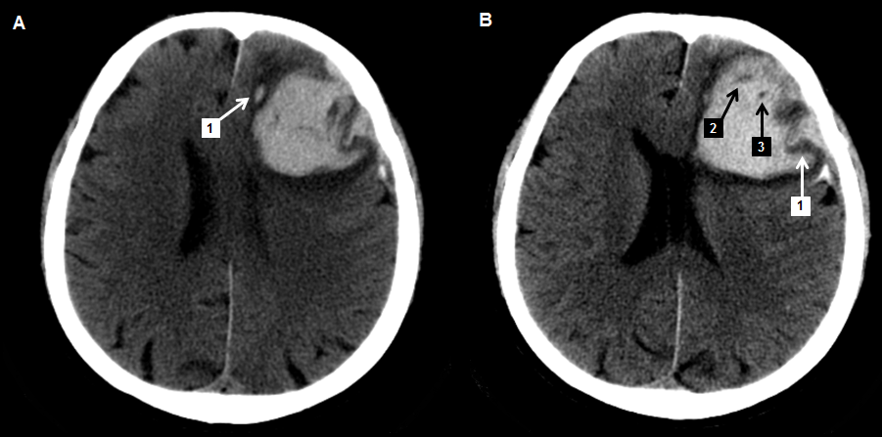
Hypodensities | Black Hole Sign |  | Swirl  Sign |  |  | Satellite  Sign |  |  | Island  Sign |  | Fluid  Level |  |  | Blend  Sign |  |  | Irregular Shape |  | Heterogeneous Density
P B2 – B3 | P B3 |  | P B1–B2–B3 |  |  | P A1 |  |  | N |  | N |  |  | N |  |  | IV |  | IV
TRAINING CASE 2
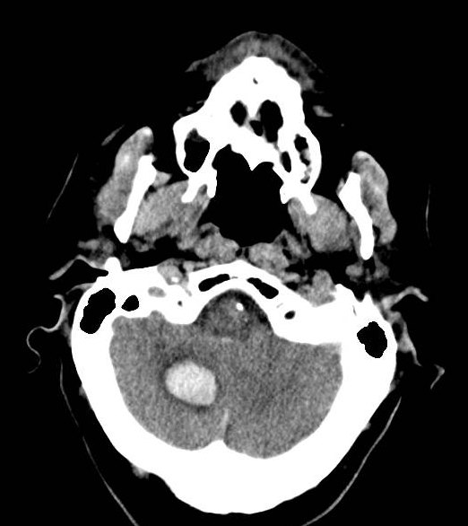
Hypodensities | Black Hole Sign |  | Swirl  Sign |  |  | Satellite  Sign |  |  | Island  Sign |  | Fluid  Level |  |  | Blend  Sign |  |  | Irregular Shape |  | Heterogeneous Density
N | N |  | N |  |  | N |  |  | N |  | N |  |  | N |  |  | I |  | I
TRAINING CASE 3
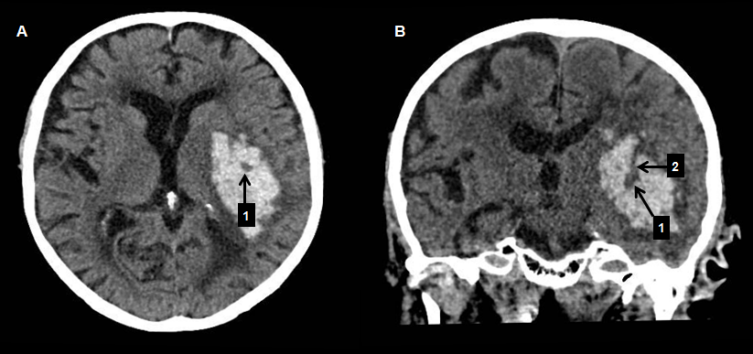
Hypodensities | Black Hole Sign |  | Swirl  Sign |  |  | Satellite  Sign |  |  | Island  Sign |  | Fluid  Level |  |  | Blend  Sign |  |  | Irregular Shape |  | Heterogeneous Density
N (A1 mimics: connection with brain parenchyma in B1-B2) | N (A1 mimics: connection with brain parenchyma in B1-B2) |  | P A1–B1-B2 |  |  | N |  |  | N |  | N |  |  | N |  |  | IV |  | III
TRAINING CASE 4
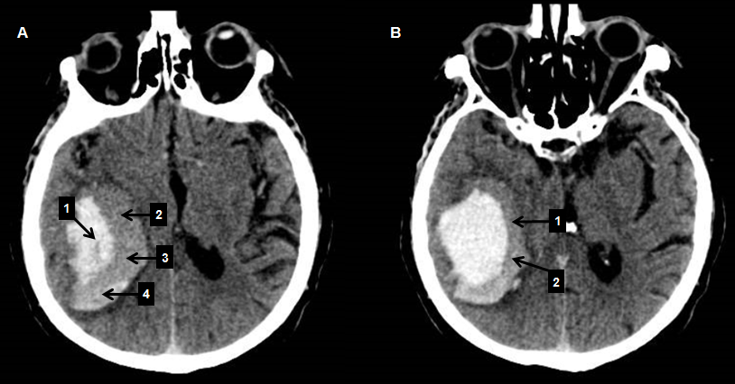
Hypodensities | Black Hole Sign |  | Swirl  Sign |  |  | Satellite  Sign |  |  | Island  Sign |  | Fluid  Level |  |  | Blend  Sign |  |  | Irregular Shape |  | Heterogeneous Density
P A1 | N |  | P A1 |  |  | N |  |  | N |  | N |  |  | P A2–A3–A4–B1–B2 |  |  | III |  | III
TRAINING CASE 5
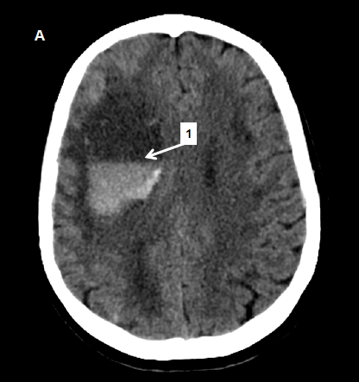
Hypodensities | Black Hole Sign |  | Swirl  Sign |  |  | Satellite  Sign |  |  | Island  Sign |  | Fluid  Level |  |  | Blend  Sign |  |  | Irregular Shape |  | Heterogeneous Density
N | N |  | N |  |  | N |  |  | N |  | P A1 |  |  | P A1 |  |  | I |  | I-II
TRAINING CASE 6
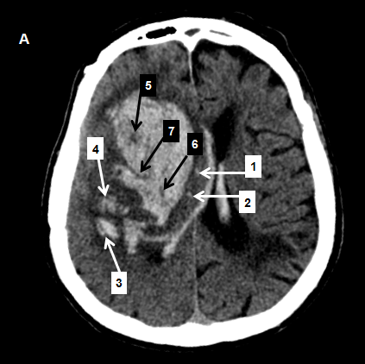
Hypodensities | Black Hole Sign |  | Swirl  Sign |  |  | Satellite  Sign |  |  | Island  Sign |  | Fluid  Level |  |  | Blend  Sign |  |  | Irregular Shape |  | Heterogeneous Density
P A5-A6. (Not A7 because connected with brain parenchyma) | P A5 |  | P A5–A6-A7 |  |  | P A1–A2–A3-A4 |  |  | P A1–A2–A3-A4 |  | N |  |  | N |  |  | V |  | IV
TRAINING CASE 7
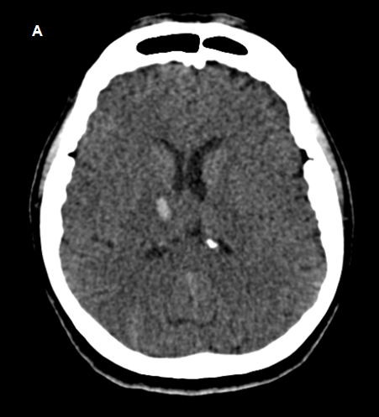
Hypodensities | Black Hole Sign |  | Swirl  Sign |  |  | Satellite  Sign |  |  | Island  Sign |  | Fluid  Level |  |  | Blend  Sign |  |  | Irregular Shape |  | Heterogeneous Density
N | N |  | N |  |  | N |  |  | N |  | N |  |  | N |  |  | I |  | I
TRAINING CASE 8
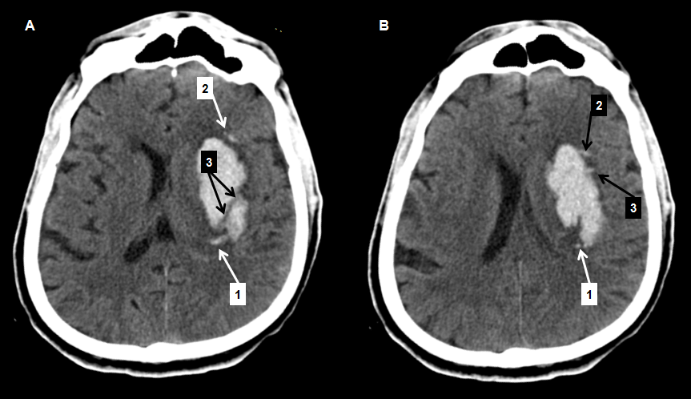
Hypodensities | Black Hole Sign |  | Swirl  Sign |  |  | Satellite  Sign |  |  | Island  Sign |  |  | Fluid  Level |  |  | Blend  Sign |  | Irregular Shape |  | Heterogeneous Density
N | N |  | P A3 |  |  | P A1–A2–B1 |  |  | N (All the small hematomas, are not visible on the same axial slice) |  |  | N |  |  | N |  | V |  | II
TRAINING CASE 9
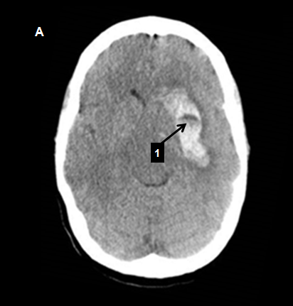
Hypodensities | Black Hole Sign |  |  | Swirl  Sign |  | Satellite  Sign |  |  | Island  Sign |  | Fluid  Level |  |  | Blend  Sign |  |  |  | Irregular Shape | Heterogeneous Density
P A1 (hypodense fluid level is encapsulated in the ICH) | P A1  (hypodense fluid level encapsulated in the ICH) |  |  | P A1 |  | N |  |  | N |  | P A1 |  |  | N (hypoattenuating area cannot be encapsulated in the ICH) |  |  |  | III | III
TRAINING CASE 10
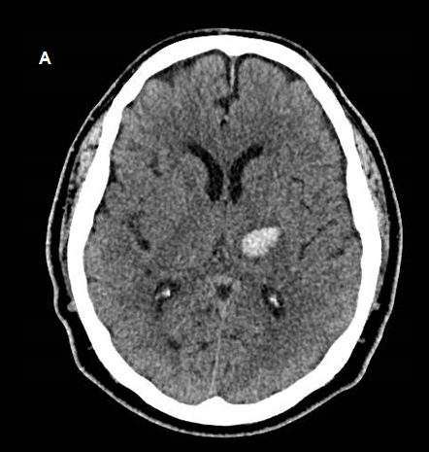
Hypodensities | Black Hole Sign |  | Swirl  Sign |  |  | Satellite  Sign |  |  | Island  Sign |  | Fluid  Level |  |  | Blend  Sign |  |  | Irregular Shape |  | Heterogeneous Density
N | N |  | N |  |  | N |  |  | N |  | N |  |  | N |  |  | I |  | I
TRAINING CASE 11
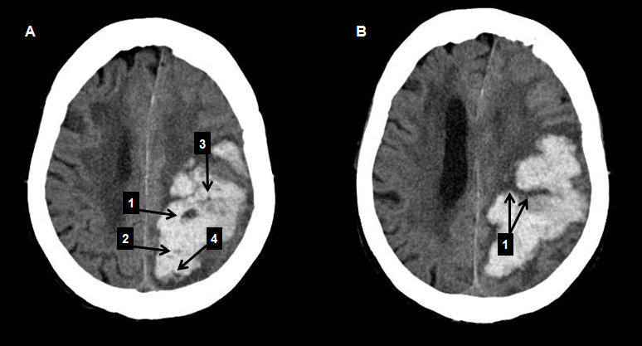
Hypodensities |  | Black Hole Sign |  |  | Swirl  Sign |  | Satellite  Sign |  |  | Island  Sign |  |  | Fluid  Level |  |  | Blend  Sign |  | Irregular Shape | Heterogeneous Density
P A1–A2–A3– A4. (B1 does not qualify for connection with brain parenchyma) |  | P A1–A3–A4. (A2 does not meet the 28 HU density delta cutoff) |  |  | P A1-A2–A3–A4–B1 |  | N |  |  | N |  |  | N |  |  | N |  | V | V
TRAINING CASE 12
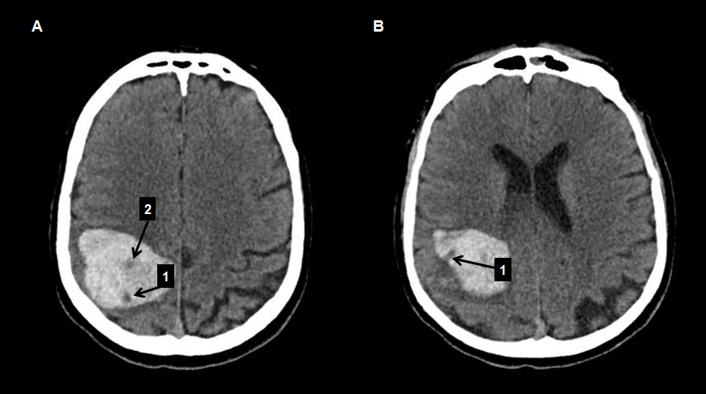
Hypodensities |  | Black Hole Sign |  |  | Swirl  Sign |  |  | Satellite  Sign |  | Island  Sign |  |  | Fluid  Level |  |  | Blend  Sign |  | Irregular Shape | Heterogeneous Density
P A1 – A2 (B1 does not qualify for connection with brain parenchyma) |  | P A1 (A2 does not meet the 28 HU density delta cutoff) |  |  | P A1 - A2 –B1 |  |  | N |  | N |  |  | N |  |  | N |  | II | V

TRAINING CASE 13
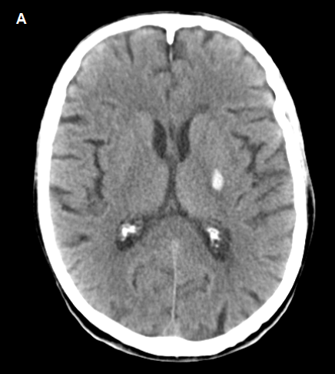
Hypodensities | Black Hole Sign | Swirl  Sign |  | Satellite  Sign |  | Island  Sign |  | Fluid  Level |  | Blend  Sign |  | Irregular Shape |  | Heterogeneous Density
N | N | N |  | N |  | N |  | N |  | N |  | I |  | I
TRAINING CASE 14
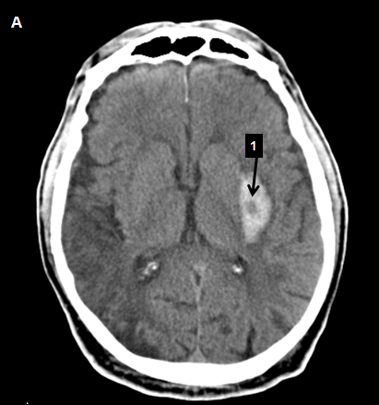
Hypodensities | Black Hole Sign | Swirl  Sign |  | Satellite  Sign |  | Island  Sign |  | Fluid  Level |  | Blend  Sign |  | Irregular Shape |  | Heterogeneous Density
P A1 | N | P A1 |  | N |  | N |  | N |  | N |  | I |  | I
TRAINING CASE 15
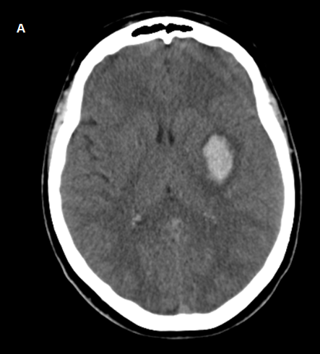
Hypodensities | Black Hole Sign | Swirl  Sign |  | Satellite  Sign |  | Island  Sign |  | Fluid  Level |  | Blend  Sign |  | Irregular Shape |  | Heterogeneous Density
N | N | N |  | N |  | N |  | N |  | N |  | I |  | I
TRAINING CASE 16
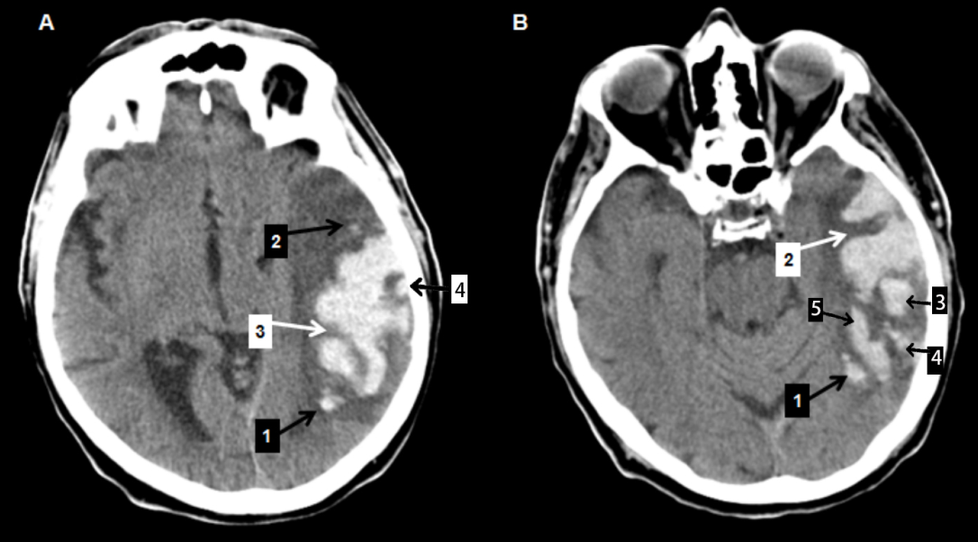
Hypodensities | Black Hole Sign |  | Swirl  Sign |  | Satellite  Sign |  | Island  Sign |  | Fluid  Level |  | Blend  Sign |  | Irregular Shape | Heterogeneous Density
N None of the multiple hypodensities is clearly encapsulated in the hemorrhage | N None of the multiple hypodensities is clearly encapsulated in the hemorrhage |  | P A3–B2 |  | P A1-A2–B1 |  | P A1–A2-A4–B1–B3–B4–B5 |  | N |  | N |  | V | I

TRAINING CASE 17
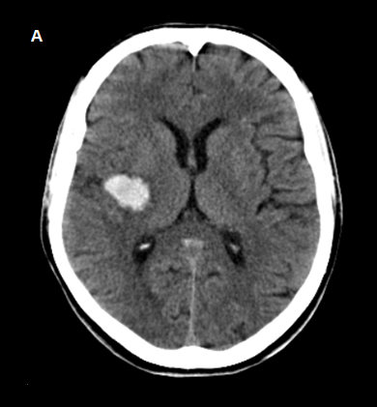
Hypodensities | Black Hole Sign | Swirl  Sign | Satellite  Sign | Island  Sign | Fluid  Level | Blend  Sign | Irregular Shape | Heterogeneous Density
N | N | N | N | N | N | N | I | I
TRAINING CASE 18
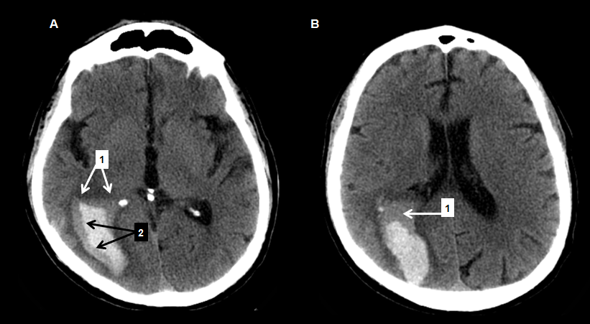
Hypodensities | Black Hole Sign | Swirl  Sign | Satellite  Sign | Island  Sign | Fluid  Level | Blend  Sign | Irregular Shape | Heterogeneous Density
N | N | N | N | N | P A1 | P A1 – A2 – B1 | I | II

TRAINING CASE 19
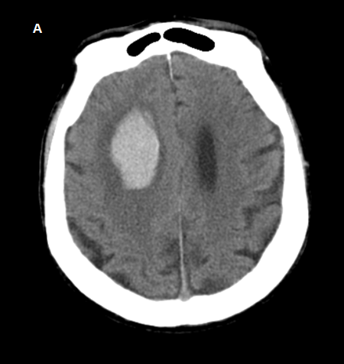
Hypodensities | Black Hole Sign | Swirl  Sign | Satellite  Sign |  | Island  Sign |  | Fluid  Level |  | Blend  Sign | Irregular Shape |  | Heterogeneous Density
N | N | N | N |  | N |  | N |  | N | I |  | I
TRAINING CASE 20
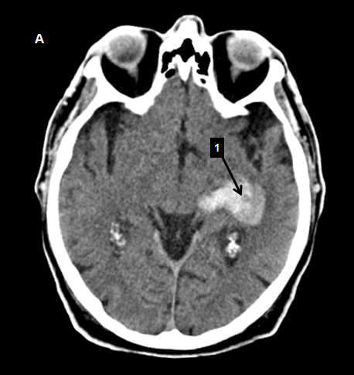
Hypodensities | Black Hole Sign | Swirl  Sign | Satellite  Sign | Island  Sign |  | Fluid  Level |  | Blend  Sign |  |  | Irregular Shape | Heterogeneous Density
P A1 | N | P A1 | N | N |  | N |  | N (No clear separation between the hyper and hypoattenuating ICH areas) |  |  | II | III
P indicates positive; N indicates negative; ICH indicates intracerebral hemorrhage; NCCT indicates non-contrast computed tomography; irregular shape and heterogeneous density rated using a categorical scale proposed by Barras and Colleagues, ranging from I (regular shape and homogeneous density) to V (maximal degree of shape irregularity and heterogeneous density).

