Improving medication safety
Focus on prescribers as well as the systems in which they work

Professor Simon RJ Maxwell PhD, Professor of Student Learning, University of Edinburgh

Professor David J Webb DSc, Christison Professor of Therapeutics and Clinical Pharmacology, University of Edinburgh

Word count – 860 words
References – 12
Figures - 1

Author for correspondence:
Professor Simon Maxwell MD PhD
Clinical Pharmacology Unit, University of Edinburgh
Clinical Research Centre, Western General Hospital
Edinburgh EH4 2XU, UK
s.maxwell@ed.ac.uk

Healthcare services around the world continue to struggle with safe and effective delivery of medication. Globally, it has been estimated that the cost associated with medication errors is US$ 42 billion each year [1]. In England, a recent review suggested that there were 237 million medication errors annually [2]. Although around half were administration errors, most of these were classed as minor with little or no potential for clinical harm. However, the authors estimated that there were 50 million prescribing and 16 million monitoring errors of which 52% and over 90% respectively had the potential to cause moderate or severe harm. Although the arrangements for prescribing and dispensing differ, these error rates are comparable with those in the US and other EU countries [3].

The consequences include patient harm, unnecessary hospital admissions, prolonged length of stay and consumption of limited healthcare resources. In that regard, it is important that patients living in low-income countries lose twice as many disability-adjusted life years due to medication-related harm than those in high-income countries [1]. Poor prescribing also contributes to three of the most important current public health challenges: inappropriate polypharmacy, opioid dependence, and antimicrobial resistance.

Although many prescribing errors are detected and corrected before they impact on patients, often by pharmacists, the prevalence of error in such a high-stakes medical intervention demands action. The WHO’s third Global Patient Safety Challenge, Medication Without Harm, commits member states to reducing severe, avoidable medication-related harm by 50% in the next five years [1].

Given the complexity of the prescribing process it is not surprising that there are multiple opportunities for error (Figure). The risk is amplified by a variety of system and individual factors, each of which offer potential targets for intervention [4]. Of the former, the implementation of electronic prescribing, clinical decision support (with linked access to electronic medical records) and support from other professionals (e.g. clinical pharmacists) all offer great promise. However, systems approaches alone will not address many instances of irrational prescribing. Working environments will always be suboptimal - fluctuations in workload, staffing absence, missing medical records, distractions, time-pressures - meaning all prescribers should be equipped with the knowledge, skills and resilience to cope with that eventuality.

Several trends in therapeutics will place further emphasis on these attributes. Ageing populations present patients who are frailer, have more co-morbidities and take more medicines, all of which might complicate prescribing decisions. The advance in genomics presents new kinds of medicines and information for prescribers intending to use them. Finally, optimal prescribing in the future will require practitioners who can move beyond the simple application of evidence-based algorithms to engage in dialogue with increasingly knowledgeable patients and help them to make shared decisions about their care. This transformation in the role of the prescriber is evident in the widespread movement to tackle inappropriate polypharmacy and the rapid growth in the deprescribing movement [1,5].

For these reasons better education and training must remain a central component of the medication safety agenda. In 2006, we highlighted our view that the emphasis on therapeutics and prescribing in UK undergraduate medical education had declined to a point where it might not be meeting the workplace demands placed on new graduates [6], concerns subsequently expressed by others [7]. Important actions that followed were the publication of statements that clarified the expected competencies of independent prescribers [8] and development of eLearning resources to enable these to be achieved [9].

Perhaps the most influential response has been the implementation of the Prescribing Safety Assessment (PSA), testing basic knowledge and competence in the prescribing and supervision of the use of medicines [10,11]. Developed by the UK Medical Schools Council and British Pharmacological Society, the PSA includes sections on prescribing and reviewing medicines, planning management, communicating about medicines, anticipating and managing adverse drug reactions, monitoring medicines and interpreting data. Having been originally implemented in 2014, the PSA is now taken by all UK final year medical students and all overseas entrants to the UK first year of postgraduate training (around 7,500 candidates each year) [11]. No progression beyond the first year is possible unless it has been passed.

This week sees the publication of the first external review examining the quality and impact of the PSA [12]. It concludes that content item development, standard setting and delivery are all of a high standard, and that the PSA enables candidates to demonstrate their competencies in relation to the safe and effective use of medicines. Moreover, it highlights that stakeholders believe it is having a positive educational impact, increases the attention paid by students and faculty to accurate prescribing and is likely to be a significant contributor to patient safety. The report also lays down the challenge of undertaking studies that demonstrate predictive validity, which are underway.

The PSA has not been universally welcomed. Some see it running counter to the philosophy of integrated medical assessment that would see it subsumed into the new UK Medical Licensing Assessment (although the report advises against this). We believe that the stark figures above justify its existence. A national assessment provides reassurance that basic standards of competence have been met by all prescribers. Patients would expect it and their healthcare services should provide it.

Competing interests
The authors have an academic interest in the success of the Prescribing Safety Assessment and have served as Medical Director (SM) and Chair of the PSA Executive (DW). They have no other competing interests to declare.

Authors’ contributions
SM prepared the initial manuscript and additional ideas and editing were provided by DJW. Both authors read and approved the final version of the manuscript.

Role of the funding source
The development and delivery of the Prescribing Safety Assessment has been funded by the Medical Schools Council and British Pharmacological Society. The project has also been supported by grants from the UK Department of Health and Social Care, NHS Education Scotland and Healthcare Education England.

References

- World Health Organisation. The third WHO Global Patient Safety Challenge: Medication Without Harm. May 1017. Available at https://www.who.int/patientsafety/medication-safety/medication-without-harm-brochure/en/ (last accessed 11.6.2019)
- Elliott R, Camacho E, Campbell F, Jankovic D, Martyn St James M, Kaltenthaler E, Wong R, Sculpher M, Faria R. Prevalence and Economic Burden of Medication Errors in The NHS in England. Rapid evidence synthesis and economic analysis of the prevalence and burden of medication error in the UK. Policy Research Unit in Economic Evaluation of Health and Care Interventions. Universities of Sheffield and York, 2018. http://www.eepru.org.uk/wp-content/uploads/2018/02/eepru-report-medication-error-feb-2018.pdf (last accessed 11.6.2019)
- Assiri GA, Shebl NA, Mahmoud MA, Aloudah N, Grant E, Aljadhey H, Sheikh A. What is the epidemiology of medication errors, error-related adverse events and risk factors for errors in adults managed in community care contexts? A systematic review of the international literature. BMJ Open 2018;8:e019101. doi: 10.1136/bmjopen-2017-019101.
- Dean B, Schachter M, Vincent C, Barber N. Causes of prescribing errors in hospital inpatients: a prospective study. Lancet 2002;359:1373–1378.
- O’Mahony D, O’Sullivan D, Byrne S, O’Connor MN, Ryan C, Paul Gallagher P. STOPP/START criteria for potentially inappropriate prescribing in older people: version 2. Age and Ageing 2015;44:213–218.
- Maxwell SRJ, Webb DJ. Clinical pharmacology–too young to die? Lancet 2006;367:799-800.
- Editorial. How to reduce prescribing errors. Lancet 2009;374:1495.
- Royal Pharmaceutical Society. A Competency Framework for all Prescribers. July 2016.
- eLearning for Healthcare programmes. Clinical Pharmacology and Prescribing, Safe Prescribing and Prescribing Simulator. Available at https://www.e-lfh.org.uk/programmes/
- Maxwell SRJ, Cameron IT, Webb DJ. Prescribing safety: ensuring that new graduates are prepared. Lancet 2015;385:579–581.
- Maxwell SRJ, Coleman JJ, Bollington L, Taylor C, Webb DJ. Prescribing Safety Assessment 2016: Delivery of a national prescribing assessment to 7343 UK final-year medical students. Br J Clin Pharmacol 2017;83:2249–2258.
- McLachlan JC. An independent review of the Prescribing Safety Assessment. [to be made available to referees while embargoed and then open access on the British Pharmacological Society website]

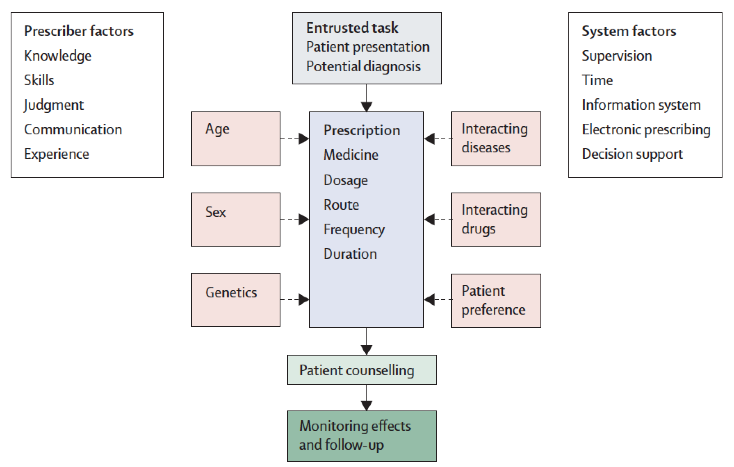

Figure: Factors that contribute to the complexity of the prescribing process
Clinicians are entrusted with prescribing tasks based on a patient presentation and likely diagnosis. They then have to select the correct medicine, dosage, route, and frequency of administration, taking account of multiple factors that might influence their choices. Because the outcome of any prescription is uncertain, the prescriber must counsel the patient and plan an appropriate strategy for monitoring and follow up.

